A Robotically-Augmented Walker for Older Adults

Jared Glover, David Holstius, Michael Manojlovich, Keirsten Montgomery,
Aaron Powers, Jack Wu, Sara Kiesler, Judith Matthews, Sebastian Thrun

Abstract

This paper describes a robotically augmented walker capable of parking itself and returning to the user when signaled by remote control. The device uses a modified version of the CARMEN localization software suite to additionally give room-by-room directions in an indoor environment. Because it is based on a commercial walker frame, this device offers the safety and stability of a non-robotic walker during normal ambulation while providing supplementary functionality for reducing fall risk. The system has received positive reviews during informal testing with elders at a Pennsylvania assisted-living facility.

1. Introduction

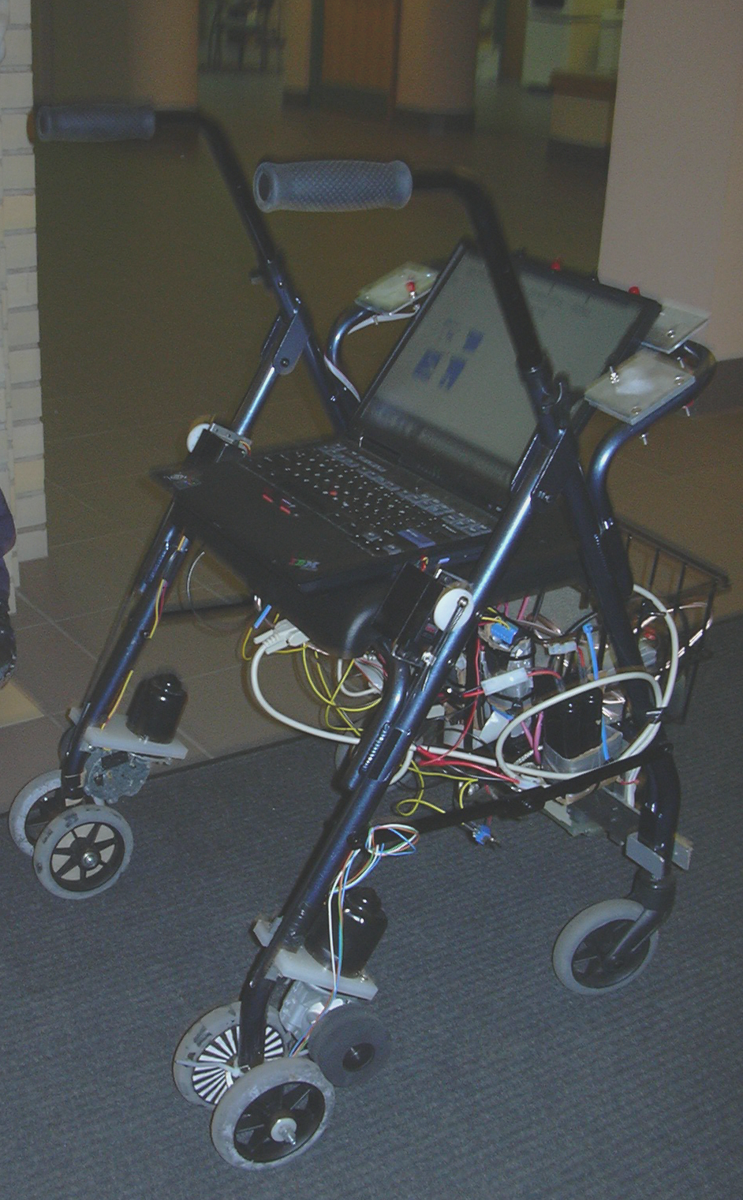
Pedestrian mobility aids (walkers) may pose certain safety risks to users when they are used infrequently or incorrectly. In particular, walker users are known to ‘park’ walkers by placing them out of easy reach. Consensus among caregivers is that this activity represents a higher level of risk for falls, a serious concern among the frail elderly. Our solution to this problem is a prototype robotically augmented walker designed to park itself unobtrusively and return when signaled by a remote control (Fig. 1). The system thus encourages users to have the walker come to them, rather than walking extended distances without support in order to retrieve it. We hypothesize that augmenting walkers in this way may increase their appeal, reduce the need for nursing supervision, and mitigate some risks by encouraging correct use.

The sensors and mapping software required to perform this remote parking and retrieval also provide global navigational assistance directly to users. A cognitive aid, in the form of a continuously updated map and large arrow makes it easy for users to discreetly

Fig. 1 Nursebot Project Walker Prototype
re-orient themselves and arrive independently at their destination.

1.1 Fall Risk Among an Increasingly Elderly Population

As mentioned, falls among the elderly are not a minor issue. Among adults 65 years of age and older, falls represent the leading cause of unintentional injury death. Approximately 1/3 of accidental deaths in this demographic, or 10,000 per year, result from falls and the complications that arise from them [5, 3]. Falls are also the leading cause of morbidity, or disability-related loss of function, within this age group. As adults age to 80 years and above, marked increases in mortality and morbidity are associated with even minor slips and falls [13]. Cognitive impairments, which may be due to degenerative conditions or polypharmacy, are contributing factors to falls, suggesting that cognitive aids – such as our map-based system – may reduce fall risk [13, 1].

Care givers and technology developers, including roboticists, must be equipped with the knowledge and background to create devices that are both medically and technologically appropriate for an increasingly elder population. The population growth rate for the elderly is double that of the general population, a trend that is expected to continue well into the 21st Century [6]. Fall-reducing technology with increased effectiveness and/or appeal has the potential to make a large difference in quality of life for the elderly, and the potential is increasing every year.

1.2. Fall Risk and Improper Walker Use

Falls are more likely to occur when individuals do not consistently ambulate with the particular assistive devices recommended for them. Anecdotal reports by health care providers and family members frequently observe people who decline to use a walker, steadying themselves instead on nearby walls and furniture. Other informal observations have shown older adults carrying the walker rather than relying on the added stability it offers, and even ‘walking to the walker’.

We conducted an ethnographic study of walker users in a Pennsylvania assisted care facility and found support for these observations. Out of 41 walkers observed, 18 (44%) were parked out of reach or outside of the room that the user was in. Eight users (20%) were observed parking their own walkers out of immediate reach, and 10 (24%) were observed being placed out of reach by staff or other residents. This supports the hypothesis that users (or staff, in a communal facility) often attempt to park their walkers unobtrusively.

In addition, we observed users engaging in the risky practice of walking back to their own walkers. 30 users were observed re-acquiring their walkers from seated or standing positions; out of the five cases in which the walker was parked outside of the room, 100% of users walked out of the room to retrieve it themselves. (Seven others had their walker returned to them at a distance in the same room by staff or residents, and the remainder had their walkers parked beside them and required no assistance in re-acquiring the walkers.)

Based on these observations, we concluded that a self-parking walker represents risk-reducing functionality that would be supportive of walker-parking practice.

1.3 Previous Mobility-Enhancing Robotic Devices

Roboticists have developed a number of mobility-enhancing assistive technologies over the last decade. Most of these are active aids, meaning that they share control of total motion with the user, and have focused on obstacle avoidance and path navigation. A number of wheelchair systems have been developed [9, 8, 10, 12], as well as several walker- and cane-based devices targeted toward blind [2] and/or elderly users.

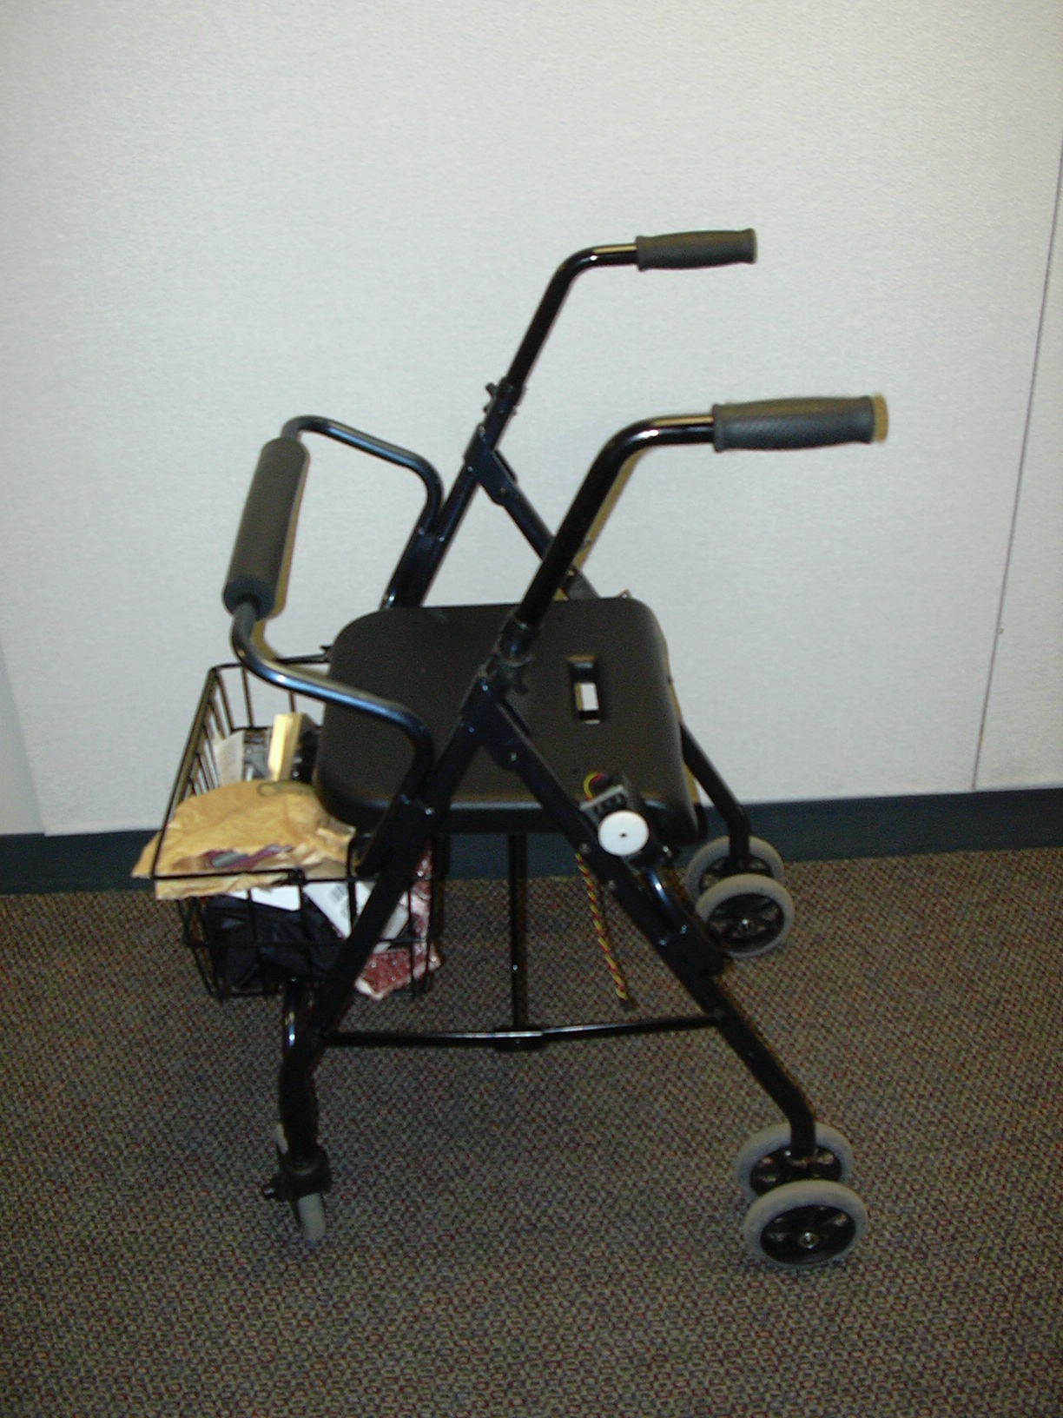
For example, the walker-based Guido system, which evolved from Lacey & MacNamara’s PAM-AID, is designed to facilitate independent exercise for the visually impaired elderly and thus focuses on power-assisted wall or corridor following [7].Dubowksy et al’s PAMM (Personal Aid for Mobility and Monitoring, distinct from PAM-AID) project focuses on health monitoring and navigation for users in an eldercare facility, and most recently has adopted a custom-made holonomic walker frame as its physical form [4,14]. Wasson and Gunderson’s walkers rely on the user’s motive force to propel the devices and steer the front wheel to avoid immediate obstacles [15]. All three are designed to exert some corrective motor-driven force on a user, although passive modes are available.

None of these systems, however, address the safety issue brought up in the introduction to this paper; that is, the potential for falls or other mishaps while the user is coupling or uncoupling from the system.

As well as being the first device designed to automate parking and retrieval, our walker also represents a design shift toward greater user autonomy, reducing cognitive load through navigational feedback while allowing full control over the path of motion.

2. Hardware Description: Motion, Location, Navigation, and Remote Control

After reviewing a number of existing commercial walkers, we concluded that a four-wheeled walker provided sufficient stability for the additional equipment we would be installing. We then took this base design and modified it to allow for autonomous navigation as well as passive guidance. The walker base is shown in Fig 2. This particular four-wheeled walker was chosen due to its original braking design. In order to brake, the user simply had to push down on the walker, bringing the bottom of the walker in contact with the floor. We used this design to our advantage and implemented a drive system that came into contact with the main wheels when the
walker was lowered. This allowed us to maintain the ability of the walker to brake

Fig 2. Walker Prior to Modification

when pushed down upon, but also allowed us to extend this function to permit motors to drive the main wheels when needed. This assembly is shown in Fig 3. Since there were two main wheels in the rear, we added a drive assembly to each side. This allowed the robot to turn in any direction with an almost zero turning radius.
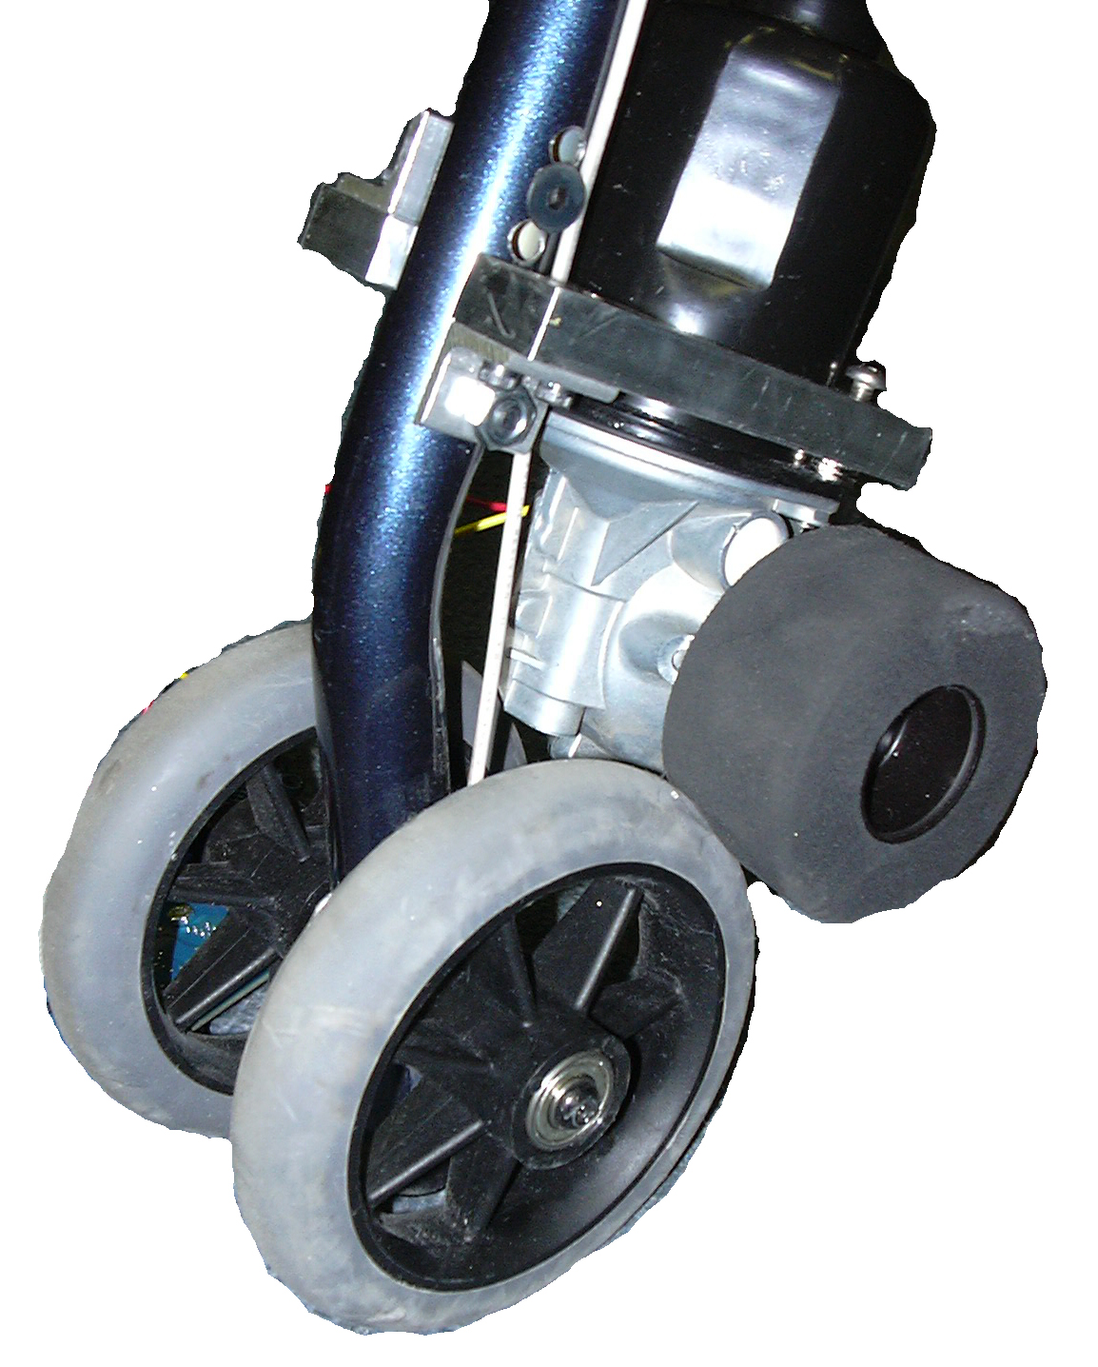
Fig 3. Detail of Walker Drive Assembly

Besides the modifications to the wheel assembly, two types of sensors were added. One sensor was used by the robotic components to gather environmental information while the other was used to gather user feedback. A SICK LMS laser range finder was mounted underneath the walker and was used to gather a 180 degree horizontal planar slice of the distances between it and any obstruction. With this sensor, as well as a pre-computed map of the environment, the walker was able to know where it was at all times. As to sensors for user feedback, six buttons built around the laptop display. Each pushbutton’s state was monitored constantly by a BasicX microcontroller which sent information to the laptop twenty times a second. Also providing user feedback was an infrared remote control that was used to control the walker with the use of buttons much like similar to that of a television remote control. The final walker design is shown in Fig 1.

3. Software Description: Mapping and Motion

The basic software components of our walker are similar to those of many autonomous robots—navigation, localization, map building and editing, motor control, and sensory interface. As a base for our software development we used CARMEN [11], which provided a robust framework where all the above components were already handled in some way, allowing us to avoid a prodigious programming effort and enabling us to focus on the development of components specific to the unique features of the walker.

Of the walker’s two main features —parking and returning and navigational guidance — CARMEN provided the basic functionality needed for the former, leaving the navigational guidance system and a fairly substantial amount of sensor component integration programming to be done by our research team.

3.1 Navigational Guidance

While the navigational abilities provided by CARMEN were extremely useful for autonomous navigation by the walker needed for its valet service, the path-planning information displayed by CARMEN is much different from what a human makes use of in accepting navigational assistance. For most people navigating through indoor environments, the most relevant information about a path pertains to the intersections it traverses, while CARMEN displays waypoints and vectors between them which usually have little or nothing to do with the topological structure of the room-based environment. Furthermore, goal-points in the default CARMEN planner are actual points in Euclidean space, while goal-points to humans in indoor environments are usually rooms. Rather than take the existing planner and augment it so that it would allow for more robust goal-points and possibly provide more meaningful information about paths to the user, an entirely new, room-based planner was written, as the existing planner was deemed to be far too complex for the task at hand.

3.2 A Room-Based Planner

In order to take advantage of the topological structure of a room-based environment, the first step is to discern the topology of the environment. One way to represent this topology is in a graph with weighted edges, where the nodes represent doors or borders, the edges represent rooms or areas, and the weights on the edges represent distances between borders. While more complicated techniques may be employed to approximate path cost between doors (including the algorithm used by the CARMEN planner), Euclidean distance was deemed adequate enough for our project, provided that the areas are sufficiently uncluttered and convex.

Once such a graph is created, the user’s location is added to the graph as a new node, with edges connecting it to the doors in the room the user is currently in. A* planning (with a Euclidean distance heuristic) can then be used on the graph to find a sequence of doors representing a path for the user to take to the goal room.

Some thought was given to building these graphs completely autonomously, but with only the 2-dimensional occupancy grids that CARMEN provides, differentiating between rooms or areas in a way that would be meaningful to humans would be a difficult problem. For example, a border between two rooms in many houses may be marked only by a change in the color of carpeting, or by the fact that there is a dining table in one room and a sofa and television in the other. Thus, with no visual data to go by, fully autonomous room discovery was deemed impractical, if not impossible. However, once we allow border locations and room names to be added manually, a simple space-filling algorithm on the occupancy grid of the map will suffice to quickly build a complete topological graph for any environment [Fig 4, Fig 5].
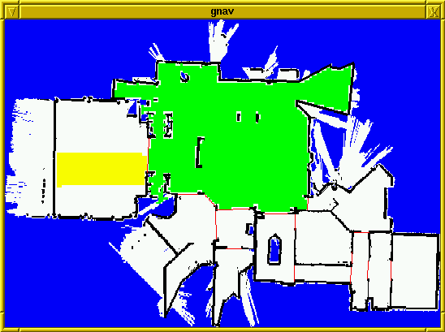
Fig. 4 Graphical display of the space-filling algorithm used to build topological graphs of room-based environments. Borders between rooms are shown in red, filled rooms in green, and rooms in the process of being filled in yellow.

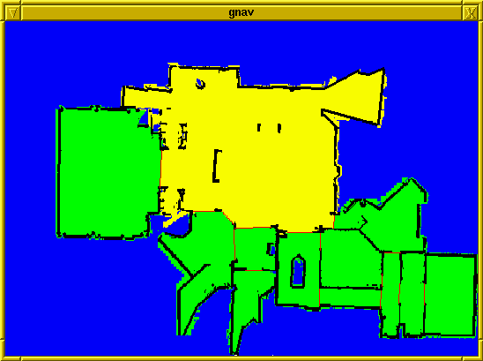

Fig. 5: Graphical display of the map after its topological graph has been built. The room the user is currently in is shown in yellow.

4. Software description of UI

The prototype walker’s user interface has five major concerns:

- Enabling the user to park and retrieve the walker;
- Allowing the user to select a destination from a list;
- Keeping the user informed of his or her current position;
- Dynamically guiding the user to his or her chosen destination; and
- Providing positive feedback and appeal.

A screen-based or voice-command interface for parking and retrieval was determined to be impractical during the design phase. There was also a handheld remote control device for parking and retrieving the walker. There were two separate buttons on the remote – one for signaling the walker to park, the other for retrieval. Possible changes in this design are discussed in Section 5.1.

The prototype’s interface output is primarily graphical, and is currently displayed on the screen of a laptop computer attached to the walker’s seat/platform [Fig. 6]. In order to accommodate older adults with reduced eyesight, this screen-based interface displays four destinations at a time in a large, high-contrast font. Users can scroll through additional destinations or select a destination by pressing another button mounted on the walker frame.

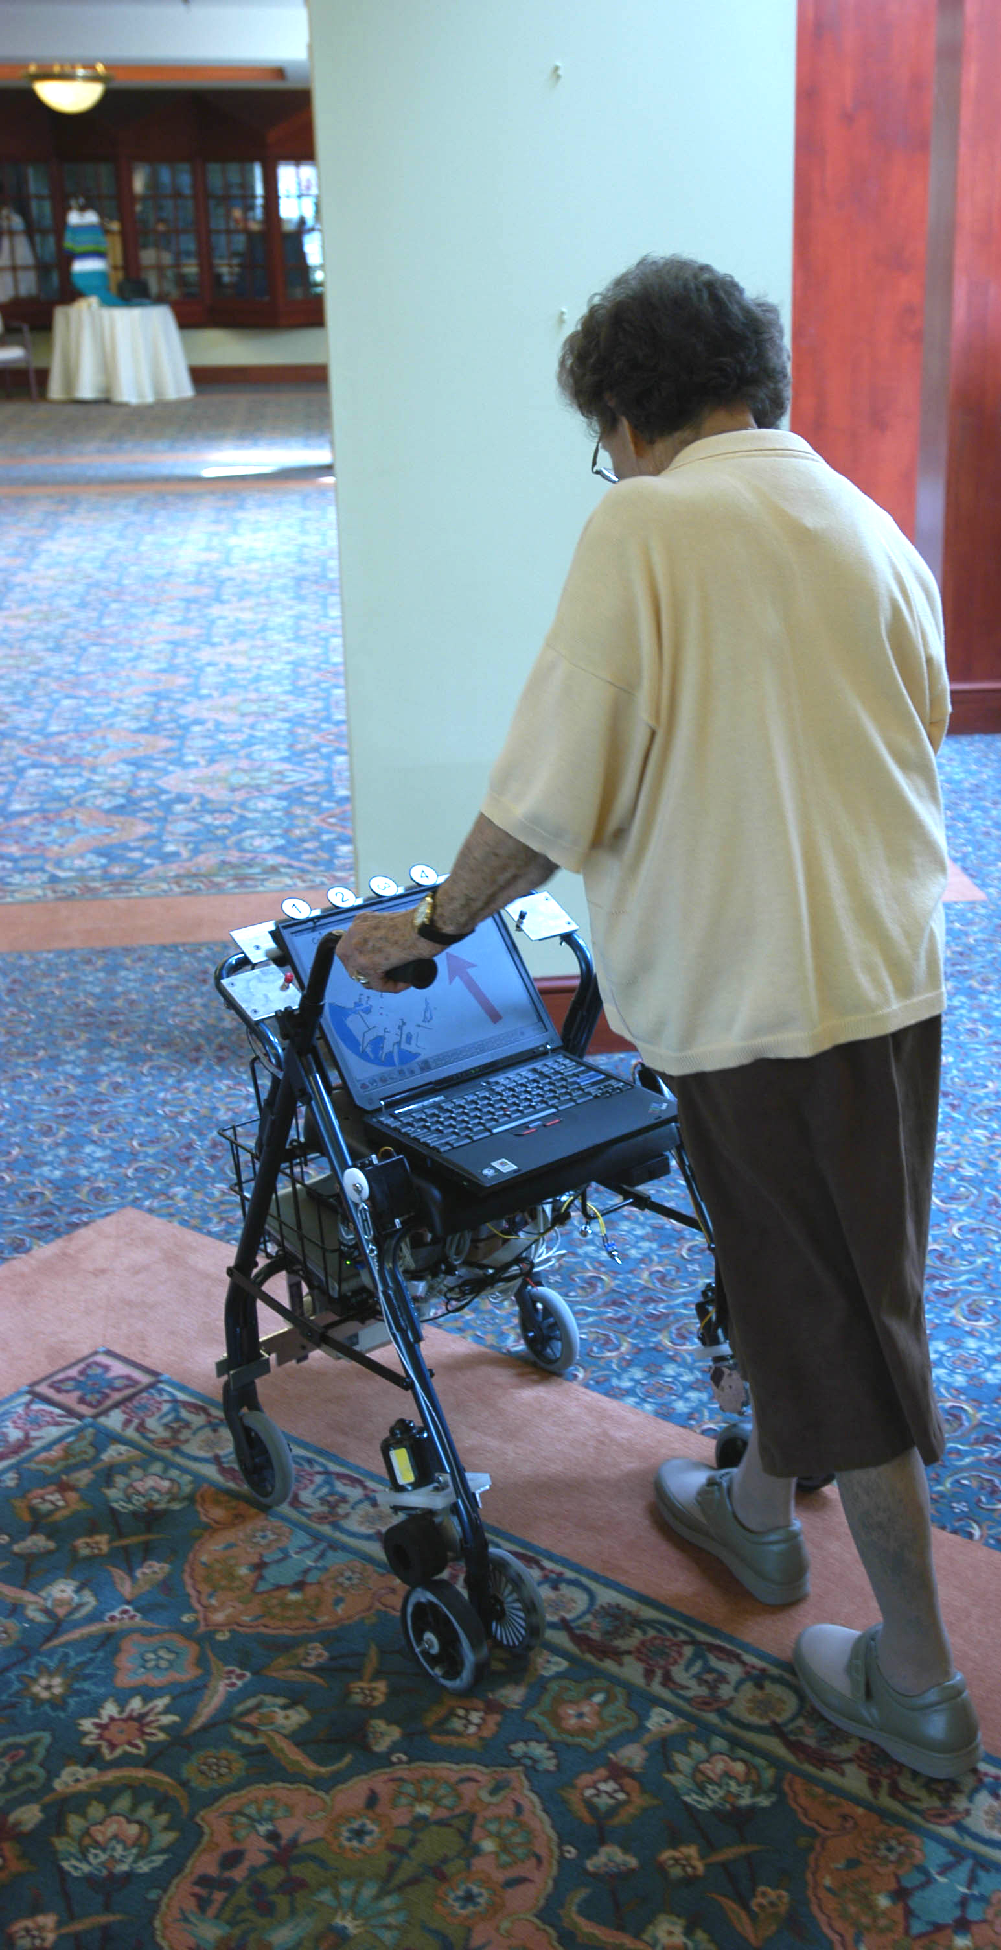
In addition to the destination-selection components, the onscreen interface features
a map generated during the site-mapping phase of the project. As the user moves the walker around, this map dynamically rotates

Fig. 6 Using the Location System. Note Buttons

located along frame above laptop screen

and translates to keep the walker’s present location and heading centered and facing upward.

Finally, a large arrow continuously updates to point the user toward his or her currently selected destination. [Fig. 7] The arrow cues the user to the next sequential room on the shortest path to the destination. Hence, users are able to discern the visual cueing even when going to an unfamiliar location that they had not often frequented.

To increase the walker’s appeal to users, a distance-traveled indicator was also added as a screen-based component. This display provides positive feedback to the user about
their current level of mobility. Just as the map’s similarity to an in-car GPS system is

Figure 7: The user interface as tested. The arrows above text point to numbered buttons above the edge of the LCD panel

intended to evoke themes of independence and mobility, the odometer display is intended to reinforce users’ self-perceptions of activity and energy. Data on how often and how far users move could also be useful to caregivers, as a side benefit of this odometer-based functionality.

5. Elderly Testing/Feedback

The walker was presented to several advisory panels at the Longwood multi-level care facility, for feedback and suggestions. There were discussions early in the design phase, in the middle of development, and after the end of development. One panel was composed of selected people who use walkers on a day-to-day basis, and a second panel of staff members who observe people using walkers on a day-to-day basis. The panelists were also offered the chance to try out the walker and see what they thought.

There were several repeated themes of conversation. All panel members were very enthusiastic about the walker being able to park itself for them – they could relate to parking their walker far away, walkers getting in the way of people sitting at tables, and other problems. The panel members were less interested in the Navigational capabilities – since we picked people who were cognitively very intact and able to give feedback, none of them personally needed help navigating around. However, several panelists said that they knew people who would need this functionality – due to poor memory. We did not test any of these people.

While testing the walker, we found that users were able to pick up and use the device. However, they did require some instruction. The remote control had many buttons, and they were unlabelled – this is commented on in section 6.2. When looking at the interface (figure 6), some users did not realize which location they were currently heading towards – perhaps because “To Dining Hall” is mixed up in a lot of other text at the top of the screen. Usage of the map was clear to all users, and the arrow was clear. This suggests some redesign of the layout of the text on the top third of the screen in the future.

One major problem many users had involved the push-down-to-brake system. Several walker users kept leaning on the walker, engaging the brake, and making it difficult to move forward. In a future version of the walker, it may use hand brakes instead of weight-activated brakes.
The added weight of the robotic equipment onto the walker did not make it harder for users to push it around – the wheels made it fairly easy to push and no users commented negatively on that weight. However, the panel commented repeatedly that they would not be able to take the device with them if it was this heavy – practically, they often needed to be able to lift their walker to put it in cars, avoid bumps outside, and other times. Thus, the walker is currently for indoor, well-mapped areas only.

6. Conclusions and Future Research

We have developed a prototype robotic walker that is capable of self-parking and returning to the user when signaled by remote control. Based on our observations, we believe this functionality represents a risk-reducing and appealing technology that could contribute to fall reduction among elders. Feedback from elders has been positive: during informal testing, users successfully navigated to a chosen destination by using the screen-based interface, and also expressed enthusiasm for the device.

The mechanical and software aspects of remote parking are currently being improved, and we expect further revisions to the interface before extensive user studies are conducted. Possible interface enhancements include voice recognition, spoken directions, dynamic user localization (rather than returning to the same spot), and/or a touch-screen interface. Although the current functionality is a significant improvement over standard walker models, as robotic technology improves, even more effective fall prevention will surely become possible through advanced sensing and actuation techniques. As with any project, we see several possible improvements that would provide avenues for extending the functionality of the walker.

6.1 UI Extensions/Improvements

The external buttons for location selection were functional but proved fragile in actual use. The use of a touch screen instead would permit an immediate mapping of location and screen prompt rather than requiring direction arrows to reference the buttons. It would also allow elimination of hardware and wiring associated with the buttons.
Visual acuity is known to decrease with age. This presents a problem for any visual interface when requesting input. We will be researching the feasibility of optional or additional audio directions and cues. Voice command recognition will require extensive development to overcome problems associated with ambient noise and changing voice characteristics and is therefore less likely to be included in future versions

6.2 Hardware / Sensors and Motor Extensions/Improvements

Though the additional weight of the hardware components was not excessive, research will continue to improve the drive mechanisms with the goal of increasing reliability and reducing weight.
An additional sensor that faces rearward on the walker is possible. This would allow the walker to stop automatically if users appear to be moving the walker while not facing the device square to the handles or placing themselves too far behind the walker for safe operation.
At present, the remote control device is infrared which requires line-of-sight to activate. Providing some form of radio/wireless control would allow the walker to park out of view.
The current remote control was also large, unwieldy, and had a number of buttons that were not in use. A better design would consist of a single button to both park and retrieve the walker.

6.3 Mapping / Location Finding Software Extensions/Improvements

For any robotics application, there is a goal to improve autonomy of the device. This would include determining how to permit autonomous discovery of topological structure maps but in a way that is immediately meaningful to humans.
An obvious issue we did not address involves the integration of this device into a community environment. This would require central monitoring and scheduling as well as handling of multi-agent scenarios (e.g., where several walkers may be vying for the same parking area).
User-sensing and localization is also an area where we can improve autonomy. We will attempt to have the walker more closely monitor the user's behavior and potentially provide better alignment and stability.
Ultimately, the walker could move from passive to active guidance. This can be done in stages, with the first being obstacle avoidance during use, and then moving into active navigational assistance and directed walking.

7. Acknowledgements

The authors gratefully acknowledge financial support from the National Science Foundation (IIS-0085796) and the various invaluable contributions of the entire Nursebot team. Thanks also to the UPMC Living-At-Home program and the UPMC Rehab clinicians who familiarized us with walkers. Special thanks to the adults who graciously served on our advisory panels, patiently gave feedback, and participated in our studies; and to the staff at Longwood At Oakmont. Thanks also to the various invaluable contributions of the entire Nursebot team and the Project on People and Robots.

References

[1]American Geriatrics Society, British Geriatrics Society, and American Academy of Orthopaedic Surgeons Panel on Falls Prevention. (2001). Guideline for the prevention of falls in older persons. The Journal of the American Geriatrics Society, 49, (5), 664 – 672.

[2] Borenstein, J. and Ulrich, I. (1997). The GuideCane – A Computerized Travel Aid for the Active Guidance of Blind Pedestrians. IEEE Int. Conf. On Robotics and Automation: 1283-1288.

[3] Craven, R. & Bruno, P. (1986). Teach the elderly to prevent falls. Journal of Gerontology Nursing, 12, 27 – 33.

[4] Dubowsky S, Genot F, Godding S, Kozono H, Skwersky A, Yu H, Yu L S. (2000) PAMM - A Robotic Aid to the Elderly for Mobility Assistance and Monitoring. In: IEEE International Conference on Robotics and Automation, San Francisco, 2000, 570 –576.

[5] Eakman, A.; Haven, M.; Ager, S.; Buchanan, R.; Fee, N.; Gollick, S.; Michels, M.; Olson, L. Satterfield, K.; & Stevenson, K. Fall prevention in long-term care: An in-house interdisciplinary team approach. Topics in Geriatric Rehabilitation, 17, (3), 29 – 39.

[6] Kinsella, Kevin and Velkoff, Victoria, An Aging World: 2001, United States Census Bureau, 2001.

[7] Lacey G, MacNamara S, Dawson-Howe K. (1998) Personal adaptive mobility aid for the frail and elderly blind. Assistive Technology and Artificial Intelligence, Mittal V, Yanco H, Aronis J, and Simpson R (eds), Lecture Notes in Artificial Intelligence 1458, Springer 1998: 211-220.

[8] Lankenau A & Röfer T. (2001). A Versatile and Safe Mobility Assistant. IEEE Robotics and Automation Magazine 8(1): 29-37.

[9] Levine, S. P., D. Bell, L. Jaros, R. Simpson, Y. Koren, and J. Borenstein. The navchair assistive wheelchair navigation system. IEEE Transactions on Rehabilitation Engineering, vol. 7, no. 4, 1999.

[10] Mazo M. (2001). An Integral System for Assisted Mobility. IEEE Robotics and Automation Magazine 8(1): 46-56.

[11] Montemerlo, M., Roy, N., and Thrun, S. Perspectives on Standardization in Mobile Robot Programming: The Carnegie Mellon Navigation (CARMEN) Toolkit. Carnegie Mellon University. Pittsburgh, PA. Submitted for publication, March 2003.
http://www.cs.cmu.edu/~carmen.

[12] Prassler E, Scholz J, & Fiorini P. (2001) A Robotic Wheelchair for Crowded Public Environments. IEEE Robotics & Automation Magazine 8(1): 38-45.

[13] Rubenstein, L.; Powers, C.; & MacLean, C. (2001). Quality indicators for the management and prevention of falls and mobility problems in vulnerable elders. Annals of Internal Medicine, 135, (8), 686 – 693.

[14] Spenko, M. (2001) Design and Analysis of the SmartWalker, a Mobility Aid for the Elderly. Master’s Thesis, MIT.

[15] Wasson G, Gunderson J, Graves S, & Felder R. (2001). An Assistive Robotic Agent for Pedestrian Mobility. Agents ’01: 169-173.

