Neuron Sandbox Expanded Worksheets

Will Hanna
Thomas County Middle School

Christina Gardner-McCune
University of Florida

David Touretzky
Carnegie Mellon University


This work was funded by National Science Foundation awards DRL-2049029 and DRL-2048502.

#1. Can I make a peanut butter and jelly sandwich? I need both peanut butter and jelly.
INPUTS |  | Solve for Weighted  Input 1: | Solve for Weighted  Input 2: | ACTIVATION  Take the weighted inputs from column B and add them together | Do we want the activation in column C to be greater than the threshold? | Determine the threshold:  What decimal number is greater than your Ns but less than your Ys? | Is activation greater than threshold?  (If the answer doesn’t match the 0 or 1 in the desired output, change your threshold.) | DESIRED OUTPUT  What is the correct answer for each case?
Input₁  Have peanut butter  0 - No  1 - Yes | Input₂  Have Jelly  0 - No  1 - Yes | Weighted Input₁  W₁ = 1  Input₁ x W₁ = __ | Weighted Input₂  W₂ = 1  Input₂ x W₂= __ | Activation  Sum of Weighted Inputs 1 & 2 | Should activation be above threshold?  (Y or N) | Threshold  Write the number you want to use for the threshold | Is Activation > Threshold ?  Write 0 for no or 1 for yes. | Desired Output  0 - No  1 - Yes
0 | 0 | 0 x 1 = 0 | 0 x 1 = 0
0 | 1 | ___ x 1 =___ | ___ x 1 = ___
1 | 0
1 | 1
 |  |  |  |  |  |  |  | Start Here
 |  | B |  | C | D | E | F | ⭐ A ⭐

#1. Can I make a peanut butter and jelly sandwich? I need both peanut butter and jelly.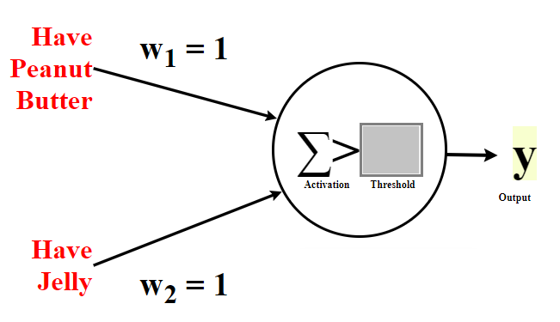

#2. Should I wear boots today? I should wear boots when it is raining or snowing.

INPUTS |  | Solve for Weighted  Input 1: | Solve for Weighted  Input 2: | ACTIVATION  Take the weighted inputs from column B and add them together | Do we want the activation in column C to be greater than the threshold? | Determine the threshold:  What decimal number is greater than your Ns but less than your Ys? | Is activation greater than threshold?  (If the answer doesn’t match the 0 or 1 in the desired output, change your threshold.) | DESIRED OUTPUT  What is the correct answer for each case?
Input₁  Is it raining?  0 - No  1 - Yes | Input₂  Is it snowing?  0 - No  1 - Yes | Weighted Input₁  W₁ = 1  Input₁ x W₁ = __ | Weighted Input₂  W₂ = 1  Input₂ x W₂= __ | Activation  Sum of Weighted Inputs 1 & 2 | Should activation be above threshold?  (Y or N) | Threshold  Write the number you want to use for the threshold | Is Activation > Threshold ?  Write 0 for no or 1 for yes. | Desired Output  0 - No  1 - Yes
0 | 0 | 0 x 1 = 0 | 0 x 1 = 0
0 | 1 | ___ x 1 =___ | ___ x 1 = ___
1 | 0
1 | 1
 |  |  |  |  |  |  |  | Start Here
 |  | B |  | C | D | E | F | ⭐ A ⭐

#2. Should I wear boots today? I should wear boots when it is raining or snowing.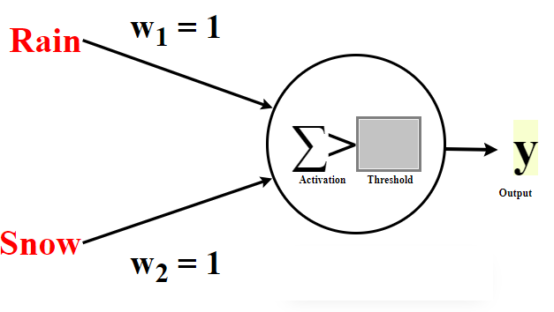

#3. John is planning a picnic with friends. He wonders if today is a good day for a picnic. It is a good day for a picnic if it is sunny outside and his friends are available today.

INPUTS |  | Solve for Weighted  Input 1: | Solve for Weighted  Input 2: | ACTIVATION  Take the weighted inputs from column B and add them together | Do we want the activation in column C to be greater than the threshold? | Determine the threshold:  What decimal number is greater than your Ns but less than your Ys? | Is activation greater than threshold?  (If the answer doesn’t match the 0 or 1 in the desired output, change your threshold.) | DESIRED OUTPUT  What is the correct answer for each case?
Input₁  Is it sunny?  0 - No  1 - Yes | Input₂  Are friends available?  0 - No  1 - Yes | Weighted Input₁  W₁ = 2  Input₁ x W₁ = __ | Weighted Input₂  W₂ = 2  Input₂ x W₂= __ | Activation  Sum of Weighted Inputs 1 & 2 | Should activation be above threshold?  (Y or N) | Threshold  Write the number you want to use for the threshold | Is Activation > Threshold ?  Write 0 for no or 1 for yes. | Desired Output  0 - No  1 - Yes
0 | 0 | 0 x 2 = 0 | 0 x 2 = 0
0 | 1 | ___ x 2 =___ | ___ x 2 = ___
1 | 0
1 | 1
 |  |  |  |  |  |  |  | Start Here
 |  | B |  | C | D | E | F | ⭐ A ⭐

3. John is planning a picnic with friends. He wonders if today is a good day for a picnic. It is a good day for a picnic if it is sunny outside and his friends are available today.

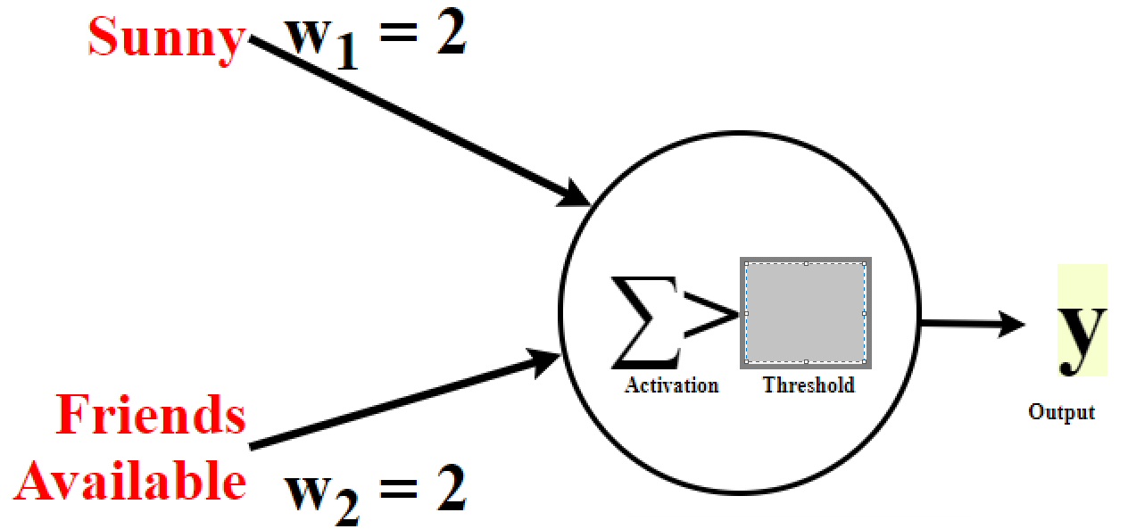

NEW WORKSHEET: “Solve for Weight”
#4. Should I play outside? I would play outside either if I need exercise or if it's sunny.
INPUTS |  | Should activation be above threshold? Answer should be based on the desired output (column A) | Type of constraint on weight W₁  Either “greater than” or “less than” | Margins for Weight W₁ | Solution for Weight W₁  What value for W₁ satisfies all constraints in columns C+D? | Compute Weighted  input 1 | Weighted  input 2 | ACTIVATION | Is activation greater than threshold?  If the answer doesn’t match the 1 or 0 in the desired output, go back to column E | DESIRED OUTPUT
Input₁  0 - Don’t Need Exercise  1 - Need Exercise | Input₂  0 - Not Sunny  1 - Sunny | (Y or N) | If column B is “Y”, put “>” here.  If column B is “N”, put “<” here. | Take the threshold 0.5 and subtract Weighted Input 2 (column G) | Example: If C+D says “> 0.5” then the value of W₁ must be something greater than 0.5 | W₁ = ___ from E  Input₁ x W₁= __ | W₂ = 1  Input₂ x W₂= __ | Sum of weighted Inputs 1 & 2 (columns F and G) | Activation > Threshold ?  Is column H > 0.5  Write 0 for no or 1 for yes. | Desired Output  0 - no  1 - yes
0 | 0 |  | Constraints on W₁ only make sense when  Input₁ is active (not 0) |  |  | 0 x __ = __ | 0 x 1 = 0
0 | 1 |  |  |  |  | 0 x __ = __ | 1 x 1 = 1
1 | 0 |  |  | 0.5 - __= __ |  | 1 x __ = __ | 0 x 1 = 0
1 | 1 |  |  | 0.5 - __ = __ |  | 1 x __ = __ | 1 x 1 = 1
 |  | B | C | D | E | F | G | H | I | ⭐ A ⭐

#4. Should I play outside? I would play outside either if I need exercise or if it's sunny.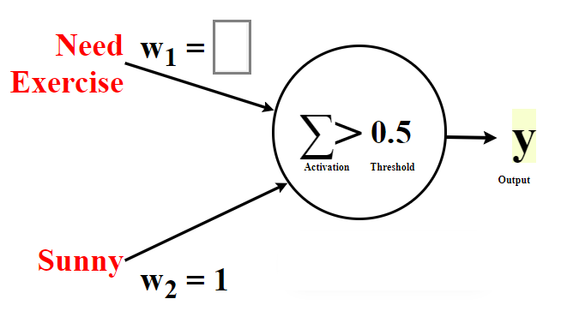

Answer to:
#4. Should I play outside? I would play outside either if I need exercise or if it's sunny.
INPUTS |  | Should activation be above threshold? Answer should be based on the desired output (column A) | Type of constraint on weight W₁  Either “greater than” or “less than” | Margins for Weight W₁ | Solution for Weight W₁  What value for W₁ satisfies all constraints in columns C+D? | Compute Weighted  input 1 | Weighted  input 2 | Activation | Is activation greater than threshold?  If the answer doesn’t match the 1 or 0 in the desired output, go back to column E | DESIRED OUTPUT
Input₁  0 - Don’t Need Exercise  1 - Need Exercise | Input₂  0 - Not Sunny  1 - Sunny | (Y or N) | If column B is “Y”, put “>” here.  If column B is “N”, put “<” here. | Take the threshold 0.5 and subtract Weighted Input 2 (column G) | Example: If C+D says “> 0.5” then the value of W₁ must be something greater than 0.5 | W₁ = ___ from E  Input₁ x W₁= __ | W₂ = 1  Input₂ x W₂= __ | Sum of weighted Inputs 1 & 2 (columns F and G) | Activation > Threshold ?  Is column H > 0.5  Write 0 for no or 1 for yes. | Desired Output  0 - no  1 - yes
0 | 0 | N | Constraints on W₁ only make sense when  Input₁ is active (not 0) |  | 1  (could be any value greater than 0.5) | 0 x 1 = 0 . | 0 x 1 = 0 | 0 | 0 | 0
0 | 1 | Y |  |  | 1  (could be any value greater than 0.5) | 0 x 1 = 0 . | 1 x 1 = 1 | 1 | 1 | 1
1 | 0 | Y | > | 0.5 - 0 = 0.5 | 1  (could be any value greater than 0.5) | 1 x 1 = 1 . | 0 x 1 = 0 | 1 | 1 | 1
1 | 1 | Y | > | 0.5 - 1 = -0.5 | 1  (could be any value greater than 0.5) | 1 x 1 = 1 . | 1 x 1 = 1 | 2 | 1 | 1
 |  | B | C | D | E | F | G | H | I | ⭐ A ⭐

NEW WORKSHEET: “Solve for Weight”
#5. Can I make a ham and cheese sandwich? I need both ham and cheese.
INPUTS |  | Should activation be above threshold? Answer should be based on the desired output (column A) | Type of constraint on weight W₁  Either “greater than” or “less than” | Margins for Weight W₁ | Solution for Weight W₁  What value for W₁ satisfies all constraints in columns C+D? | Compute Weighted  input 1 | Weighted  input 2 | Activation | Is activation greater than threshold?  If the answer doesn’t match the 1 or 0 in the desired output, go back to column E | Desired Output
Input₁  0 - Don’t Have Ham  1 - Have Ham | Input₂  0 - Don’t Have Cheese  1 - Have Cheese | (Y or N) | If column B is “Y”, put “>” here.  If column B is “N”, put “<” here. | Take the threshold 1.5 and subtract Weighted Input 2 (column G) | Example: If C+D says “> 0.5” then the value of W₁ must be something greater than 0.5 | W₁ = ___ from E  Input₁ x W₁= __ | W₂ = 1  Input₂ x W₂= __ | Sum of weighted Inputs 1 & 2 (columns F and G) | Activation > Threshold ?  Is column H > 1.5  Write 0 for no or 1 for yes. | Desired Output  0 - no  1 - yes
0 | 0 |  | Constraints on W₁ only make sense when  Input₁ is active (not 0) |  |  | 0 x __ = __ | 0 x 1 = 0
0 | 1 |  |  |  |  | 0 x __ = __ | 1 x 1 = 1
1 | 0 |  |  | 1.5 - __= __ |  | 1 x __ = __ | 0 x 1 = 0
1 | 1 |  |  | 1.5 - __ = __ |  | 1 x __ = __ | 1 x 1 = 1
 |  | B | C | D | E | F | G | H | I | ⭐ A ⭐

#5. Can I make a ham and cheese sandwich? I need both ham and cheese.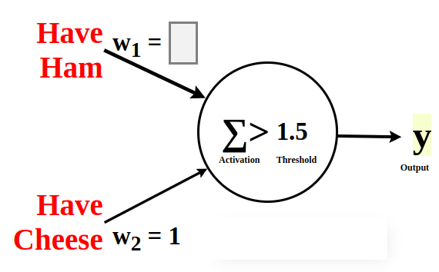
Answer to:
#5. Can I make a ham and cheese sandwich? I need both ham and cheese.
INPUTS |  | Should activation be above threshold? Answer should be based on the desired output (column A) | Type of constraint on weight W₁  Either “greater than” or “less than” | Margins for Weight W₁ | Solution for Weight W₁  What value for W₁ satisfies all constraints in columns C+D? | Compute Weighted  input 1 | Weighted  input 2 | Activation | Is activation greater than threshold?  If the answer doesn’t match the 1 or 0 in the desired output, go back to column E | Desired Output
Input₁  0 - Don’t Have Ham  1 - Have Ham | Input₂  0 - Don’t Have Cheese  1 - Have Cheese | (Y or N) | If column B is “Y”, put “>” here.  If column B is “N”, put “<” here. | Take the threshold 1.5 and subtract Weighted Input 2 (column G) | Example: If C+D says “> 0.5” then the value of W₁ must be something greater than 0.5 | W₁ = ___ from E  Input₁ x W₁= __ | W₂ = 1  Input₂ x W₂= __ | Sum of weighted Inputs 1 & 2 (columns F and G) | Activation > Threshold ?  Is column H > 1.5  Write 0 for no or 1 for yes. | Desired Output  0 - no  1 - yes
0 | 0 | N | Constraints on W₁ only make sense when  Input₁ is active (not 0) |  | 1  (could be any value between 0.5 and 1.5) | 0 x 1 = 0 . | 0 x 1 = 0 | 0 | 0 | 0
0 | 1 | N |  |  | 1  (could be any value between 0.5 and 1.5) | 0 x 1 = 0 . | 1 x 1 = 1 | 1 | 0 | 0
1 | 0 | N | < | 1.5 - 0 = 1.5 | 1  (could be any value between 0.5 and 1.5) | 1 x 1 = 1 . | 0 x 1 = 0 | 1 | 0 | 0
1 | 1 | Y | > | 1.5 - 1 = 0.5 | 1  (could be any value between 0.5 and 1.5) | 1 x 1 = 1 . | 1 x 1 = 1 | 2 | 1 | 1
 |  | B | C | D | E | F | G | H | I | ⭐ A ⭐

