|  |  |  |  |
| --- | --- | --- | --- |
| **05-863/08-763/45-888: Introduction to Human Computer Interaction for Technology Executives**  **Usability Evaluation Report Template**  **Dated**  **MM/DD/YYYY**   |  | | --- | | **Prepared By**  **NAME:**  **SIGNATURE :** | | | |
| Brief Description of User | | << Give a brief description of the user that you selected as a participant. The description should contain the user’s profile/demographic, his/her skill level in using the product, and the reasons for his/her selection. It should *not* contain any personally identifiable information.>> |

|  |  |
| --- | --- |
| Process Overview | << Describe the usability evaluation set-up. Include the **complete script**, which should include the questions asked of the users. >> |

|  |  |
| --- | --- |
| Transcript | << Provide a summary of what the user did and said, and what you did and said. If at some points you have to help the users, because they cannot figure out what to do, that must be included in your transcript. It is not necessary to write down every word that the user says, just what is interesting and useful. Be sure to write down all actions on the device, whether correct or wrong. Include any notes of what happened along the way. Note: we **do not** want you to turn in your videotape or audiotape, just the transcript. This section has line numbers, which you can use as the references in the next section, or add time codes if you want.>> |

## 

|  |  |
| --- | --- |
| Feedback & Critical Incidence | << Record your observations in the table on the following page, based on your observations and notes taken during the usability evaluation  Description of columns in the table are as follows:  *Prototype Screen/Page:*  Which screen of the user interface the user was evaluating at the point of feedback/critical incidence/problem.  *Reference:*  This column should be used to relate an item back to a specific point in the session. The reference can be to a specific line number in the transcript above or a time code.  *User feedback / critical incidence / problem:*  This column may contain :   * Feedback (positive or negative) given by the users, **or** * Critical incidences (breakdowns or problems encountered by users) and/or mistakes committed by users.   *Reason for negative feedback / breakdown:*  Briefly explain the reason for a breakdown or any negative feedback.  *Scope:*  Describe the scope of the feedback or the problem; include whether the scope of the issue is throughout the product or within a specific screen or screens. If the problems are specific to a page, include the appropriate page reference.  *Severity (H/M/L) :*  Your assessment as to whether the implication of the feedback is *low*, *medium*, or *high* severity.    *Way(s) to rectify:*  Suggestion for the modifications that might be made to the user interface to address the issue or issues in this row. You MUST include trade-offs to be credible. If you can’t think of some bad trade-off, say so. |

##### **Usability Evaluation Feedback Analysis**

|  |  |  |  |  |  |  |  |
| --- | --- | --- | --- | --- | --- | --- | --- |
| **#** | **Prototype Screen** | **Reference** | **User’s feedback/ critical incidence/ problem** | **Reason for negative feedback / breakdown** | **Scope** | **Severity**  (High/ Medium/ Low) and **Justification** for giving it that rating | **Way(s) to rectify and any Tradeoffs (i.e., why the fix might not work)** |
| 1 | See Picture 1 below | 01:10 | CDW website includes a search text box to help users locate items. When an item and model number were searched for, the site failed to return any results, instead loading a page with more advanced search options. | In this case, the user inputted both the kind of device (iPaq) and the model number (3870) correctly, which should have given the system enough data to understand what he was looking for. It would have been more beneficial to the user to list all the iPaq models instead of displaying no results. With a list of results, the user is capable of scanning through it to find what he is looking for. With no results listed, the user is given no help, and much figure out another term to search for. | This specific screen | High.  Because most people start with search, so it should work well | If the system finds no results by imputing two search terms (such as iPaq 3870), then it should return at least some results for the terms independent of each other. This could save the user the extra step of having to decide how to broaden the search.  Tradeoff: this could potentially overwhelm the user with too many results. It will also be much harder to implement. |
| 2 | See Picture 2 below | 07:22 | User is informed that he needs to enter a shipping address and a name (title) for his address. The state/province field and the phone number have disappeared, and user must re-enter those. | When asking a user to correct an error in filling out fields, as is the case here, the user’s previously entered information should be preserved. There is no reason why some of the user’s information disappears and some doesn’t. It is an extra burden on the user to have to retype the state and phone number. | This specific screen | Medium  because users will probably not notice that it is missing | Preserve user’s information when asking a user to fill in some fields they missed.  Tradeoff: no downside for the user to doing this correctly, but require some implementation effort. |
| 3 |  |  |  |  |  |  |  |

Picture 1:

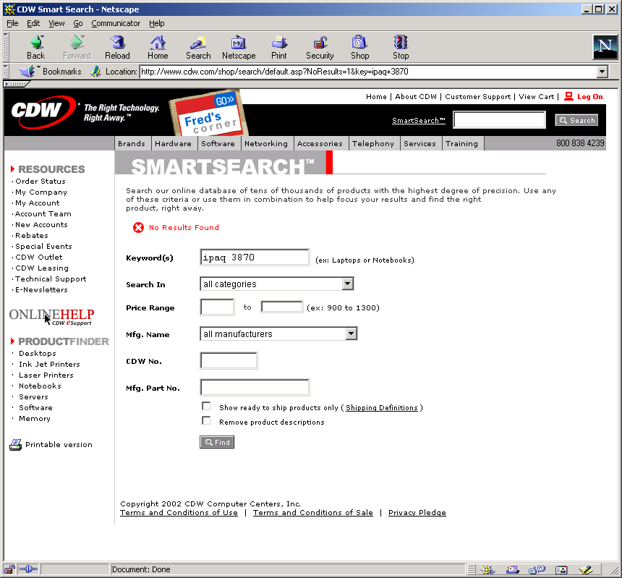

Picture 2:

