Product Name:
CDW Web site
Date of Study:
Summer, 2002
Experimenters’ Names:
Brad Myers, Konstantine (Gus) Prevas, Allison Gallant, Devin Blais, Jacqueline Weber
Subject ID: S-01

No. UE-01 | Problem
Name: Search returns no results

Evidence:
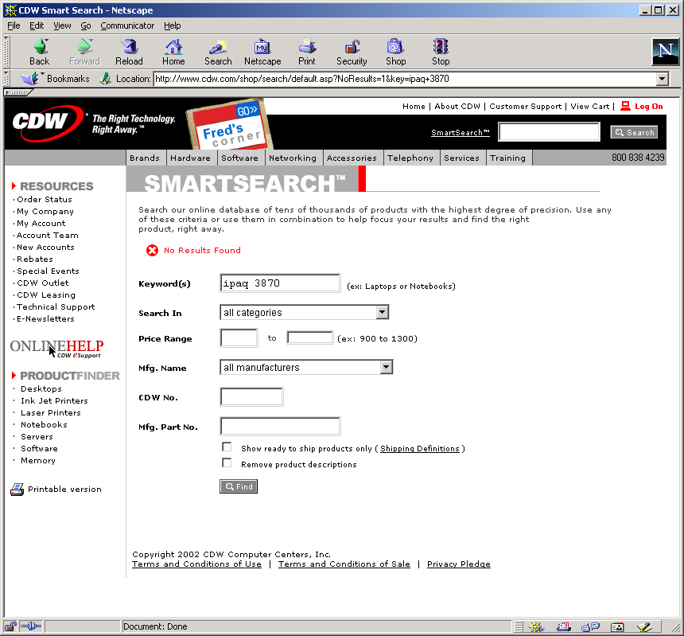

CDW website includes a search text box to help users locate items. When an item and model number were searched for, the site failed to return any results, instead loading a page with more advanced search options.
Explanation:
When possible, a search should always return results to help the user find or narrow down what they are looking for. In this specific case, the user inputted both the kind of device (iPaq) and the model number (3870) correctly, which should have given the system enough data to understand what he was looking for. Even if the model number weren’t correct, it would have been more beneficial to the user to list all the iPaq models instead of displaying no results. With a list of results, the user is capable of scanning through it to find what he is looking for. With no results listed, the user is given no help, and much figure out another term to search for.

Severity or Benefit:
Rating: 3 - Major
Rationale: Although it is not clear if this is a frequent problem (would searching for other models and model numbers have no results as well?), it definitely has a severe impact (difficult for the user to work around this problem) and is persistent (the user had to overcome it two times in the video).
Possible solution and/or Trade-offs:
If the system finds no results by imputing two search terms (such as iPaq 3870), then it should return at least some results for the terms independent of each other. This could save the user the extra step of having to decide how to broaden the search, though could potentially overwhelm the user with too many results.

However, there is no clear reason why searching for “iPaq 3870” shouldn’t return the model that the user was looking for.
Relationships:
None

No. UE-02 | Problem
Name: Some of the user’s information is lost when redoing form

Evidence:

User is informed that he needs to enter a shipping address and a name (title) for his address. The state/province field and the phone number have disappeared, and user must re-enter those.

Explanation:

When asking a user to correct an error in filling out fields, as is the case here, the user’s previously entered information should be preserved. There is no reason why some of the user’s information disappears and some doesn’t. It is an extra burden on the user to have to retype the state and phone number.

Severity or Benefit:
Rating: 2 - Minor
Rationale: This may be a frequent problem, since users might often neglect an odd field like ‘title’, but it has very low impact – it just creates slightly more work for the user. The problem is presumably persistent, since if the user once again had failed to fill in a field, they probably would have lost the same information again.

Possible solution and/or Trade-offs:
Preserve user’s information when asking a user to fill in some fields they missed

Relationships:

None

No. UE-03 | Problem
Name: User’s address is not stored in system as user expects

Evidence:

After ordering, the user is presented with blank shipping address fields.
Explanation:

The logged-in user assumes that his address information will be stored by the system. This is common in many sites, and it is a reasonable assumption on the part of the user. The user is clearly not pleased that the website is making him type all of his information in again.

The fact that the page lists this is a ‘new address’ indicates there could be an old address somewhere with stored information. For some reason, this doesn’t seem to have been stored for this user, who has bought items from this site before.

Severity or Benefit:
Rating: 3 - Major
Rationale: This would be a frequent problem, since it would presumably happen every time a user logs into the site to buy something. It would be persistent, occurring each time. The impact is medium. It creates a lot of extra work for the user, but nothing that prevents them from proceeding.

Possible solution and/or Trade-offs:
Preserve user’s address information and auto-fill the fields

Relationships:

None

