|  |  |  |
| --- | --- | --- |
| **05-863/45-888: Introduction to Human Computer Interaction for Technology Executives**  **Heuristic Evaluation Report Template**  **Dated**  **MM/DD/YYYY**   |  | | --- | | **Prepared By:**  **YOUR NAME:** Brad Myers |  |  | | --- | | **Evaluation Of:**  **Name of system being evaluated (if any):** Stuttering Foundation website: [www.stutteringhelp.org](http://www.stutteringhelp.org)  **Person who created the system being evaluated:** N/A | |

## 

|  |  |
| --- | --- |
| Feedback & Critical Incidence | << Record your observations in the table on the following page, based on your observations and notes taken during the evaluation.  Description of columns in the table are as follows:  *Prototype Screen/Page:*  Which screen of the user interface was being tested at the point of feedback/critical incidence/problem.  *Name of Heuristic:*  Which of the 10 heuristics is being referenced. Enter the full name of the heuristic. Here is a list: <http://www.useit.com/papers/heuristic/heuristic_list.html>  *Reason for negative feedback / breakdown:*  Explain the reasons why the interface violates this heuristic. Be sure to be clear about *where* in the screen you are referencing.  *Scope:*  Describe the scope of the feedback or the problem; include whether the scope of the issue is throughout the product or within a specific screen or screens. If the problems are specific to a page, include the appropriate page numbers.  *Severity (H/M/L) :*  Your assessment as to whether the implication of the feedback is *low*, *medium*, or *high* severity, and a justification for why you are giving it that rating.    *Way(s) to rectify and Tradeoffs (i.e., why the fix might not work):*  Suggestion for the modifications that might be made to the user interface to address the issue or issues in this row. You MUST include trade-offs to be credible. If you can’t think of some bad trade-off, say so.  *Action taken and Justification:*  DO NOT FILL IN THIS COLUMN. This will be filled in by the person who created the system being evaluated, to say what he did with respect to the recommendations you make. |

| **#** | **Prototype Screen** | **Name of Heuristic** | **Reason for negative feedback / breakdown** | **Scope** | **Severity**  (High/ Medium/ Low) and **Justification** for giving it that rating | **Way(s) to rectify and any Tradeoffs** (i.e., why the fix might not work) | **Action taken and Justification (*to by filled in later by the person who created the system being evaluated*)** |
| --- | --- | --- | --- | --- | --- | --- | --- |
| 1 | See Picture 1 | **Consistency** | **Some of the entries are missing the picture:** Some of the entries in the list do not have a picture, and that makes the text go in a different place | Some of the products, which may affect various results pages. | Rating: Medium –Rationale: In the user study, the user missed the entry because the text is in an inconsistent place. And it is important to have pictures for all items | There should be a picture for every item. If an item must have a missing picture, then the text should at least be aligned with the other entries. Tradeoff: it might be hard to get pictures for some items, and moving the text to align requires more knowledge of html/css. |  |
| 2 | See Picture 2 |  |  |  |  |  |  |
| 3 | See Picture 3 |  |  |  |  |  |  |
| 4 | See Picture 4 |  |  |  |  |  |  |
| 5 | See Picture 5 |  |  |  |  |  |  |
| 6 | See Picture 6 |  |  |  |  |  |  |
| 7 | See Picture 7 |  |  |  |  |  |  |
| 8 | See Picture 8 |  |  |  |  |  |  |

Picture 1:

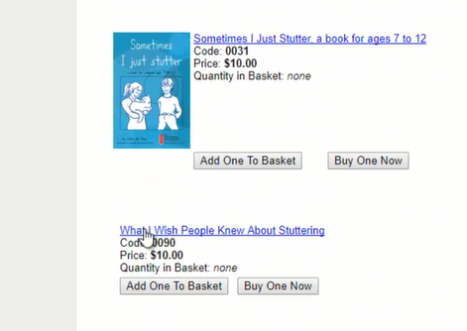

Picture 2:

<< insert picture 2 here >>

Picture 3:

<< insert picture 3 here >>

Picture 4:

<< insert picture 4 here >>

Picture 5:

<< insert picture 5 here >>

Picture 6:

<< insert picture 6 here >>

Picture 7:

<< insert picture 7 here >>

Picture 8:

<< insert picture 8 here >>