Example of Good and Bad UI Features Report for PUI, Spring. 2004.
By Brad Myers

Good feature: Microsoft Word XP 2003 intelligently cuts and pastes the right amount when a word is selected, and it has punctuation before or after it. In particular, if a word is followed by a period and is moved or deleted, the space before it is removed, but the period is not (even though the space isn’t selected).

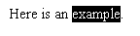

Bad Feature: It is difficult in Microsoft Word XP 2003 to control the numbering of sections. Often the numbering offered in the Format Bullets and Numbering dialogs mysteriously seem to not have any effect..

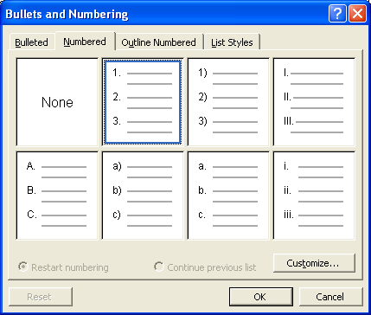

I would be happy to present these examples in class, and give live demos.

