05-630 Programming Usable Interfaces Assignment: VB Warm-up
Assigned: Thursday, Jan 15, 2004
Due: 3:00pm (before class), Thursday, Jan 22, 2004

Objective
This goal of this assignment is to demonstrate that you can use Visual Basic (VB) by creating three small programs. This will require going through a simple tutorial and then playing with the system and reading more on your own about VB. Warning! This should be an easy assignment if you start early. It's ugly if you don't. Students who do not complete this assignment on time will be assumed to not have the pre-requisites for the course and will not be allowed to continue in the course.

Resources
You can use either VB version 6 or VB.Net to do this assignment. Be sure to note in your turn-in which one you are using. We think most of the public CMU clusters are still running VB v6, but many of you might have VB .Net or VB .Net 2003. Using any of these is fine, but note that they are different, so you will want to get the documentation for whatever version you end up using.

First, make sure you have access to Visual Basic, either on your own machine or on the public cluster PCs that CMU provides. Do this today!

Our TAs have graciously volunteered to run tutorial sessions during two class periods (see the on-line schedule). In-person help will also be available in the Wean 5202 cluster on Tuesdays, 4:30-6:30, and Wednesdays 3-5 for the first four weeks.

Also, email to pui-everyone@lists.andrew.cmu.edu will be read frequently, and archived on MyAndrew (see the course main web page). When you need help, please do not email the professor or a TA individually; that can only increase how long you have to wait for help. pui-everyone@lists.andrew.cmu.edu goes to all three of us plus the other members of the class. Visual Basic is currently available on PCs in the public clusters. There is no textbook specified for VB for this course, but there are many excellent online references. See the resources page for more information and lists:
http://www-2.cs.cmu.edu/~bam/uicourse/630spring04/resources.html

Since this is a graduate course, I expect you to be using the WWW, and all other available resources, at all times, and to be letting me know of any particularly good resources you find so I can inform the class. I will add them to the resources page. You should also examine the online documentation for VB, and check out the wide variety of VB books available in any well-stocked bookstore. Let me know what is particularly useful or useless.

Your Three-Part Task
Part 1: Write a VB program that, when a button is pressed, computes the average of 3 numbers which are typed in, and looks like this (please match the appearance closely enough to demonstrate you can move/resize/change font etc, but don’t worry about an exact match). You must check to make sure that the user has typed in valid numbers.
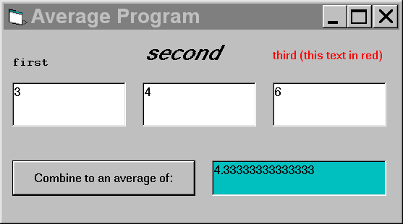

Part 2: Modify the existing project sortdown.vbp (for VB6) or sortdown.vbproj (for VB.net) so that when a button is clicked, it sorts a list of text strings in decreasing order. (Note that the "sorted" property of the listbox is something you do not want to try to use here; it would only work against you). The existing project has a list and a button; when the button is clicked, the program finds the lexicographially largest and smallest text strings and switches their positions. The existing program is in a VB project (which means four files), and can be downloaded from the ZIP file at:
- VB 6: http://www.cs.cmu.edu/~bam//uicourse/630spring04/sortdown.vb6.zip
- VB .net: http://www.cs.cmu.edu/~bam//uicourse/630spring04/sortdown.vbnet.zip
Once you have downloaded the ZIP file, double-click it to "extract" four files. If ZIP is new technology to you, feel free to ask whoever is nearby; most CMU undergraduates are used to using ZIP. After "unzipping" all four files into a new folder, double-click on sortdown.vbp or sortdown.vbproj to run the VB project.

Part 3: Write a VB program that does anything you like, but impresses me with its utility or entertainment value. Even with the small set of VB that you know now, you can do something clever if you try! Be prepared to explain why you invested your time in the particular program you spent time on. Note that I’ll be judging you on utility or entertainment value, not on the quality of the programming per se. This way is more fair (and more fun!). Please don’t go crazy loading megabytes of media (images, etc); go for a clever program, not a piggish multimedia extravaganza.

Grading
The first part of the assignment is pass fall; the others will be graded on programming correctness and style (part #2) and creativity (part #3). Your sorting code should be commented to help explain what you are doing. Students who do not complete this assignment on time will be assumed to not have the pre-requisites for the course and will not be allowed to continue in the course. Start early, and see the TAs if you need help.

Turning In:
By 3:00pm (before class) on the due date, email three zip files (one for each part of the assignment) as attachments to pui-staff@lists.andrew.cmu.edu. The .zip file should contain your full project. They must be named exactly as below. Please make sure the email tells us your name, since that’s not always obvious from your return address. Also include a readme.txt or readme.doc in each .zip file with your name and anything else you would like to tell the TAs about that part.
average.zip
sortdown.zip
impress.zip
In addition, please bring to class a hard copy printout of your code for the sortdown program (the only part we need is the part that is actually doing the sorting). Please make sure your name is on that hard copy.

