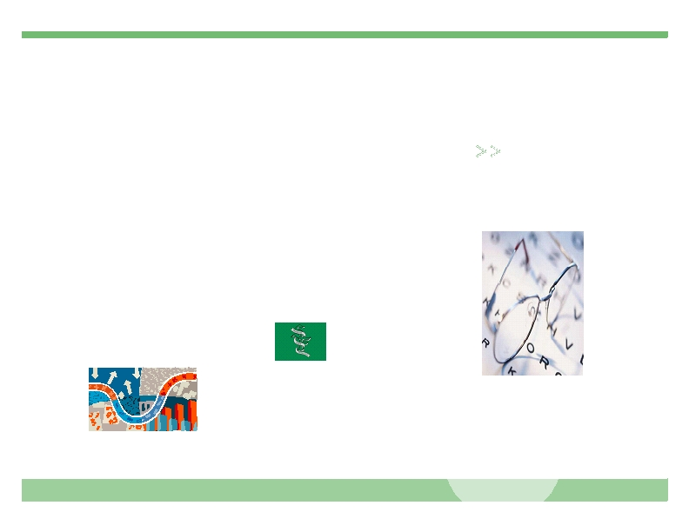• fffi

• fffiffi,-ff-ff. ff/
•,0-,1ffi23

40ff/.ffff56/4-/ffi708-9 -3
•
•
•
!"!#
-ffi$,0ff/ .ffff%6
&,0ffff$,0ff/ .ffff%6
•85ffiff/-4'-,3
•
•
•
#(
),,5ffffi3 * *(
/ffff3++ 8ffffff%-+
• ff
5ffi66-/9ff/ff748ff/
,ffiff. 106,82ffi-/ffi
• 50)0ff.
• 504-/ffi,
• 505,
7ff2.,/14'-,3
•
•
*-- .*##.## * **
/ffff3++222%6ff2./1%6+
40ff/.ffff/2,/0ffi-1ffff
• *#

0ff,/ 1062-3
• 222%806 %6

4235424ffffi)ffi6/0, 2ffi-/ffi8
1065 ff3
•
•
•
.** 423542*
/ffff3++-8%,/,%6'
•
ffiff,-.ffff1,2-fi(fffi1ff
ffiff,-.ffff/fi0,1,23,ff
•1,456778
977
$#%7)2*)+*2,*
•1-2*5.!7!9 6!%7
,46 66 4!46
-"964 #8$ 8%4$
&&&'(ffiff,.ffff'0
•
8+fi030ff,)ffi9,fi2*

3,fi(*.fi0ff,ff(ffffi*ff(fi
•ffi1 ffififf.fi/2/*fi*ffi0
*21,2ffi('3,fi(012 5,&
/fi(ffffifi2ffiffffiff,-.ffff'
3*0*fi+fi0**ffi0ffi(
•11ffi(/.&,'3,fi(00 fi(
*(fi0*ff)45)3,464ffff,fi(
1ff*2ffifi0ffi(ffff+1fffi fiffi
, (5(1,2(5*1 ffififf.'6ffi
ffff*1ffff,fi(/fffi(ff,fi(ff
(ff0fi**((fi0ff,fi(&fi*(0*
012 '

3,ffi0,(fi(
1+ffiff(((fi(&fiff,
fi*fi/fi*ffi2(,fi0,2."0fi
1*fi*2fi0&fiff,
*2(1ff*ffi0*
21,2ffi(5&,0ff
fi **ffi1ff0
ff(1ffiff&,ffff2+
5ff,1(ff0/ff
fffi/ (ffi(ffff+*&,ff
ffffi,20fi.ffi(ffi(01ff+&
.ffi1,fi2*fi(ffi(fi0*ffi0(21,2'
(ff(
•

- *:fi1(;-* /2ff,1
/fi1(

ffi2:0 :ff&.,,1/fi1(

,(,./fi0 -* /2ff,1
/fi1(

9,fi(< ffiff,-.ffff/fi0,1,2
:ffifi*19ffi(2

0ff+<fiff 90fi2fi1
-0ff ff

-fifi1 -* /2ff,1
/fi1(

9,fi<ffifi(=22 ffiff,-.ffff3&0'
2fi1-0ff ff

ff/> fi0(+. 3ffiff29+=22.
•ff2/2ff,/fi1(?ffiff,-.ffff
/fi0,1,2-ffi0*.21,2<fifi(
30fi1(ff,fi(/fi0&fi22fi12ffi*
•

•
•

•
•
•
•
.ff7((01fffi/-ffi0*
.21,23(

412fi0-ffi0*.21,23(

8,ff3ffiff,205/2ffifffi
*ffff ff

.02fi1*0ff ff0(01fffi/
&,fffi(,00fi0fiffi1 ffififf.
*&,ff0ff(1*ff,20'

(ff*ffiffffi1(2ffi1(
*2(1ff*ffi0*21,2ffi(

8,ff(ffi1(/fi212(ffffi
*ff(*0ff(ff,ffi0,ffiff,-.
ffff1,2-fi(fffi1ff
3,00 &fi22fi12ffi*1+ffiff((
(fi(*00ffffififf.2ffi(fffi(5
(&(**fi20ffi&fiff,ffi0(ff(
*ff,(1,25,2ff,1*2&
1 ff0((fi2('

•
•
•

