`Week: 03 Date: 02/01/2024
15-110 Recitation Week 3

Reminders
- Check 2 due Monday 2/05 at Noon!
- Check your email if a TA can’t find you during OH
- HW 1 grades are out!
- Check 1 and HW1 Revisions (+Ex revisions) due 2/06 at Noon
- For recitation today:
  - There is a starter code file on the website
  - Recitation feedback form: https://forms.gle/dWgvmGvTSMbRi7rv5

Overview
- Debugging
- Conditionals Practice
- Circuits and Gates

Problems

DEBUGGING
- Rubber Duck Debugging

- Printing and Experimenting

- Thorough Tracing

Catch the Error:
These are also in the starter file, with some additional code to help you.
For each function, specify the type of error (syntax/runtime/logical), error name, and what the error means.
- def computeIntAverage(x, y, z):
sum = x + y + z
count = 3
return sum // count
print(computeIntAverage(5, “6”, 7))

Type:
Name:
What it means:

- def findLineIntersect(m1, b1, m2, b2):
x = (b2 - b1) / (m1 - m1)
y = m1 * x + b1
print(‘y coord’, y)
return x

Type:
Name:
What it means:

- # leaving is a boolean that tells us if we should say hello or goodbye
def sayHelloOrGoodbye(leaving, name):
if leaving == True:
return “Hello ”+ name
else:
return “Goodbye, ”+ name+ “ and have a great day!

Type:
Name:
What it means:

- import math

def circleArea(x0, y0, x1, y1):
minRad = x_1 - x0 / 2
maxRad = y1 - y0 / 2
area = math.pi * minRad * maxRad
return area

Type:
Name:
What it means:

- import math
def roundDistance(x1, y1, z1, x2, y2, z2):
dX = x2 - x1**2
dY = (y2 - y1) ** 2
dZ = pow(2, (z1 - z2) )
dist = math.ceil(dX + dY + dZ) ** 0.5
return dist

Type:
Name:
What it means:

CONDITIONALS PRACTICE

In the heart of the fantastical town of Ticktockton lies the Enigmatic Clock Tower, which chimes magical melodies based on the time of day and the weather.

As the timekeeper of the Clock Tower, your responsibility is to decide the tower's chimes. The head timekeeper left you this python function to help:
def clockTower(time, weather):
if time == "Morning":
if weather == "Sunny":
print("Chime of Cheerful Chipmunks")
else:
print("Melody of Morning Dew")
elif time == "Afternoon":
if weather == "Windy":
print("Anthem of Airy Adventures")
else:
print("Ballad of Breezy Bluffs")
print(“With an encore Serenade of Starry Skies")
elif weather == "Rainy":
print("Raindrop Rhapsody")
else:
print("Twilight Tune")

Function Call | Displayed in Shell
clockTower(“Evening”, “Rainy”)
clockTower(“Afternoon”, “Windy)
clockTower(“Morning”, “Rainy”)
clockTower(“Night”, “Cloudy”)

CIRCUITS AND GATES

Write the equivalent Boolean expression demonstrated by the circuit:
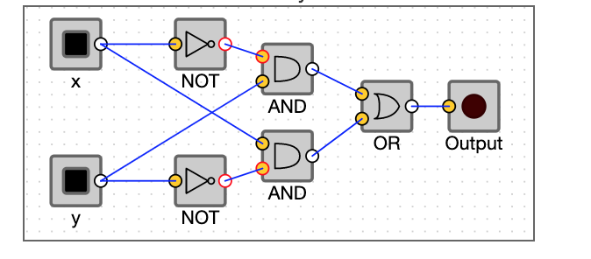

Fill out the truth table that corresponds to the circuit and boolean expression above:
x | y | output

