Week: 02 Date: 09/04/2025

| 15-110 Recitation Week 2 |
| --- |

# **Reminders**

* Hw1 due Monday, Sept. 8 at noon!
* Check1 grades are out! The revision deadline is Tuesday, Sept. 16.
  + Make sure to look at any feedback you got on Gradescope!
* For recitation today:
  + There is a starter code file on the website – use that to get some practice running code!
* Make sure to complete the recitation exercise by Monday at 2:00 PM. It will be based on what we practice today!
* [Recitation feedback form](https://docs.google.com/forms/d/e/1FAIpQLSdmDI_O2QXLQlB5byfC3QhWzUwTaNenNC3Bdk3BVdoXUyJWBQ/viewform?usp=dialog)

# **Overview**

* TA + student introductions + course logistics
* Binary practice, ASCII
* Functions, arguments, returned value, side effects
* Graphics practice, tkinter

| Problems |
| --- |

**BINARY PRACTICE**

**Conversion Practice:**

Convert 38 to binary using 8 bits

What is 01110111 in decimal?

What is the next binary number after 0011?

**ASCII Conversion Practice:**

Convert 1010101 to ASCII.

**FUNCTION PRACTICE**

**Parts of a Function Call:**

**Function Reference**

Built-in Functions:

* **abs(a)**: takes the absolute value of a
* **pow(a, b)** : raises a to the power of b
* **round(a, b)**: rounds a to b number of decimal places

Random Library

* **random.randint(a, b)**: randomly chooses an integer on the **closed** interval [a, b] (a and b are included!)
* **random.random()**: picks a random float between [0, 1) (1 is excluded!)

Math Library

* **math.ceil(a)**: takes a number and returns the next highest integer
* **math.log(a, b)**: takes the log of a with base b
* **math.radians(a)**: converts degrees to radians

A painter is doing some planning for this year, and is hoping to predict how much paint he’ll need and how much money he’ll make. He’s hoping you’ll help him with your vast knowledge of Python built-in functions, and the math/random libraries.

The painter knows that in general, it rains between 10-15% of days in his area. He asks us to pick a random percentage in this range and calculate the number of days, out of 365, that it rains on (rounded up to the nearest integer). The painter works every single day that it doesn’t rain, and makes $100 dollars every day. He loses $50 on every day that it rains, since his paint from the previous day is half washed away and he has to redo it. What is the painter’s expected revenue this year?

**Built-in Functions, Return Values, and Side Effect Practice**

For each of the following function calls, what is the return value and side effect, if any?

| **Function Call** | **Returned Value** | **Side Effect?** |
| --- | --- | --- |
| abs(-1) | 1 | No side effect |
| print(“hello”) |  |  |
| print(float(4)) |  |  |
| print(“None”) |  |  |
| type(“110 rocks!”) |  |  |
| math.log(16,2) |  |  |

**GRAPHICS PRACTICE**

**Tkinter review**

Discuss with your TA how to draw the robot below!  
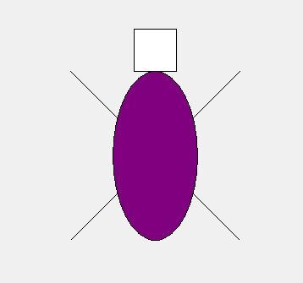

Here’s another TA’s robot for more inspiration of what tkinter can do:  
