Week: 03 Date: 01/30/2025
15-110 Recitation Week 3

Reminders
- Check 2 due Monday, Feb 3 at noon!
- HW 1 grades are out
- Check 1 and HW 1 Revisions due Tuesday, Feb 4 at noon
- Recitation feedback form

Overview
- Debugging
- Conditionals Practice
- Circuits and Gates

Problems

DEBUGGING
- Rubber Duck Debugging 

- Printing and Experimenting

- Thorough Tracing

Catch the Error
Read the following descriptions of what each function should return, along with the code itself. These are also in the starter file.
For each function, specify the type of error (syntax/runtime/logical), error name, and what the error means.
- Return the average of three numbers:
def computeIntAverage(x, y, z):
sum = x + y + z
count = 3
return sum // count
print(computeIntAverage(5, “6”, 7))

Type
Name
What it means

- Return the intersection of two lines with slopes m1, m2 and y-intercepts b1 and b2, respectively:
def findLineIntersect(m1, b1, m2, b2):
x = (b2 - b1) / (m1 - m1)
y = m1 * x + b1
print(‘y coord’, y)
return x

Type
Name
What it means

- Return an appropriate statement depending on whether someone is leaving (i.e. leaving == True) or not:
def sayHelloOrGoodbye(leaving, name):
if leaving == True:
return “Hello ”+ name
else:
return “Goodbye, ”+ name+ “ and have a great day!

Type
Name
What it means

- Return the area of a rectangle with length and width x0 and x1:
def rectArea(x0, x1):
area = x0 * x_1
return area

Type
Name
What it means

- Return the distance between two points, (x1, y1, z1) and (x2, y2, z2), rounded up to the nearest integer (search up the distance formula if you need to!):
import math
def roundDistance(x1, y1, z1, x2, y2, z2):
dX = x2 - x1**2
dY = (y2 - y1) ** 2
dZ = pow(2, (z1 - z2))
dist = math.ceil(dX + dY + dZ) ** 0.5
return dist

Type
Name
What it means

CONDITIONALS PRACTICE
In the heart of the fantastical town of Ticktockton lies the Enigmatic Clock Tower, which chimes magical melodies based on the time of day and the weather.

As the timekeeper of the Clock Tower, your responsibility is to decide the tower's chimes. The head timekeeper left you this python function to help:
def clockTower(time, weather):
if time == "Morning":
if weather == "Sunny":
print("Chime of Cheerful Chipmunks")
else:
print("Melody of Morning Dew")
elif time == "Afternoon":
if weather == "Windy":
print("Anthem of Airy Adventures")
else:
print("Ballad of Breezy Bluffs")
print("With an encore Serenade of Starry Skies")
elif weather == "Rainy":
print("Raindrop Rhapsody")
else:
print("Twilight Tune")

Based on the specific combination of time of day + weather condition, this function will tell you (or print) the name of the song you should play. What will clockTower print for each function call below?
Function call | Printed value
clockTower(“Evening”, “Rainy”)
clockTower(“Afternoon”, “Windy”)
clockTower(“Morning”, “Rainy”)
clockTower(“Night”, “Cloudy”)

CIRCUITS AND GATES
Write the equivalent Boolean expression demonstrated by the circuit:
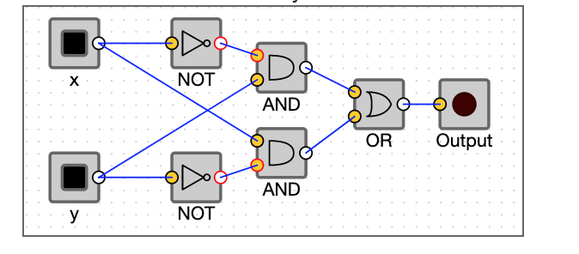

Fill out the truth table that corresponds to the circuit and boolean expression above:
x | y | output

