Week: 03 Date: 02/18/2021
15-110 Recitation Week 3

Reminders
- Check2 due Monday 2/22 @ Noon EDT
- Check1 and HW1 resubmissions are due Tuesday 2/23 @ Noon EDT
- First Quiz is Wednesday 2/24!
- Small groups for homework and quiz! Link a when2meet/Google form for student availability
- Recitation feedback form: https://forms.gle/WKrrbawKktmRu1xp9

Overview
- If/Elif/Else statements, nested if statements
- Circuits and gates
- While loops

Problems

Practice with Boolean Expressions
You are at Disneyland, but each ride has its own restrictions. Write a boolean expression based on the ride’s requirements. For example:

Splash Mountain: the water level (level) must be an even depth or the weather (weather) must not be rainy or snowy.
Boolean Expression:

Mad Tea Party (the spinning cups): the sum of the weights of the three people (x_weight, y_weight, z_weight) in the teacup must be no larger than 700 lbs. Additionally, the number of children (child) should be no more than twice the number of adults (adult).
Boolean Expression:

Space Mountain: you must be in between the age (inclusive) of 4 and 65 (age) and not pregnant (pregnant).
Boolean Expression:

Pirates of the Carribean: your “argh matey” levels (AM) must be larger than 100 (AM) or an odd number.
Boolean Expression:

Control Flow to Code
Convert this control flow chart into code!

city == “Pittsburgh”
isGoodMIT== True
print(“Carnegie Mellon University”)
print(“Central Michigan University”)
print(“Michigan Institute Technology”)
print(“Massachusetts Institute of Technology ”)
True
False
True
False

college == “CMU”
True
False

Conditional Code Trace
Trace through the following function on the given input below.

def f(a, b, c):
result = 'A'
if (a > b):
result += 'B'
elif (b > c):
result+='C'
if (a % c != 1):
result += 'D'
else:
result += 'E'
result += 'F'
return result
print(f(1,2,3), f(2, 3,1))
Print Output:

How can we write this print check as assert statements instead?
Assert Statements:

CIRCUITS AND GATES
Fill out the Truth Table and complete the Boolean Expression below based on the following circuit.
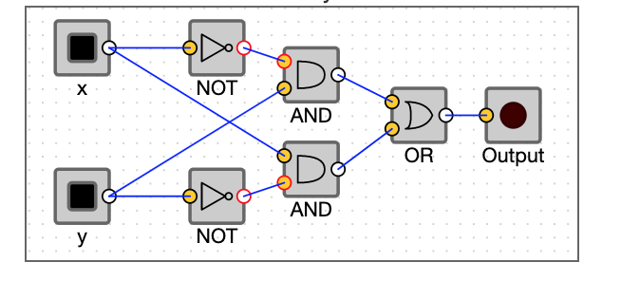
Truth Table:
x | y | output

Boolean Expression:

Bonus: What gate is this circuit equivalent to?

HasIncreasingDigits
While Loop Notes:
Key features:
- Iterator variable declared outside of loop
- Loop condition - must evaluate to False at some point, otherwise infinite loop!
- Update iterator variable within loop
Important notes:
- While loops require declaring an iterator variable outside the loop and updating that variable within the loop.
- A while loop’s condition must evaluate to False at some point, otherwise, you will have an infinite loop!

Write a function hasIncreasingDigits that returns whether or not an number has all increasing digits (from left to right)
hasIncreasingDigits(1234) -> True
hasIncreasingDigits(77)-> False
hasIncreasingDigits(56734)->False
Code:

