Week: 10 Date: 11/06/2025
15-110 Recitation Week 10

Reminders
- How was Exam 2?
- HW5 due Monday, November 10 at noon
- Recitation feedback form
Overview
- Meme cipher encryption
- Asymmetric encryption
- Reading files
- Helper functions

Problems

Meme Cipher Encryption
Carnegie Mellon | 
surprised | 
I | 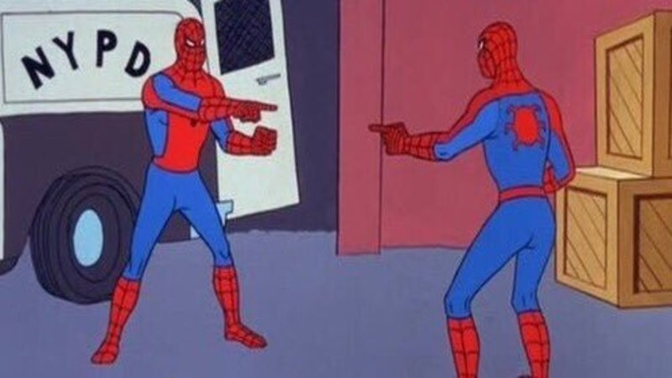
good | 
cool | 
grade | 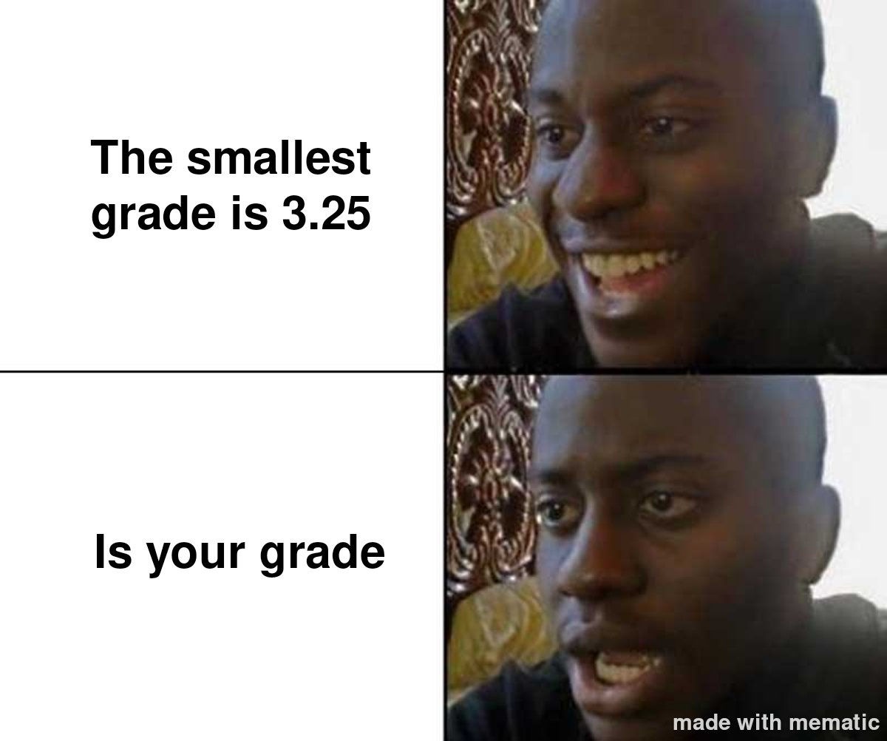

Encrypt:
Carnegie Mellon is cool.

Decrypt:

What is the plaintext? __________________________

What is the ciphertext? _________________________

Is this a symmetric or asymmetric encryption algorithm? _________________________

How many keys are used? _________________________

What is the key? _________________________

What is the runtime to break this cipher? Keep in mind that an adversary knows each meme corresponds to a word, but they don’t know which words are being used in the message. For this question, assume there are N words in the dictionary and 6 memes that are used. _____________

Asymmetric / RSA Encryption
Emily wants to send a super secret message to Chloe about the 110 exam. She translates the message into a number: 11, and then finds Chloe’s public key online. Her key is (5, 133).

How can Emily create the ciphertext? _____________

Emily puts the ciphertext on her Instagram story, and tags Chloe. Why should this not worry Chloe or Emily?

Then Chloe receives it and decrypts it with her _____________ (65, 133).

Chloe gasps!

Reading Files
Match the following actions to the correct line of code.

filename = “file1.txt”

___Opening a file in read mode a. f.readlines()

___Reading a file b. f.close()

___Data type that results when reading a file c. string

___Read lines of a file d. f.write(text)

___Opening a file in write mode e. f = open(filename, ‘w’)

___Writing a string in a file f. f = open(filename, ‘r’)

___Closing a file g. f.read()

Helper Functions
Michelle wants to build a game where you start with a list [2, 3, 4, 5, 6, 7, 8, 9, 10] and try to remove all the numbers in the list based on random dice rolls. At each turn, you roll two dice and sum them. Then, you can remove either a pair of numbers that add up to the sum, or the sum itself. You win by removing all the numbers, and lose if you get stuck and can no longer do any removals.

For example, if Michelle rolls 3 and 4 on the first roll, she can either remove 7, 5 and 2, or 3 and 4 from the list.

Try the game out for yourself here.

Describe the steps needed to make this game in plain English:

I

Now download the starter code. Michelle created a couple helper functions that implement these steps, but she forgot to write the playGame function! Let’s help her out. (First look over the helper functions! What are they doing?)

