15-110 Recitation 15

LAST RECITATION !!

Reminders
- HW6 is due TOMORROW Friday 12/11 at 12pm EST! (late submissions will not be accepted and there are NO revisions!!)
- Final Exam is Thursday 12/17 from 1 to 4 PM EST (for most students)
- Check Piazza for the review session schedule starting this weekend
  - There will be multiple 1 hour review sessions each focusing on a few core topics
  - OH are adjusted for finals week starting Saturday

Plan for Today:
Part 1 – Topic Review for Final Exam
Part 2 – 1 on 1 Student Check-Ins

Suggested Problems
Graphs
Draw the graph specified by the representation given below.
graph = [
"A" : ["B", "G"],
"B" : ["A", "C", "D", "E"],
"C" : ["B", "F"],
"D" : ["B", "F"],
"E" : ["B"],
"F" : ["C", "D", "G"],
"G" : ["A", "F"]
]
Answer

Now run both a BFS and DFS on the graph starting from node A. Visit nodes in lexicographic order.
BFS:
DFS:

Code Writing
Write a function secondDegree which takes in a graph g and a node node as input and outputs a list of the neighbor’s of each of node’s neighbors. Make sure not to include any duplicate nodes or the initial parent node - it’s not a neighbor of itself!
def secondDegree(g, node):

Big-O and Tractability
Answer the questions about the following function:
def roundOne(n):
newN = n**2
result = []
for i in range(0, newN, n):
print(i * n)
for j in range(i):
result.append(i * j)
return result

What is the Big-O complexity of this function if we only count the print statements?
Answer

What is the Big-O complexity of this function if we only count appending to result?
Answer

Some basic Tractability/P vs. NP questions:

What are the Useful NP Problems?
Answer

If you try to solve the subset sum problem by finding the sum of all subsets of the input, is this tractable or intractable? Explain.
Answer

If someone gives you a potential solution to the subset sum problem, is verifying whether the solution is correct tractable or intractable?
Answer

What complexity class is the subset sum problem in and why?
Answer

Family Trees
Write a recursive function getOldestAncestor(tree) that takes in a family tree and returns the name and age of the oldest ancestor of the person represented by the root node as a list. A family tree can be thought of as
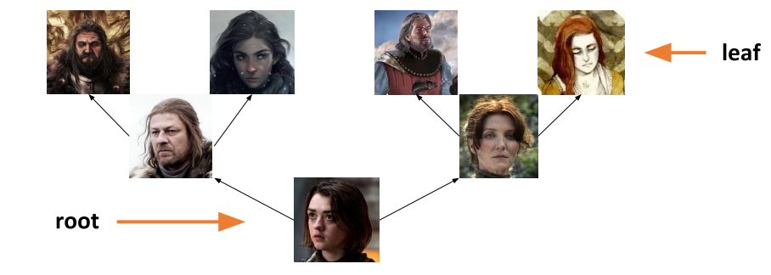
where the root represents a child and the leaves represent their oldest ancestors. You are guaranteed that the oldest ancestor in a given tree will be in a leaf node. The “value” key for a given node stores a list where the 0th index is the name of the person and the 1st index is the age of the person.
def getOldestAncestor(tree):

Simulation - Model, View, Controller

Imagine we have the following parts of a simulation:
Set the starting position and radius of a circle and drawn it in the center of the canvas.
What functions would we use for this?
Answer

The circle moves horizontally left and right across the canvas based on time (when it reaches one end it switches directions)
What functions do we need?
Answer

Now go to your starter file where we have provided this simulation! Let’s add the following elements to the simulation:
Inside keyPressed function:
- If we hit the return/enter key, we make the circle stop or start moving
- If we hit the up arrow key, we move the circle up the canvas by 10 pixels
- If we hit the down arrow key, we move the circle down the canvas by 10 pixels

Recall that in keyPressed(data, event) we can use event.keysym to get the "name" for characters we can’t show in strings
Enter/Return: event.keysym == "Return"
Up arrow key: event.keysym == “Up”
Down arrow key: event.keysym == “Down”

