15-110 Recitation 11

Recap
- Security
- Authentication
- Encryption/Decryption
- File I/O
- Modules

Reminders for Students
- HW 5 was due yesterday! Revision Deadline is Thursday 11/19 @ 12 PM EST
- Test 5 is next Friday (not tomorrow) 11/20
  - Hold small groups before the test

Problems

SECURITY REVIEW
Quick Questions:
- Describe the two main types of authentication.
  - Answer
  - Answer
- What makes RSA nearly impossible to break?
Answer
- What is the process called by which a VPN keeps a user’s internet activity private?
Answer
- Match the descriptions below to the corresponding types of security attack:
- Every student in 15-110 goes to gradescope at the same time to check their Test 4 grades
Answer
- One malicious student connects to a class wifi access point and looks at the packets for their roommate's andrew ID and password to send prank emails from their accounts
Answer

MEME CIPHER/ENCRYPTION
Consider this meme cipher below, where instead of letters mapping to pictures, words are mapped to pictures. Note: we can map letters to pictures but it would make messages way too large.
Carnegie Mellon | 
surprised | 
I | 
good | 
cool | 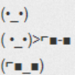
grade | 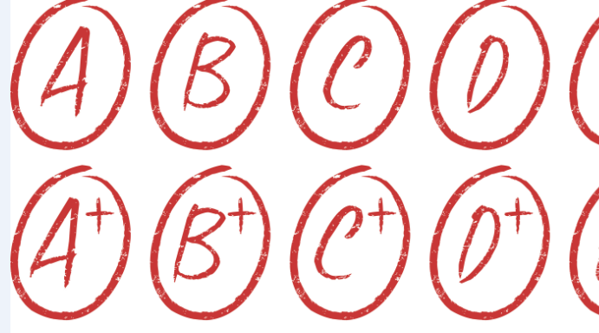

For the following problems, exclude common articles when encrypting and decrypting

Encrypt:
Carnegie Mellon is cool.
Answer (insert pictures)

I got a good grade at Carnegie Mellon
Answer (insert pictures)

Decrypt:
Answer
Answer

Answer these questions:
What is the plaintext? Answer
What is the ciphertext? Answer
Is this a symmetric or asymmetric encryption algorithm? Answer
How many keys are used? Answer
What is the key? Answer
What is the runtime to break this cipher? Keep in mind that an adversary knows each meme corresponds to a word, but they don’t know which words are being used in the message. This means they would have to check each possibility in the dictionary. For this question, assume there are N words in the dictionary and 6 memes that are used. Answer

USER INPUT CODE WRITING
Your high school teacher knows you are currently taking 15-110 and asks you to program a simple guessing game for your high school’s annual student fair! Your teacher wants you to write a program that takes in student guesses as input and tells the students whether or not they’ve correctly guessed a secret number from 1 to 100 that you’ve already picked. Your teacher reminds you that high school students are juvenile creatures, and that they might try to break your program with inputs that cannot be processed as numbers.

Use the provided starter code file to write a function guessingGame. Make sure to account for all input cases as mentioned in the starter code writeup!

TEST 4 QUESTIONS/OPEN OH
Go over how to approach/the solutions for any of the problems from Test 4 that students have questions regarding. If they don’t have any questions on Test 4, use this time as Open OH for students to ask any questions about recent material, homeworks, etc.

