15-104 Introduction to Computing for Creative Practice – FALL 2023

NAME: ENTER YOUR NAME HERE

ANDREW ID: ENTER YOUR ANDREW ID HERE

SECTION: ENTER YOUR SECTION LETTER HERE (A-E)

CONCEPTS QUESTIONS 10

Enter your answers to each of these questions in the space provided. Do not use online tools (including AI tools). Do not consult with other students when answering these questions. The information you fill in should be your work and only your work.

1. Recall that a periodic sound is made up of sinusoidal waves at various amplitudes and frequencies all added together, as shown below.

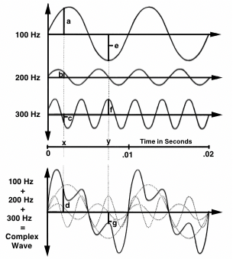

If a sound's highest frequency is at 10,000 Hz, what is the minimum sampling rate we need to accurately capture the frequency content of the sound digitally on a computer?

YOUR ANSWER: _________________ samples per second
2. We have an oscillator osc that has a frequency that is determined by the movement of the mouse horizontally. When the mouse is at the left edge of the canvas, the frequency should be 400 Hz and when the mouse is at the right edge of the canvas, the frequency should be 900 Hz. In between the frequency should rise linearly between 400 and 900. The frequency should not change if the mouse goes off the edge of the canvas horizontally.

Complete the following p5.js statement that controls the frequency based on this description above.

YOUR ANSWERS:
osc.freq(constrain(______ + _______*(mouseX / width), ______, ______));

3. On a musical keyboard, two notes that are one octave apart have the same letter name (e.g. C4 and C5). Let f equal the frequency in Hz of a note, and let m be the MIDI number of the same note. What is the value of the same named note two octaves above this note as functions of f and m, respectively?

YOUR ANSWERS: A note two octaves above f Hz is at ______________ Hz.
A note two octaves above MIDI value m is MIDI value _____________.

4. When we compute the mutual interaction between 10 particles, how many computations need to be performed if we treat one interaction between particles as a single computation? How many computations for 11 particles?
YOUR ANSWERS: __________ computations for 10 particles
__________ computations for 11 particles

