15-104 Introduction to Computing for Creative Practice – FALL 2023

NAME: ENTER YOUR NAME HERE

ANDREW ID: ENTER YOUR ANDREW ID HERE

SECTION: ENTER YOUR SECTION LETTER HERE (A-E)

CONCEPTS QUESTIONS 4

Enter your answers to each of these questions in the space provided. Do not use online tools (including AI tools). Do not consult with other students when answering these questions. The information you fill in should be your work and only your work.

- What is the value of z after the following instruction is executed? Write a single number as your answer.

z = map(6, 0, 10, 200, 400);

YOUR ANSWER: _______________

- What value is stored in the variable p after the following code is executed in its entirety?
var p = 0;
for (var n = 1; n < 11; n += 2) {
p = p + n;
}
Write a single number as your answer.

YOUR ANSWER: _______________

- Consider the 400 X 400 canvas below. Thin black lines are given to help you determine coordinates but are not considered part of the final sketch. The square is 100 X 100.

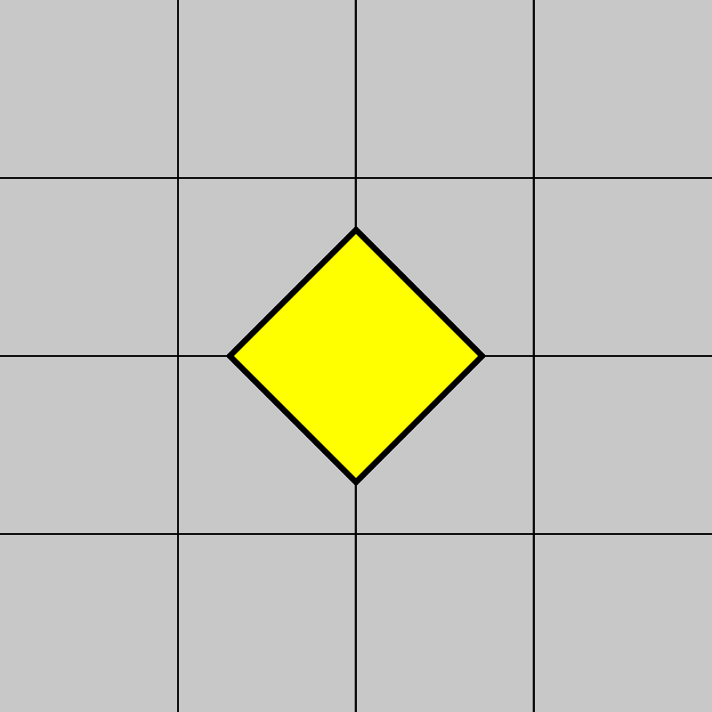

The following function is used to draw this sketch (without the grid lines). Fill in the missing instructions and parameters.

YOUR ANSWER:

function draw() {
strokeWeight(3);
push();
___________________________________________;
___________________________________________;
fill(255, 255, 0);
rectMode(CENTER);
square(___________, ___________, 100);
pop();
}

- Consider the 400 X 400 canvas below. Thin black lines are to given help you determine coordinates but are not considered part of the final sketch.

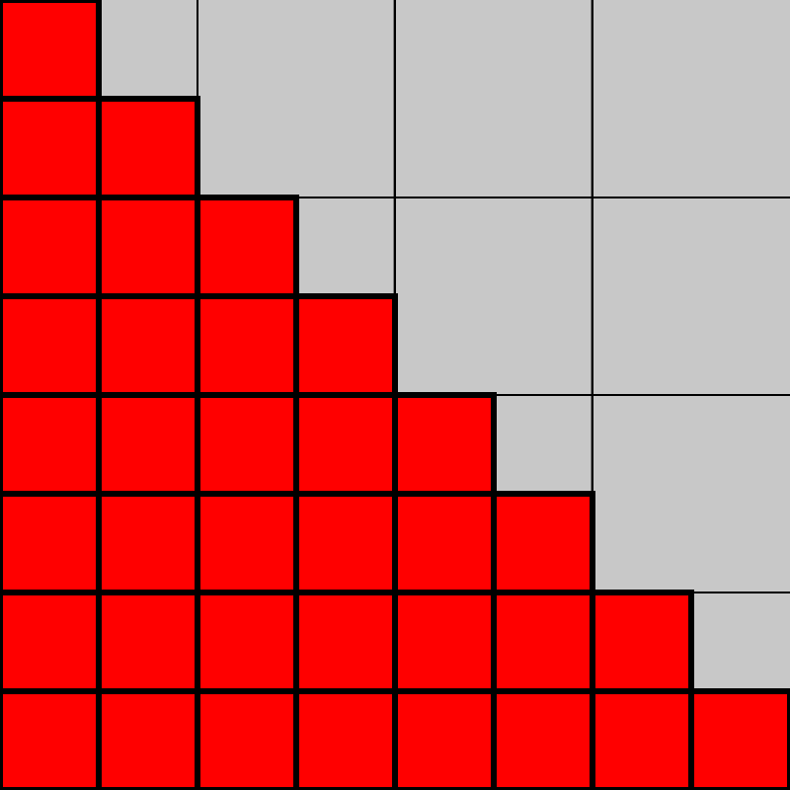
Complete the following function so that it creates the sketch shown above (without the grid lines). Assume that rectMode is NOT set to CENTER.

YOUR ANSWER:

function draw() {
strokeWeight(3);
fill(255, 0, 0);
for (var y = 0; _____________; _____________) {
for (var x = 0; _____________; _____________) {
square(x, y, 50);
}
}
}

