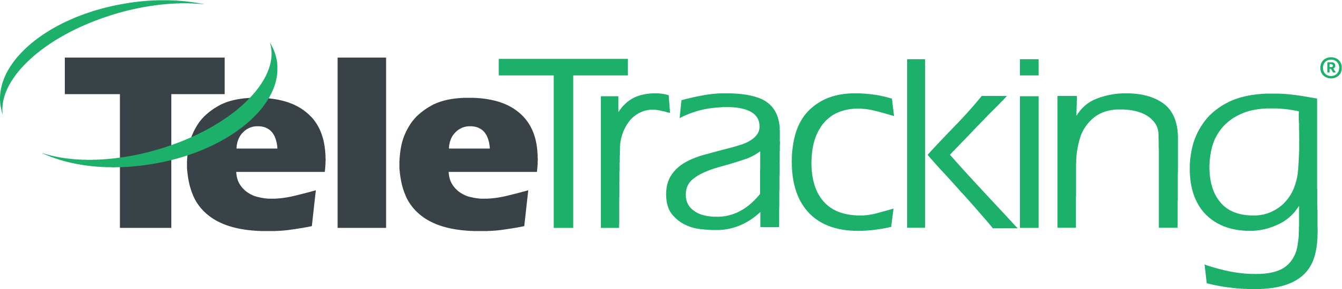
“TO ENSURE THAT NO ONE WILL EVER WAIT FOR CARE”

Architect- Data Platform

WHO WE ARE
For every hour patients wait for care, they face objectively worse outcomes. TeleTracking believes it is unacceptable that patients are not able to access the care they need, when they need it, due to operating inefficiencies and unnecessary cost barriers. Our mission is simple, to ensure no one waits for the care they need. Named one of Becker's "Great Places to Work" and a Pittsburgh Business Times “Corporate Citizenship Award” winner, TeleTracking delivers extraordinary outcomes that have been the subject of study by the RAND Corporation, and is the perennial KLAS Patient Flow Category Leader.
JOB SUMMARY

The Big Data Architect leads the architecture and design of TeleTracking’s Data Platform in alignment with TeleTracking’s vision of providing a unified data solution: aggregating customer and healthcare operational data, and providing easy access to powerful insights. As such, this position will be responsible for the technical and security architecture of the software applications, as well as the supporting infrastructure. This position will help drive quality, reliable, secure applications, using industry standard best practices.
PRIMARY DUTIES AND RESPONSIBILTIES
- Lead a development team of big data designers, developers, data scientists, and DevOps
- Implement a big data enterprise warehouse, BI and analytics system using Hive, Spark, RedShift, EMR (Hadoop), and S3
- Develop and maintain processes to acquire, analyze, store, cleanse, and transform large datasets using tools like Spark, Kafka, Sqoop, Hive, NiFi, and MiNiFi
- Provide recommendations, technical direction and leadership for the selection and incorporation of new technologies into the Hadoop ecosystem
- Participate in regular status meetings to track progress, resolve issues, mitigate risks and escalate concerns in a timely manner
- Contribute to the development, review, and maintenance of product requirements documents, technical design documents, and functional specifications
- Help design innovative, customer-centric solutions based on deep knowledge of large-scale, data-driven technology and the healthcare industry
- Help develop and maintain enterprise data standards, best practices, security policies and governance processes for the Hadoop ecosystem

EDUCATION
Bachelors- computer information technology, computer science, management
Masters Degree Preferred- computer information technology, computer science, management
EXPERIENCE
- Prior experience leading the design and development of software products
- Agile methodologies experience
- Strong communication skills, ability to learn, demonstrate intellectual curiosity, ability to work in a team environment. Self-motivated, passionate and strong leadership skills
SKILLS
- Minimum 5+ years of experience in large systems analysis and development, addressing unique issues of architecture and data management. Has the experience to work at the highest technical level of all phases of systems analysis and development activity, across the full scope of system development cycle
- 4+ years related experience on data warehousing and business intelligence projects
- 3+ years implementation or development experience with the Hadoop ecosystem
- Working knowledge of the entire big data development stack
- Experience handling very large data sets (10’s of terabytes and up preferred)
- Experience with secure RESTful Web Services
- Highly proficient with Java/Scala application development
- Expert in Apache Spark infrastructure and development
- Experience with Sqoop, Spark, Hive, Kafka, and Hadoop
- Experience with automated testing for Big Data platforms
- Experience with best practices for data integration, transformation, governance and data quality
- Experience with developing, designing and coding, completing programming and documentation, and performing testing for complex ETL applications (Spark & Scala preferred)
- Experience with Agile software development process and development best practices
- Experience with Big Data text mining and big Data Analytics preferred
- Understanding of Big Data Architecture along with tools being used on Hadoop ecosystem
- Ability to lead tool suite selection and lead proofs of concepts
- Ability to share ideas among a collaborative team and drive the team based on technical expertise and sharing best practices from past experience

WORK ENVIRONMENT and TRAVEL

The work environment characteristics described here are representative of those an employee encounters while performing the essential functions of this job. Reasonable accommodations may be made to enable qualified individuals with disabilities to perform the essential functions. The term "qualified individual with a disability" means an individual with a disability who, with or without reasonable accommodation, can perform the essential functions of the position. While performing the duties of this job, the employee is regularly required to communicate professionally in person, over the telephone, through email and other electronic means, move about the office, handle various types of media and equipment, and visually or otherwise identify, observe and assess. The employee is occasionally required to lift up to 10 pounds unless otherwise specified in the job description.

TeleTracking is committed to providing equal employment opportunity to all people in all aspects of the employment relationship, without discrimination because of race, age, sex, color, religion, national origin, disability or status as a Vietnam era or special disabled veteran or any other unlawful basis, as defined by applicable law, and fostering a workplace free of unlawful discrimination and retaliation. This policy affects decisions including, but not limited to, hiring, compensation, benefits, terms and conditions of employment, opportunities for promotion, transfer, layoffs, return from a layoff, training and development, and other privileges of employment. An integral part of TeleTracking’s commitment is to comply with all applicable federal, state and local laws concerning equal employment and affirmative action.

