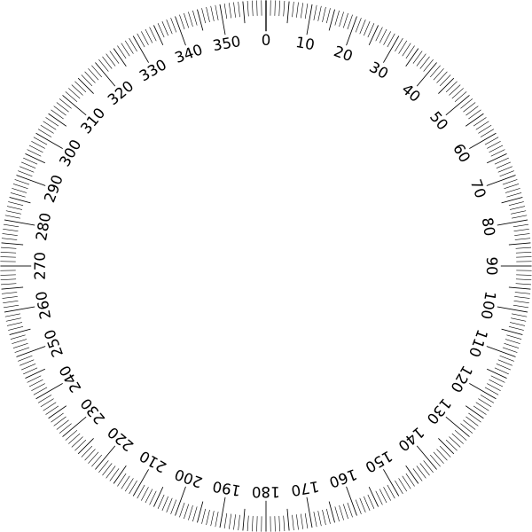
Wheel
Lift
Wheel
Wheel
Wheel
Line spacing is 5 mm.
Robot origin is at the center of the front axle.

Cozmo Odometry Test Sheet
Carnegie Mellon University
Line spacing is 5 mm.
Robot origin is at the center of the front axle.

