Articles on the topic of SLICING

A Method for Slicing CAD Models in Binary STL Format
TOBB University of Economics and Technology, Ankara, Turkey
http://web.firat.edu.tr/iats/cd/subjects/Manufacturing/MTE-31.pdf
- “This study concentrates on the process planning stage of the [advanced manufacturing] and presents a STL slicing algorithm with the ability of G-Code generation…”(1)

Slicing Triangle Meshes: An Asymptotically Optimal Algorithm
Federal University of Technology, Curitiba, Brazil
http://www.academia.edu/8352847/Slicing_Triangle_Meshes_An_Asymptotically_Optimal_Algorithm
(also accessible here) http://www.dainf.ct.utfpr.edu.br/~murilo/public/slicing.pdf
- “While current algorithms for slicing run on O(n²+k²) or O(n² + n log nk) for n triangles and k planes, the algorithm proposed in this paper runs on O(nk), where k is the average number of slices cutting each triangle, what is asymptotically the best that can be achieved under certain common assumptions…”

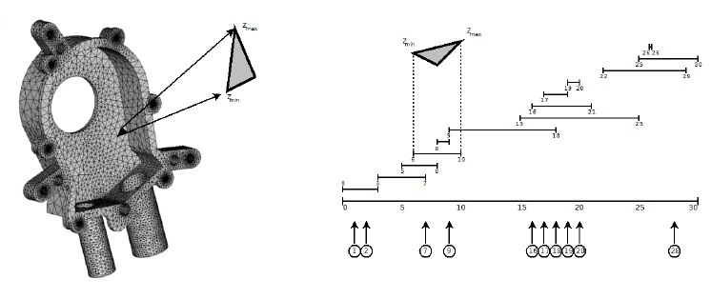

Marching Cubes: A High Resolution 3D Surface Construction Algorithm
http://fab.cba.mit.edu/classes/S62.12/docs/Lorensen_marching_cubes.pdf
- Not relevant to 3D-printing (is a medical paper), but is relevant to the slicing of 3D surfaces

Stereolithography (3D Printing) Algorithms and Thoughts
https://ravehgonen.wordpress.com/2013/02/19/stereolithography-3d-printing-algorithms-and-thoughts/
- Aim of blog entry is to briefly consider the process of generating 2D slices of a 3D model
- Presents pseudo code of process
- Shows pictures of code running on the Stanford Bunny model
- Presents some example code that the author created
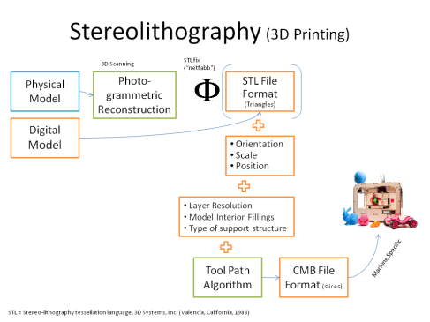
Figure 1: Presents a picture from 3D Systems
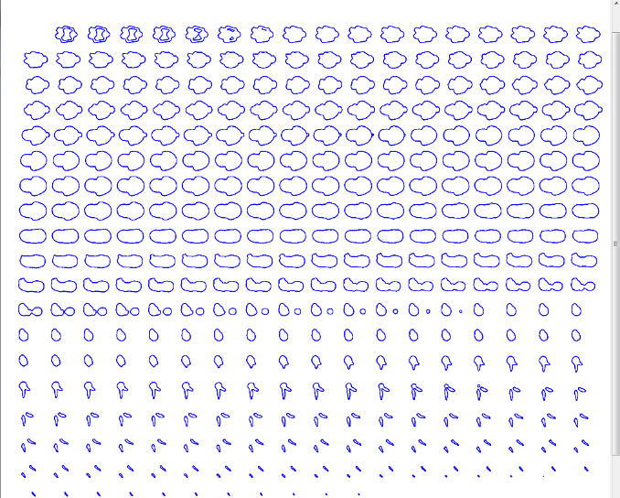
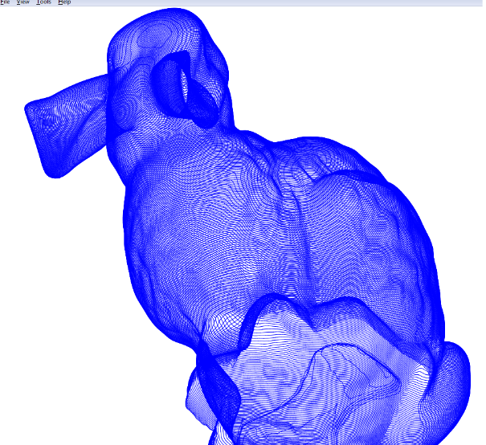
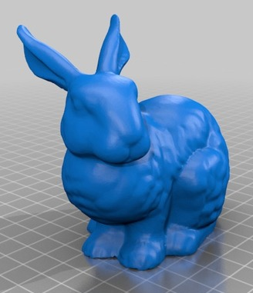
- “A Guide to Creating Good STL Files”
- http://www.padtinc.com/blog/the-rp-resource/a-guide-to-creating-good-stl-files
  - Slicing algorithms only need 3D models made up of polygons
    - STLs are used over NURB (non-uniform rational basis spline)
      - STereoLithography or Standard Tessellation Language
      - Invented by 3D Systems
      - Consists of polygons
        - Defined by outward vector and vertices
        - Supports more than three vertices, but in practice only triangles are used
      - Rules for STL creation
        - No corners can touch an edge
        - Triangles are flat
    - Works by taking the intersection of triangles in 3D and the current “z plane” to create lines that represent the perimeter of a part at a certain height.

  - “3D Printing: your friend the Slicer”
  - https://exploreideasdaily.wordpress.com/2013/04/24/3d-printing-your-friend-the-slicer/
    - Output of a slicer engine is a g-code file
      - Contains instructions for the printer
    - Examples of slicing engines:
      - Cura
      - Slic3r
      - KISSlicer
    - Slicing is an optimization problem and has multiple solutions
      - Improvements are still needed to deal with:
        - Stringing
        - Seams
    - Cura has a “Joris Mode”
      - Prints single-wall objects in a single path
      - (ex: a cone shell would be printed as a spiral with a decreasing diameter)
    - How slicing engines work:
      - Note: Article does the following explanation in 2D to simplify things, but would obviously have to be done in 3D, which requires some additional work
      - For each Z level, engine needs to find some 2D geometry to describe the model at that plane.
        - Not efficient to calculate intersection of every triangle. Instead, only the triangles that do intersect the plane need to have their geometry referenced.
        - Identify triangles that need to be referenced, working from the bottom of the model to the top:
          - Start by creating two lists (since only the minimum and maximum points in a triangle are needed to figure out if the triangle intersects):
            - Min List: contains the minimum Z-value of the 3 points in a given triangle, alongside the ID for the triangle, in order from lowest Z to highest Z.
            - Max List: The other lists the maximum Z-value of each triangle’s three points, alongside the ID of the triangle, also in order from lowest to highest.
          - Create a third “working” list of IDs describing the triangles with minimum Z’s below the Z level being checked
            - Check the Min List and take the section that ends with the triangle with the highest minimum below the Z level
            - The triangles should still be in order of how low their minimum Z is
          - Remove from that set the triangle IDs with maximum Z’s below the Z level being checked
          - This same triangle that was removed from the working set should be removed from both lists for the next plane since it will be below the Z-plane and is no longer useful
            - This has the effect of reducing the number of triangles being checked as the z-plane rises, meaning a uniform part will be processed slower at the beginning and faster towards the end.
    - Project the triangles onto the plane
      - Provides some imagery describing ways to project the geometry of a triangle onto the plane
  - Shows the outline resulting from gear composed of triangles
  - Links to example code which the author provides.
  - (Article doesn’t continue).

HydraRaptor (blog by nophead)
http://hydraraptor.blogspot.com/
Github: https://github.com/nophead/Mendel90
Thingiverse: http://www.thingiverse.com/nophead/designs

- Extremely comprehensive blog about nophead’s work developing his own 3D-printers and documents his developments in and observations on both hardware and software
- Article about accommodating for hole shrinkage in 3D-printing:
  - http://hydraraptor.blogspot.com/2011/02/polyholes.html
- Article about poor dimensioning by slicer engines
  - Explains the math behind determining extrusion geometry and tuning printers further than what most do
  - http://hydraraptor.blogspot.com/2014/06/why-slicers-get-dimensions-wrong.html
- Article about embedding nuts inside 3D-printed parts
  - http://hydraraptor.blogspot.com/2014/03/buried-nuts-and-hanging-holes.html
- Many others…

SLICING ENGINES
- Slic3r: G-code generator for 3D printers
- http://slic3r.org/blog
  - Is one of the most popular, free, open source slicing engines available
  - Has many interesting features and supports many printers and usage cases
  - Features:
    - Selective application of settings for local regions of parts
    - Supports multiple extruders
    - Wide compatibility with many printers
    - Print thin layers on the perimeters and thick layers on the interior to save time and increase accuracy
  - Has a blog that explains new features and what’s under development, but doesn’t really focus on the “how” of the engine

- Skeinforge
- http://fabmetheus.crsndoo.com/wiki/index.php/Skeinforge
  - Very powerful, but can be overwhelming
    - Gives control over dozens of parameters
      - Not just control over tuning and optimizing printing
      - Also provides features like:
        - Dwindle
          - “Reduces the feed rate and flow rate at the end of the thread, in order to reduce the ooze when traveling.”
        - Fillet
          - Rounds the corners slightly in a variety of ways in order to reduce corner blobbing and sudden extruder acceleration.
        - Jitter
          - Change where every layer starts in order to prevent a ridge from being created on the side of the object.

