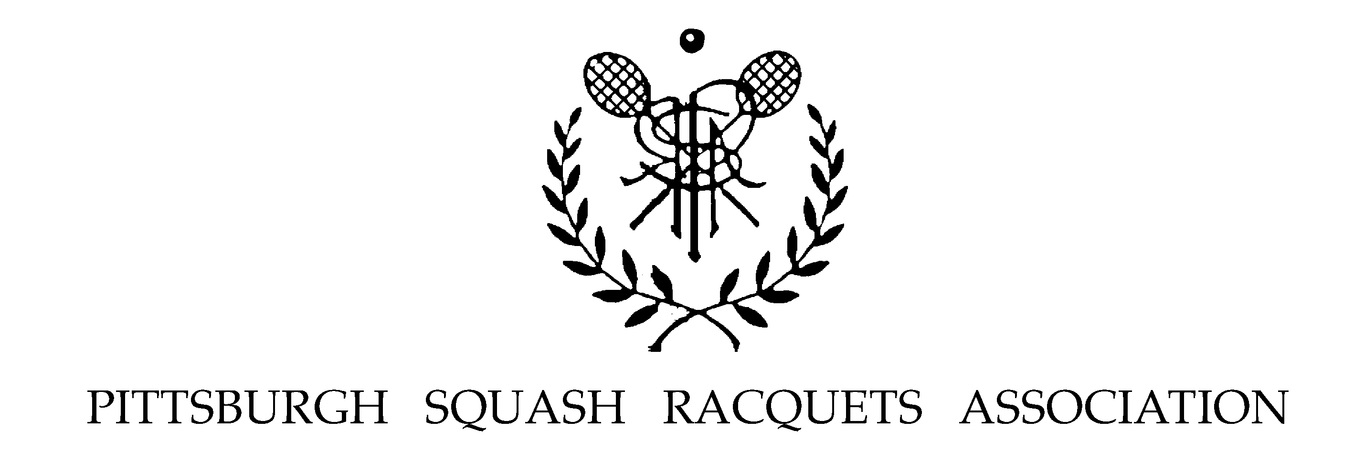
The Pittsburgh Squash Racquets Association Presents

The 2002 Pittsburgh City Championships

May 3rd, 4th, and 5th, 2002

Oxford Athletic Club East in Monroeville, PA

Events* Men (5.0 4.0 3.0 2.0) Women
Juniors (U19 U16 U14 U12) Veterans

* In the event the tournament director determines there are an insufficient number of players to warrant a separate flight, he may combine two or more. In the event you sign up to play more than one draw, please be aware that you may be scheduled to play two matches back to back.

Entry Fees: $35.00 PSRA/USSRA Member
$42.00 Nonmember

$10.00 each additional draw

Entry Deadline: Tuesday, April 30th, 2002

Tournament Director: Mr. Duilio Costa (412.856.3930)

Official Ball: Dunlop XX

Starting Times: Contact the Oxford Athletic Club at 412.856.3930 after 2:00 PM on Thursday, May 2nd, 2002.
USSRA Sanctioned Event
Eye Protection will be required.

Awards will be presented on Saturday, May 11th, 2002, at the Annual PSRA Banquet, which will also feature an exhibition match between Graham Ryding and Chris Walker. Details at http://www-2.cs.cmu.edu/~psra/.

Please Print & Return

Name: Signature:

Division:

Men 5.0 4.0 3.0 2.0

Women

Veterans

Junior U19 U16 U14 U12

PSRA/USSRA Member Yes No

Phone:

Email:

Please include a check made payable to PSRA:

PSRA c/o Don Kirwan
413 Sylvania Drive
Pittsburgh, PA 15229

