Multirobot/Multiagent Reading Group Notes
3-2-05

Part 1: RoboCup Rescue Physical League
Overview:
- 3 arenas of various levels of difficulty (yellow = easy, red = hard)
- Mannequin victims with motion, sound, heat, and CO₂ emissions
- Any number of/any kind of robots are allowed
- 20 minutes to map environment, discover victims
- Score points for each victim based on accuracy of location, victim state, situation, signs of life, ID tag
- Score divided by (1 + # operators)²
Pros:
- Humanitarian goals
- Simultaneous addresses many problems
  - Challenging terrain
  - SLAM
  - Adjustable autonomy
  - Human-robot interaction
  - Multirobot coordination
  - Sensing
  - Other?
- Standardized metric for comparison for different lines of research
Cons:
- Not applicable for real disaster sites
- Murphy claims 2 operators per robot while RoboRescue encourages 1 operator per n robots.
- Must simultaneously address many problems (large initial time investment before addressing “research” in any single area)

Part 2: CMU/U.Pittsburgh RoboRescue Team
Overview:
- Robots as agents
- Heterogeneous robots: PERs (2), Pioneer P3AT (for mapping), Tarantula (stairs)
- Focus on adjustable autonomy and situational awareness
- High fidelity simulator (may be useful to others—available online): http://usl.sis.pitt.edu/ulab/usarsim_download_page.htm
Strengths:
- Lots of thought in system design and architecture
- “Cheap” heterogenous robots
- Victim identification fairly advanced
Weaknesses:
- Mapping (in process of switching to ActivMedia software)
- Cheap robots lack sensors and limit autonomy

Part 3: Coordination in USAR environment
Overview:
- Set of robots with (binary) heterogeneous capabilities
- Set of tasks with (binary) heterogeneous requirements, duration, reward
- Physical environment that can be represented as graph
- Reward decreases over time (want to find victims as soon as possible)
- Goal: allocation of robots that maximizes utility
Our approach:
- Anytime algorithm for robot/task allocation
- Formulate problem as MILP problem
- Interleave domain specific planning algorithms and general ILP algorithms over various planning horizons
- Distributed centralized approach
- Replanning based on reasoning about constraints
Pros:
- Explicitly considers team utility
- Ability to provide performance bounds (based on relaxed solution)
- Anytime algorithm
- Can represent different travel times for different classes of robots
- Can easily represent task dependencies (Partially ordered plans)
- Decreased communication costs/solution time (compared to DCOP algorithms)
- Reasoning about commitments when replanning
Cons:
- Not scalable for large teams (need to subdivide problem)
- Relationships must be linear
- Goal satisfaction is binary (could be overcome)
- Capabilities are binary (could be overcome)
- All robots need access to all information
Challenges:
- Faulty communication
- Relaxing full observability requirements
Results: Should have been included in notes (sorry!)
- Greedy heuristics are effective due to time varying reward
- Using previous solution to start search improves performance
Other thoughts? Feedback?
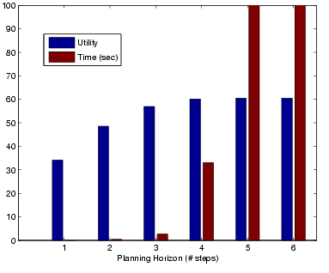
Fig. 1 Utility-Time tradeoff for example problem with varying levels of look-ahead.

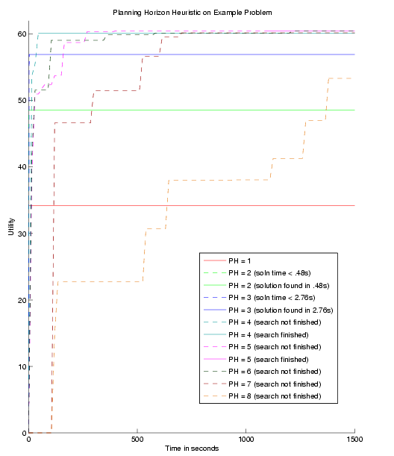
Fig. 2 Effect of planning horizon on solution convergence on example problem.
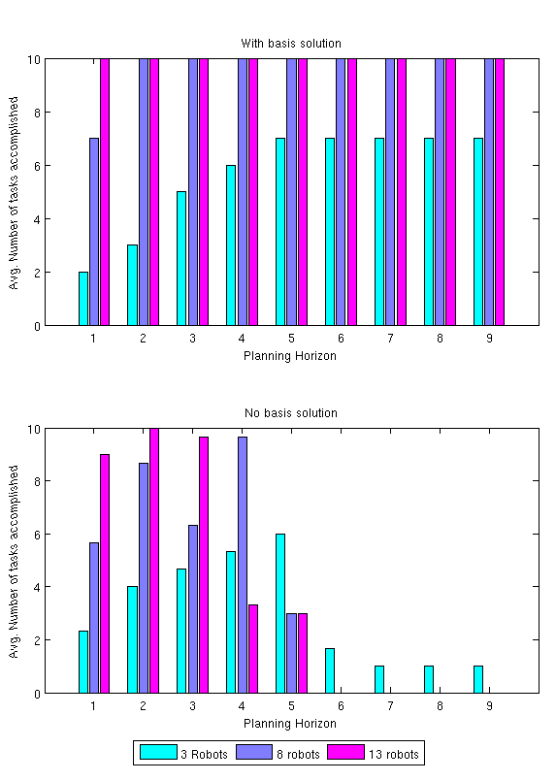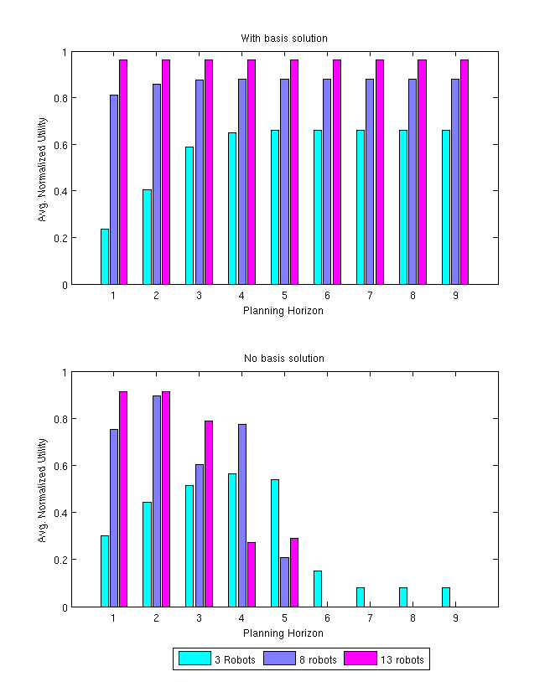
Fig. 3 Effectiveness of starting solution on randomly generated test cases (each set was averaged over 3 randomly generated test cases). If the optimal solution was not found after 3 minutes, the search was halted and the best solution so far was used.

