Geometry for Programming Competitions

Eugene Fink (www.cs.cmu.edu/~eugene)

Available online:
- Word version: www.cs.cmu.edu/~eugene/research/talks/compete-geom.doc
- pdf version: www.cs.cmu.edu/~eugene/research/talks/compete-geom.pdf

Let no one who is ignorant of geometry enter here.
— Inscription on the entrance to Plato’s academy

We humans are good at visual reasoning, but computers are not;
intuitive visual operations are often hard to program.

Overview

- Basic geometry: points and lines, triangle, circle, polygon area
- Convex hull: gift wrapping, Graham scan

Readings:
- Steven S. Skiena and Miguel A. Revilla. Programming Challenges
- Joseph O’Rourke. Computational geometry in C
- Wikipedia (wikipedia.org)
- Wolfram MathWorld (mathworld.wolfram.com)

Points and lines

Representation in Cartesian coordinates:
- Point: (x₁, y₁)
- Line:
- y = m ∙ x + b (more intuitive but does not include vertical lines)
- a ∙ x + b ∙ y + c = 0 (more general but non-unique and less intuitive)
- Line segment: two endpoints

Yes/No tests:
- Point (x₁, y₁) is on line (m, b) iff y₁ = m ∙ x₁ + b (available in Java)
- Lines (m₁, b₁) and (m₂, b₂) are…
- identical iff m₁ = m₂ and b₁ = b₂
- parallel iff m₁ = m₂
- orthogonal iff m₁ = − 1 / m₂
- Counterclockwise predicate ccw (available in Java):
Consider points (x₁, y₁), (x₂, y₂), and (x₃, y₃),
and let A = x₁ ∙ y₂ + x₂ · y₃ + x₃ ∙ y₁ − y₁ · x₂ − y₂ ∙ x₃ − y₃ · x₁.
- If A > 0, the points are in a counterclockwise order
- If A < 0, the points are in a clockwise order
- If A = 0, the points are collinear

Basic computations:
- Distance between (x₁, y₁) and (x₂, y₂):
$\sqrt{(x_{1}−x_{2})^{2}+(y_{1}−y_{2})^{2}}$
- Line through points (x₁, y₁) and (x₂, y₂):
m = (y₁ − y₂) / (x₁ − x₂)
b = y₁ − m ∙ x₁
- Intersection of (m₁, b₁) and (m₂, b₂), where m₁ ≠ m₂:
x₁ = (b₂ − b₁) / (m₁ − m₂)
y₁ = m₁ ∙ x₁ + b₁
- Angle between (m₁, b₁) and (m₂, b₂):
arctan ((m₂ − m₁) / (m₁ ∙ m₂ + 1))

Other useful operations:
- Intersection of two segments (available in Java)
- Distance from a point to a line or a segment (available in Java)
- Point on a line closest to a given point

Triangle

A triangle specification may include three sides and three angles.
Given three of these six values, we can find the other three.
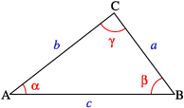
- α + β + γ = π (or 180˚)
- Law of sines:
a / sin α = b / sin β = c / sin γ
- Law of cosines (generalized Pythagorean theorem):
c² = a² + b² − 2 · a · b · cos γ
- Law of tangents (less useful):
(a − b) / (a + b) = tan ((α − β) / 2) / tan ((α + β) / 2)

Area:
- Area = a · b · sin γ / 2
- Area = | x₁ ∙ y₂ + x₂ · y₃ + x₃ ∙ y₁ − y₁ · x₂ − y₂ ∙ x₃ − y₃ · x₁ | / 2
- Heron’s formula:
Let s = (a + b + c) / 2; then Area = $\sqrt{s⋅(s−a)⋅(s−b)⋅(s−c)}$
- Less useful:
Area = r ∙ s = a ∙ b ∙ c / (4 ∙ R), where r is inradius and R is circumradius

Other useful operations:
- Centers of inscribed and circumscribed circles

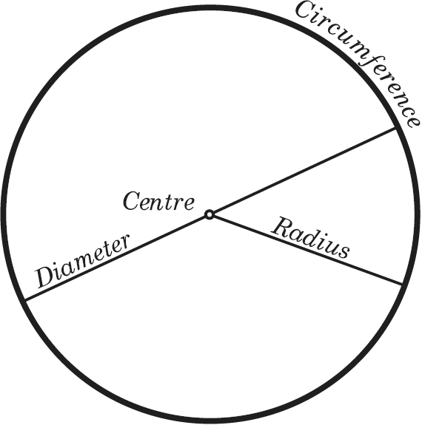
Circle

- A circle is the set of points located at a given distance from a given center.
- A disk is the set of points located no further than a given distance from a given center.

Representation:
Let r be the radius and (x_{c}, y_{c}) by the center.
- Circle: (x − x_{c})² + (y − y_{c})² = r²
- Disk: (x − x_{c})² + (y − y_{c})² ≤ r²

Basic computations:
- Circumference: 2 ∙ π ∙ r
- Area: π ∙ r²
- Point (x₁, y₁) is inside the circle iff (x₁ − x_{c})² + (y₁ − y_{c})² ≤ r²

Other useful operations:
- Intersection of a circle and a line
- Intersection of two circles
- Tangent to a circle through a given point

Polygon area
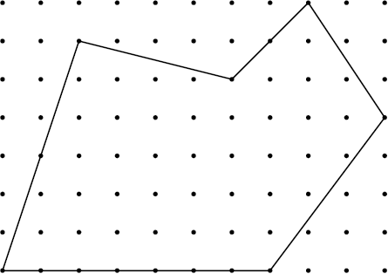
- Based on vertex coordinates:
| x₁ ∙ y₂ + x₂ · y₃ + ... + x_{n} ∙ y₁ − y₁ · x₂ − y₂ ∙ x₃ − ... − y_{n} · x₁ | / 2
- Pick’s formula for a polygon on a lattice:
If a polygon has i lettice points inside and b lettice points on the boundary, its area is i + b/2 − 1

Convex hull

The convex hull of a geometric object is the minimal convex set containing the object.
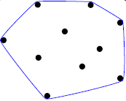
Intuitively, it is a rubber band pulled taut around the object.
- The hull of a finite point set is a convex polygon.
- The hull of a set of polygons is identical to the hull of their vertices.
- A polygon is convex (i.e. identical to its hull) iff all its angles are at most π (180º).

Gift wrapping (a.k.a. Jarvis march)
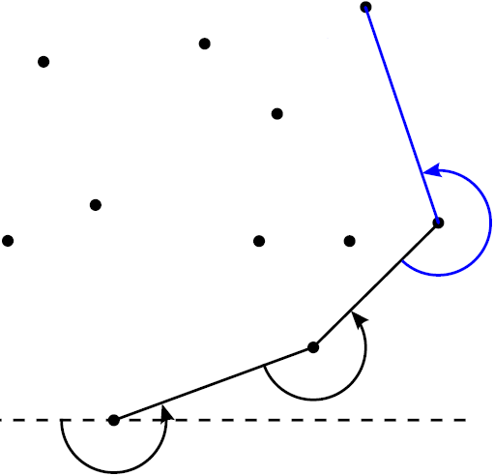
Intuitively, wrap a string around nails; simple but slow.
Time complexity is O(n ∙ h), where n is the number of points
and h is the number of hull vertices.

- Select the smallest-y point as the first hull vertex;
if several, choose the largest-x point among them
- At each step, select the next hull vertex, which is the “rightmost” as seen from the previously selected vertex

Detailed description in Wikipedia: en.wikipedia.org/wiki/Gift_wrapping_algorithm

Graham scan
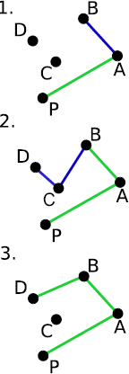
Efficient version of the gift wrapping.
Time complexity is O(n · lg n).

- Select the smallest-y point as the first hull vertex;
if several, choose the largest-x point among them
- Sort the other points right-to-left, as seen from the selected vertex
- Walk through the points in the sorted order;
when making the “right turn,” prune the respective point
- The remaining points are the hull vertices

Detailed description in Wikipedia: en.wikipedia.org/wiki/Graham_scan

