Week: 13 Date: 4/16/2026
15-110 Recitation Week 13

Reminders
- Check6-2 due tomorrow (4/17) at noon
- Check6-2 revisions due Wednesday (4/22) at noon
- Full HW6 due Friday (4/24), no revisions
  - Details about submission depend on your project, as explained on course website / Piazza
- Recitation feedback form

Overview
- ML Fast Facts
- Artificial Intelligence
- Monte Carlo Methods
- Data Visualizations with Matplotlib
- HW6 Check-ins

Problems

ML Fast Facts
Use the following table to highlight the differences between classification, regression, and clustering:
Reasoning Category | Labeled/Unlabeled Data? | What does this tell us about the data? | Example
Classification
Regression
Clustering

What is the difference between supervised and unsupervised learning?

Artificial Intelligence

What are the three steps AI agents cycle through in order to reach their goals?

From this Connect Four board, draw the next level of the game tree for the red player. (If you aren’t familiar with Connect Four, you can read about it here!)
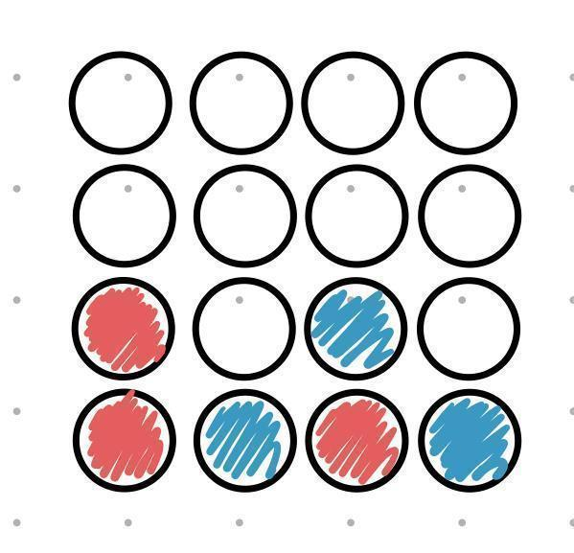

Monte Carlo
First, some notes to fill in:
A Monte Carlo Method is a program that a simulation many, many times, giving us the of an .

Monte Carlo Method programs consist of two main components:

  - Example:

  - Example:

Now, write a Monte Carlo Method to compute the expected number of units you will take in a given semester at CMU. Assume you take anywhere from 3 to 5 classes a semester and each class is between 9 and 12 units. Hint: you may want to import a helpful package!
Data Visualization Practice: Matplotlib
Recall the ice cream data from lecture that contains the top 3 favorite ice cream flavors of 110 students from past semesters. Using the starter code provided, write the following two functions to visualize the data:

- Write the function makeFlavorDict(data) that takes in a 2D list representation of the data and returns a new dictionary mapping ice cream flavors in the “#1 cleaned” (i.e. students’ favorite flavors) column to a count of their occurrences.
- Using the returned dictionary from the function above, write the function visualize(dict) that creates a bar chart plotting each ice cream flavor.

