Week: 9 Date: 4/1/2021

|  |
| --- |
| 15-110 Recitation Week 9 |

# **Reminders**

* Check 4 and HW 4 revisions due next Tuesday, 4/6
* Quiz 4 is next Wednesday, 4/7

# **Overview**

* Concurrency
* mapReduce
* Laundry Pipelining
* Individual student check-ins

|  |
| --- |
| Problems |

# **CONCURRENCY:**

**Merge sort:**

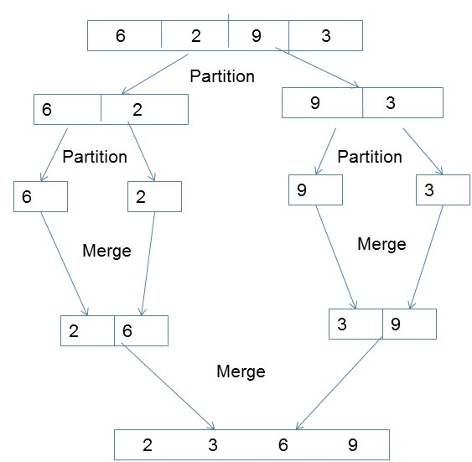

What steps can be done in parallel?

Answer

Draw the concurrency tree for the following math equation:

**(5 + 3) / (1 + 1) * ((36 / (10 - 4)) + (8 * 3)) – 9**

Drawing:

What is the number of **total steps**? Answer

What is the number of **time steps**? Answer

# **MAPREDUCE**

Recall the components of a mapReduce algorithm…

Suppose we make a mapReduce function to count the number of files that have an even number of even numbers. Define the mapper, reducer, and manager actions.

Mapper:

Reducer:

Manager:

# **LAUNDRY PIPELINING**

You just started your summer job working at the best burger restaurant in the United States, In-N-Out! It’s the daily 1 hour lunch rush and you are trying to figure out what the most efficient way of churning out burgers is. Preparing the burgers for customers takes 4 steps that must be performed in this order: grilling burgers takes 5 minutes (G), toasting buns takes 2 minutes (T), placing vegetables takes 2 minutes (V), and dressing condiments takes 1 minute (C). You start off by just making the burgers one after another.

How many burgers can you fully complete in the 1 hour lunch rush?

Answer



You and your friend just learned about pipelining in 15110 and your friend proposes the following pipelines to speed up burger production. Your friend asks you to check over the pipelines they made and see if there are any errors. For the following pipelines identify the error if there is one or say no error if there is none. (Assume you have as many workers and as much equipment as you need to build burgers)

Option 1)



Answer 1:

Option 2)



Answer 2:

Option 3)



Answer 3:

Option 4)



Answer 4:

Using the correct pipelining strategy, how many burgers will you be able to make during the lunch rush?

Answer:

With the correct pipelining strategy, how many workers do we need? With this number of workers, does pipelining allow for faster burger production? What are the tradeoffs?

Number of workers:   
Additional answers/Notes:

# 

# **STUDENT 1 ON 1 CHECK-INS**

Roughly 2-minute check-ins on how the course is going!