Week: 13 Date: 4/29/2021

|  |
| --- |
| 15-110 Recitation Week 13 |

# **Reminders for Students**

* HW 6 Check 2 due tomorrow 4/30 at 12 PM EST
  + Make sure to read the function instructions - most of the information you will need to correctly implement the function is in the writeup as well as important tips and details to help you!
  + Make sure you are testing your code before submitting your project to Gradescope
  + We have provided test cases for you in a separate file. All you need to do to run these cases is simply go to your main hw6 file and hit “run file as script”. This will import the test cases from the separate file and run the tests for you, which will display either an error or as successful in the shell. Make sure you are paying attention to the shell output and are using print statements to aid in debugging!

# **Overview**

* AI Fast Facts
* Monte Carlo
* Unit 4 Review
* HW6 Check-Ins

|  |
| --- |
| Problems |

# **AI FAST FACTS**

What are the 3 steps taken by Intelligent Agents to accomplish their goals?

Answer

What is 1 benefit and 1 drawback to using a heuristic over a brute-force algorithm?

Benefit: Answer

Drawback: Answer

Draw the minimax tree for a tic-tac-toe board starting at the given state. Label each following state with -1, 0, or 1 depending on if it is advantageous for Player X. It is Player X’s turn to play.

Initial State:

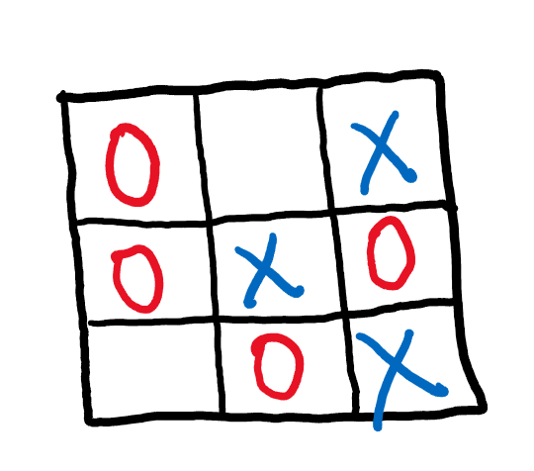

# **MONTE CARLO – CODE WRITING**

Write a Monte Carlo Method to compute the expected number of units you will take in a given semester at CMU. Assume you take anywhere from 3 to 5 classes a semester and each class is between 9 and 12 units. Hint: you may want to import a helpful package!

code

# **UNIT 4 REVIEW**

What topics from Unit 4 would you like to review?

Some possible popular topics: input/try-except, models-components-rules, data analysis, simulation

Notes

# **HW 6 CHECK-INS**

For roughly 2 minutes, check in with your TA to discuss any concerns with the course and specifically HW6. Are you on track to submit by the deadline tomorrow? Do you understand and did you fix all the feedback from Check 6-1? (Recall that fixing Check 6-1 is part of the final submission, so be sure to review that feedback!)