Week: 10 Date: 11/07/2024
15-110 Recitation Week 10

Reminders
- How do you feel about Exam 2 (if you’ve taken it or if you’re still preparing for Friday)?
- HW5 due Monday 11/11 at noon
- Recitation feedback form
Overview
- Meme Cipher Encryption
- Asymmetric Encryption
- Helper Functions

Problems

Meme Cipher Encryption
Carnegie Mellon | 
surprised | 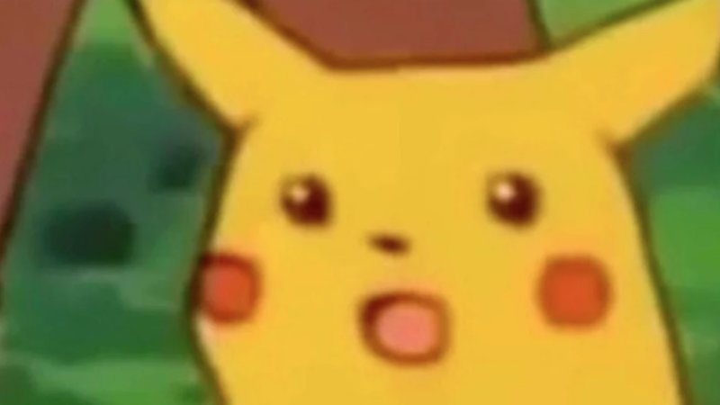
I | 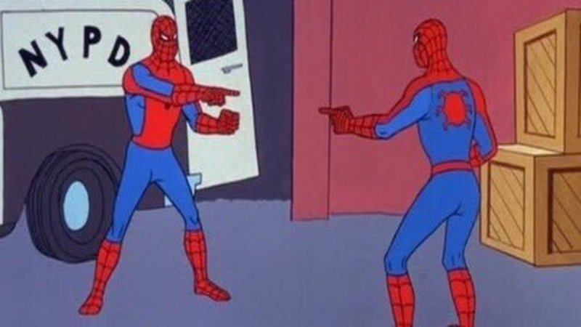
good | 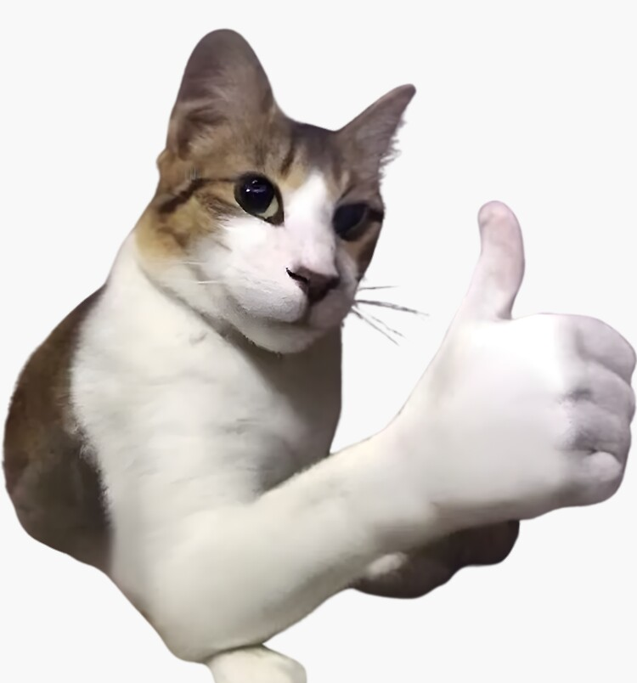
cool | 
grade | 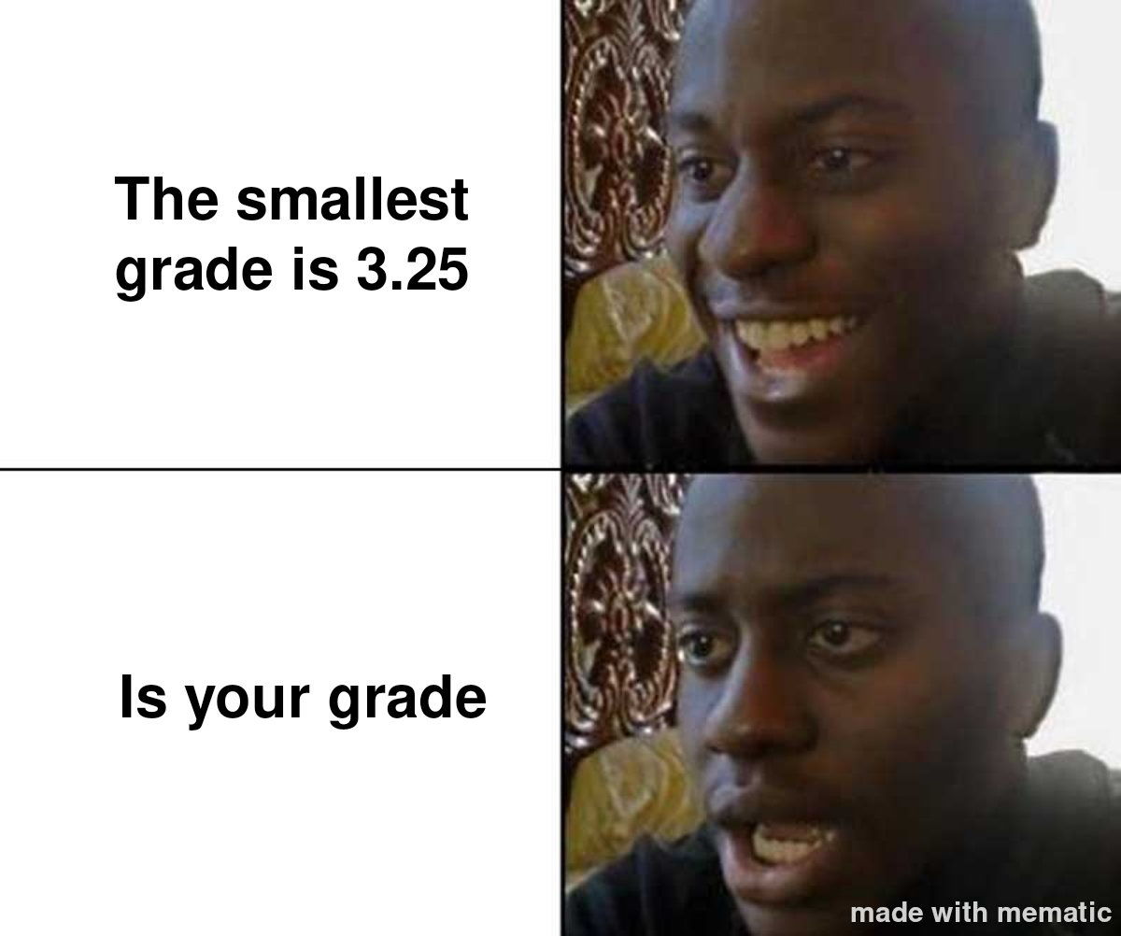

Encrypt:
Carnegie Mellon is cool.

Decrypt:

What is the plaintext? __________________________

What is the ciphertext? _________________________

Is this a symmetric or asymmetric encryption algorithm? _________________________

How many keys are used? _________________________

What is the key? _________________________

What is the runtime to break this cipher? Keep in mind that an adversary knows each meme corresponds to a word, but they don’t know which words are being used in the message. For this question, assume there are N words in the dictionary and 6 memes that are used. _____________

Asymmetric / RSA Encryption
Emily wants to send a super secret message to Chloe about the 110 exam. She translates the message into a number: 11, and then finds Chloe’s public key online. Her key is (5, 133).

How can Emily create the ciphertext? _____________

Emily puts the ciphertext on her Instagram story, and tags Chloe. Why should this not worry Chloe or Emily?

Then Chloe receives it and decrypts it with her _____________ (65, 133).

Chloe gasps!

Helper Functions
Anishka wants to build a game where you start with a list [2, 3, 4, 5, 6, 7, 8, 9, 10] and try to remove all the numbers in the list based on random dice rolls. At each turn, you roll two dice and sum them. Then, you can remove either a pair of numbers that add up to the sum, or the sum itself. You win by removing all the numbers, and lose if you get stuck and can no longer do any removals.

For example, if Anishka rolls 3 and 4 on the first roll, she can either remove 7, 5 and 2, or 3 and 4 from the list.

Describe the steps needed to make this game in plain English:

I

Now download the starter code. Anishka created a couple helper functions that implement these steps, but she forgot to write the playGame function! Let’s help her out. (First look over the helper functions! What are they doing?)

