15-104 Introduction to Computing for Creative Practice – FALL 2024

NAME: ENTER YOUR NAME HERE

ANDREW ID: ENTER YOUR ANDREW ID HERE

SECTION: ENTER YOUR SECTION LETTER HERE

CONCEPTS QUESTIONS 3

Enter your answers to each of these questions in the space provided. Do not use online tools (including AI tools). Do not consult with other students when answering these questions. The information you fill in should be your work and only your work.

- Complete the simple draw function below that draws a 50 X 50 rectangle in the center of a canvas of size 200 X 200 at an angle of +30 degrees, as shown in the example below:
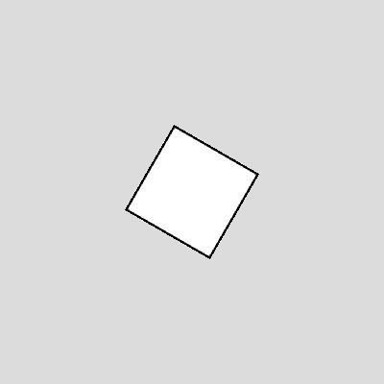

YOUR ANSWER:

function draw() {
rectMode(CENTER);
translate(__________________, __________________);
rotate(____________________);

rect(0, 0, 50, 50);
}

- Complete the simple draw function below that draws two 50 X 50 rectangles touching at the center of an arbitrary-sized canvas of size at least 200 X 200, as shown in the example below:
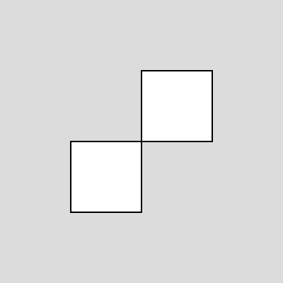

YOUR ANSWER:

function draw() {

push();

translate(____________________, _____________________);

rect(0, 0, 50, 50);

pop();

push();

translate(____________________, _____________________);

rect(0, 0, 50, 50);

pop();
}

- In the previous problem, if the push and pop function calls were removed, would either rectangle move to a new location? If so, identify which would move and where, and briefly explain why this happens. If not, briefly explain why not.
YOUR ANSWER:

- Consider the Random Lines program discussed in Lecture 4, shown below. The program draws an extra line for each row off the right end of the canvas and an entire additional row below the canvas, but we don’t see them. Show how to fix the code below so that we don’t draw these extra unseen lines. Make the change(s) in the code itself and add a comment starting with // to indicate which line(s) had the change(s).

YOUR ANSWER:
var x = 0;
var y = 0;
function setup() {
createCanvas(400, 400);
background(255);
}
function draw() {
if (random(1) >= 0.5) {
line(x, y, x+20, y+20);
} else {
line(x, y+20, x+20, y);
}
x += 20;
if (x > width) {
x = 0;
y += 20;
}
if (y > height) {
background(255);
x = 0;
y = 0;
}
}

