Gwydion and the Sheets Hypercode Environment

Gwydion is a research project exploring tools for implementing and maintaining computer software throughout its lifecycle. It is based at Carnegie Mellon University and funded by EDCS. Gwydion is founded upon three complementary beliefs:

- Dynamic computer languages provide the flexible framework required for rapid prototyping and evolution of software systems,
- In order to get the best results out of a dynamic language, you need an equally dynamic and flexible development environment.
- The best way to accomplish this is through hypercode.

Hypercode
The notion of hypercode extends the familiar WWW hypertext paradigm of linked documents into the realm of software development. Hypercode allows multiple groupings of code and documentation fragments. Hypercode’s query mechanisms and link navigation provide a powerful facility for creating new groupings and discovering details about existing ones, thus making maintenance and further engineering practical. Everything you need to know about an evolving software system is at your fingertips.

Sheets
The Gwydion Project has implemented Sheets:
- A framework for building programming environments.
- An excellent Java environment.
- A platform for experimenting with hypercode features.

Sheets provides:
- Multiple arbitrary organizations of code and documentation.
- Instant creation of new temporary organizations via queries.
- Simple point-and-click navigation of code interconnections.
- Constantly updated information about whatever code is beneath the user's cursor.

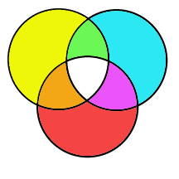
Distinctive features of Sheets:
- It provides the best features of text and structure editing by dividing the system into fragments: individual code definitions, documentation paragraphs, etc.
- Fragments are grouped into sheets, which provide all the traditional capabilities of text files and more.
- Sheets allow the viewing of many fragments at a time, and allow them to be manipulated by familiar techniques such as search and replace.
- Fragments have no single home; they can appear in multiple sheets and be can be edited anywhere they appear. This permits multiple persistent organizations of the system.
- Any fragment can be viewed at multiple levels of detail, or in alternative ways (such as graph nodes, change logs, etc).
- There is a unified data presentation. Even special purpose "help", "compiler errors", or "search" windows use the same methods for finding, navigating, and editing the contents as "ordinary" windows.
- Users can create documentation fragments and cross-link them to the corresponding code.

Future Plans
- Sheets will support other languages that can complement Java. Possibilities include Architecture Description Languages, process languages, and other programming languages such as C++.
- Sheets will allow arbitrary annotation and inter-connection of fragments.
- Sheets will provide the same powerful capabilities for searching and navigating old versions of the system (or individual fragments) that we now provide for the current "mainline" version.
- Sheets will provide better multi-user support, with the addition of integrated version control, optimistic concurrency, release management, etc.

Evolutionary Software Development
We believe that evolutionary development is distinguished by its acknowledgment that developers of long-lived systems are always suspended between an imperfectly understood past and an unpredictable future.

In order to modify an existing system to meet new requirements, we must retrospectively understand what the system does and why. We must also prospectively assist future evolution by leaving the system with a comprehensible organization after every change and by providing future maintainers and developers with as much useful information as possible. A little prospective work done at the time of each modification can often save a lot of retrospective work later, but only if the development environment provides excellent support for organizing, saving, and accessing the additional information.

Sheets supports evolutionary development by allowing an effortless flow between the retrospective and prospective modes of development. Retrospective understanding is supported by semantics-based queries of the current implementation and by hyperlink browsing of documentation and past system versions. Prospective propagation of knowledge is supported by the tightly integrated documentation facilities.

Sheets encourages prospective reengineering of the system by allowing reorganization to be done at a meta-linguistic level, eliminating concerns about "breaking" the system. Once a new understanding of the system has matured the user can translate the existing code into a new architecture; this is greatly aided by the retrospective tools already described.

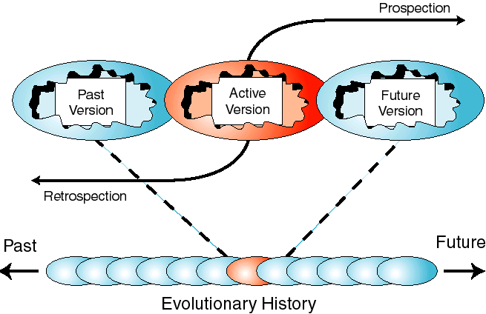

Contact Info
For more information, contact the Principal Investigator, Scott E. Fahlman (sef@cs.cmu.edu), or visit our web site at: “http://legend.gwydion.cs.cmu.edu”.

Current project members:
- Paul Gleichauf (phg@cs.cmu.edu)
- William Lott (wlott@cs.cmu.edu)
- Rob MacLachlan (ram@cs.cmu.edu)
- Robert Stockton (rgs@cs.cmu.edu)
- Stephen Chin (sjc@andrew.cmu.edu)

