The Sheets Hypercode Editor
by Robert Stockton and Nick Kramer

Introduction

General Overview – Fragments Inside Sheets
The Sheets Hypercode Editor (henceforth referred to as SHEETS) is a prototype development environment that introduces some significant new models for organizing, viewing, and editing program code. It operates by dividing the code into small self-contained objects (which we refer to as fragments) and then organizing them within file-like containers that we call sheets.
Like files, sheets provide a linear textual display of the code, and users may directly edit the displayed text in order to modify the program. However, sheets transcend the purely textual view in several ways. Firstly, a single fragment may be contained within several sheets, thus allowing multiple simultaneous organizations of the same code. Secondly, a sheet supports several different textual views of a fragment. In addition to the full textual view, the user can choose several abbreviated summary views, ranging from the fragment’s name, through a one-line summary of its interface, up to a commented header. The user can also expand the view to display (and, perhaps, edit) other properties, such as error messages, which are not inherent in the text of the fragment.
Fragments make up the basic unit of structure for program code. Each fragment typically corresponds to a single class, field, method, comment, etc., and encapsulates not only the text that comprises its code, but also derived information, such as information on methods which it calls, and possibly arbitrary user annotations.
SHEETS enforces hard boundaries between different fragments in a sheet. The user makes changes to individual fragments rather than to the entire program. If he introduces syntax errors, their effects will be limited to the fragment in which they were introduced. Adjacent fragments will be unaffected.
In figure 1, we see a typical SHEETS window. In the largest pane, we see a typical sheet. The fragment with a black border is the selected fragment, and is in the FULL view. The other fragments in the sheet are in the HEADER view, which shows the interface but not the implementation. (In the gray bar to the left of the main panel, the little shapes indicate which view is currently selected. A circle indicates a FULL view, while a square indicates the HEADER view.)
To the left of the sheet, we have a table of contents (or TOC) pane, which allows quick navigation of the more detailed main view. Although it looks much like similar facilities in other environments, it is actually just another view of the same sheet (and is thus automatically updated to reflect any changes to the main view). The TOC pane is constrained to show fragments in the SHORT_NAME view, which gives an abbreviated form of their names. The two panes are connected so that an item that is selected in one is also selected in the other.
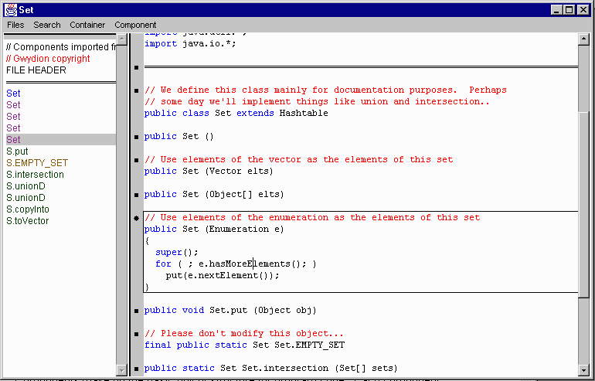

Figure 1 – A typical SHEETS window

Language Support
At its core, SHEETS provides a language-independent framework for editing structured objects with a textual representation. However, SHEETS also provides facilities for creating language-specific support. We've used these facilities to implement support for the Java programming language, and in the future will add extensions for other languages.
The fragment model proves to be very useful in implementing language-specific support. Small bite-sized fragments provide a very natural boundary for many operations. Parsing can be performed more quickly because SHEETS need only process changes to single fragments. Error recovery becomes much simpler because errors will never propogate beyond the scope of a fragment.. Dynamically maintained lists of fragments (such as error lists or identifier completions) can be displayed simply by placing the fragments within special-purpose sheets. (Such sheets can set the views of the fragments to optimize for compactness or completeness, and can allow in-place editing of their contents.) We will examine all of these functions in more detail later.
As implementers, we can choose the level of support to provide for any given programming language. We could use simple heuristics to break text into fragments, or we could use a full parser. We can perform full semantic analysis, or none at all, or anything in between. We can also choose whether or not to provide syntax highlighting, automatic indentation, or context-sensitive help. The SHEETS framework helps implementers with all these things, but doesn't require them to be implemented.
It's important to realize that the SHEETS framework is not strictly necessary to implement any of these functions; other programming environments implement some of the same features without using fragments. However, SHEETS does greatly simplify their implementation.

Sheets and other containers
As described above, users may embed fragments in sheets in order to display, organize, and edit these fragments. Sheets are, however, simply one example of the more general class of containers. Other common varieties of containers include class- and call-graphs..

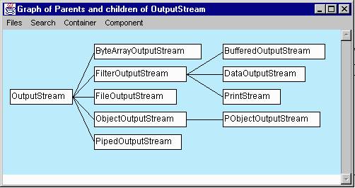

Figure 2 – Graphs are another variety of container
Containers are defined by the obvious: they hold fragments. However, they also provide an organization to the contained fragments. In the case of sheets, they provide a very simple (but useful) linear ordering. Graphs provide a more complex organization based upon relationships between fragments, and other varieties of containers can provide arbitrarily complex orderings. Since containers are themselves considered to be fragments, users can nest them in order to provide convenient hierarchical organizations.
By grouping fragments together into containers, SHEETS provides a simple way to view many related fragments at once. To our knowledge, SHEETS is the only fragment-oriented environment to support the convenient viewing of more than one fragment at a time. Other environments offer "one at a time" viewing, typically by putting each fragment in its own window. Allowing multiple fragments within the same window may sound like a minor issue, but it provides a substantially different (and, we hope, more intuitive) user model. (If you don't believe us, imagine a word processor that only showed you one paragraph at a time!) This capability also allows us to unify the concepts of “list windows” (such as many environments use for displaying errors) and “edit windows” by simply choosing an appropriate view of the window’s contents.
SHEETS containers allow the viewing and manipulation of fragments while at the same time providing a familiar interface to the user. Sheets, for example, should be comfortably similar to files. (In fact, it is easy to convert sheets to and from files if desired.) However, in addition to normal viewing and editing, sheets allow the user to select the amount of detail to be viewed, and to trivially reorder fragments via drag-and-drop.
In SHEETS, containment is not an exclusive thing — a fragment can be included in more than one container. If a fragment conceptually belongs on more than one sheet, you can put it on both. And if you don't like the way your co-workers have organized their code, you can create an alternate organization without disturbing the original one.
This multi-organizational capability is a cornerstone of SHEETS. SHEETS uses this, for example, to display query results, context-sensitive help, and compiler errors. Since it allows direct manipulation of fragments within sheets, users can edit the code within query windows (and compilation error windows) and be confident that the changes will be properly reflected in other (more permanent) sheets.

Views
As mentioned above, each fragment can be displayed in a wide variety of views. Each fragment is required to support a set of five standard views, although some fragments support more.
Most views are purely textual, and allow us to navigate through (and potentially edit) that text. However, some fragments (such as graphs) may choose to display themselves in a non-textual form.

Standard Views
The standard views are designed for viewing the fragment on a sheet (which is the most common way to view a fragment). The standard views are:

FULL: A view that displays everything about the fragment. For fragments with a text representation, the full view is simply the complete text of the fragment.

HEADER: A view that gives a fairly verbose description of the fragment, while leaving out implementation details. (For instance, a Java method's header view will include the parameter list and documentation comments, but won't include the method body)

SUMMARY: A single line summary of the fragment.

NAME: The complete name of the fragment.

SHORT_NAME: An abbreviated version of the NAME view. (SHORT_NAME views were designed for the table of contents, where space is at a premium.)
By convention, the SUMMARY, NAME, and SHORT_NAME views are expected to fit within a single line of text. This allows us to do very concise displays. The FULL and HEADER views can contain text or graphics of arbitrary size, and are expected to contain sufficient information for detailed browsing and editing.

Specialized views
Although the standard views are sufficient for most purposes, sometimes it's useful to define special purpose views. For instance, the TOC panel uses a view that looks like the SHORT_NAME view, but won't allow the user to switch to another view.
Since we can’t expect the implementers of every fragment to anticipate every specialized view that might ever be needed, we typically provide a default implementation of the specialized view that uses the same building blocks provided for the standard views. Of course, if the fragment's implementer is aware of the specialized view, he can override the default implementation of the view.
The edit view is a specialized view of particular importance. An edit view provides a view of a fragment in transition – it is being actively modified by the user, and need not be syntactically correct. Within the edit view, the fragment is treated as arbitrary text that may eventually become a complete fragment. Edit views are displayed with a pink background so that they can easily be distinguished from normal views.
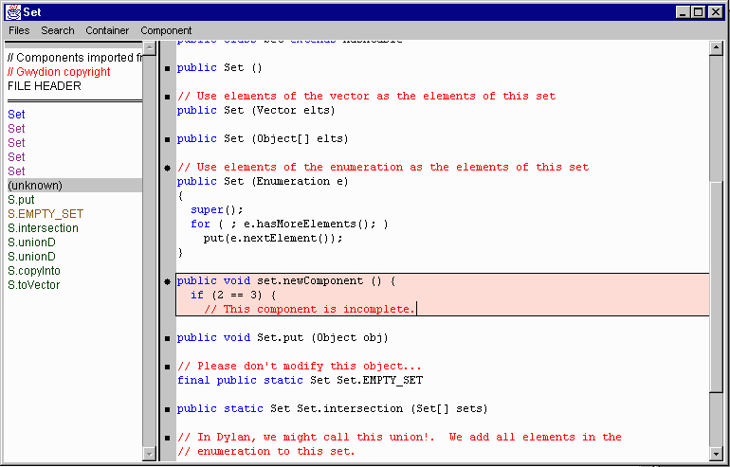
Figure 3 – An edit view

Fragments in depth

Granularity
The division of text into fragments is, in some respects, an intuitive one. It will tend to follow the natural boundaries within a programming language or document – be they functions and variables, or simply paragraphs. However, there are some criteria that should be followed: Fragments should make some degree of sense even when taken out of context, and they should be as small as possible. For example, we choose to separate Java class headers from their methods and fields in order to keep the fragments sufficiently small.
By making fragments small, we gain many advantages. For one, it allows a greater number of potential arrangements and presentations of fragments. Query results can be more specific, and documentation can refer to just the relevant parts of the program rather than large chunks of code. It is also precisely this capability for rearrangement and excerption that makes it necessary for fragments to be meaningful outside of their basic context, which in turn limits how small a fragment can be. For Java, we believe that a single method is meaningful out of context, but that anything smaller (such as an assignment statement) would not be.
Small, self-contained fragments also simplify semantic analysis. As the user makes changes, SHEETS can do complete internal analyses of small fragments and combine them with stored information from past analyses of other fragments. The same boundaries between fragments that allow flexible presentation tend also to be useful boundaries for incremental analysis.
Fragments provide a natural boundary for allowing a user to undo editing operations. SHEETS provides capabilities for both character-at-a-time and whole-fragment undo.
Finally, the divisions between fragments can potentially serve as the basis for fine-grained history tracking. Although we have not yet implemented any revision control or change-tracking facility, we believe that traditional file-based versioning is the wrong granularity to serve our purposes. We expect the finer granularity provided by distinct fragments (combined to form versions of the entire system) will fulfill our needs nicely.

Text vs. Structure
As we have noted before, most fragments can be viewed and even edited textually. This property makes it easy to confuse the text with the fragment itself. Fragments are really structured objects that can hold arbitrary information, be it simple derived data such as parse trees, or arbitrary user annotations.
Whenever possible, however, we wish to be able to display the fragments textually, and to convert text into complete fragments. The reason for this is quite simple – it is what users are accustomed to manipulating, and it is what the current generation of programming languages is designed for. As stated before, our goal has been to salvage the useful aspects of familiar file-based development environments while freeing the user from many of the limitations of those environments.
The textual aspect of our fragment model is particularly important when a fragment is being actively edited. Past experience with structure editors has shown that it is very awkward to work only with syntactically correct code. The intermediate stages of development within a function simply don’t tend to be perfectly structured, and this need not be a problem so long as the user finishes with a well-structured fragment. In SHEETS, when the user declares that he is done editing the fragment (which we refer to as committing the edit), it attempts once more to interpret the fragment as a structured object. Committing is a frequent and simple operation; typical edits are committed after a few minutes, or even seconds. (It may sound awkward to explicitly declare when you're done editing a fragment, but our experience has been that this is not the case.)
The free textual editing process makes it much easier for the user to control the formatting of his code, and to place comments and blank lines where needed. The user’s original text and formatting are maintained essentially intact, although SHEETS is allowed to make small changes.

In-place Editing
As noted above, SHEETS allows users to edit most fragments as simple text. Rather than pop up a “text edit” window, it allows the user to edit fragments in place. Most of the time, a user can simply start typing anywhere he sees a piece of text. If the user wasn’t already editing the fragment, SHEETS will shift the fragment into an edit view, which will be highlighted to reflect the potentially incomplete state of the fragment. All navigation commands will continue to work, but they will be augmented by the usual text editing operations.
The user can simultaneously edit as many fragments as he wishes, and can combine editing operations with all of the normal browsing functions. There is no global edit mode for the development environment – just for individual fragments.

Replacement Model
When the user is done editing a particular fragment, he typically commits the edit. At this point, SHEETS analyzes the final text and converts it into one or more new fragments that completely replace the original fragment. This can be a bit confusing at first – the process of editing a fragment doesn’t actually change the fragment at all, but instead creates new fragments to go in its place. Fragments which are replaced are replaced everywhere they occur. No references to the original fragment will remain.
We chose the replacement model for a simple reason. Since SHEETS allows arbitrary textual manipulation during editing, the resultant text may not correspond to the same sort of fragment, and may indeed be better interpreted as several different fragments. For example, if the user edits a Java method by placing “//” at the beginning of each line, he will no longer have a method – he will have a comment instead.
If the user types a new field declaration at the end of an existing field, he will have two different fields, rather than a single fragment comprising two fields. Users can usually add new fragments by simply typing in new text in any appropriate spot. This provides an elegant alternative to other fragment oriented environments, which require you to invoke specialized commands to create new fragments. Similarly, if he deletes all of the text for a method, he will replace it with nothing at all, which effectively deletes the method.
Since there are many different types of fragments, it could be potentially difficult to figure out which sort of fragment correctly reflects a new piece of text. We handle this problem by dividing fragment types into families, each of which is moderated by a language expert. For example, the Java language expert uses a parser to determine the difference between a comment and a method. A Text language expert could simply extract paragraphs by looking for blank lines. In any case, a language expert will always choose to replace an edited fragment with other fragments which it moderates.

Queries
The facilities we’ve described above are perfectly suitable for editing programs, but taken on their own, they don’t yet fully exploit the capabilities of the SHEETS framework. The real strength of the model becomes apparent when we introduce the ability to create new sheets (or graphs) on the fly using queries.
A query is simply a search that returns some subset of the currently defined fragments. If there is only one fragment that matches the search criteria, SHEETS can take the user to a sheet that contains the fragment. However, when there are multiple matching fragments, SHEETS can either find an existing sheet which contains all of them, or create a new sheet to contain them.

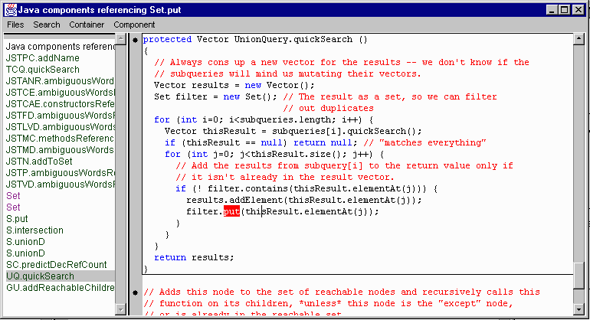

Figure 4 – Queries can generate new sheets
Although the new sheet is purely temporary (unless the user explicitly makes it persistent), it is nonetheless possible to simply edit the fragments in-place on the new sheet. When the edits are committed they will automatically affect all other sheets. Even if the user splits a fragment into several fragments, the replacement semantics described above ensure that all of these routines will also find homes within their “original” sheets.
The language independent portion of SHEETS implements only a few universal queries for arbitrary text matching and for errors, but language experts can define new language-specific queries. For example, our Java support lets you search for definitions of or references to any Java class or member, the members of any class, or the inheritance hierarchies for a class or method.
SHEETS maintains indices for these queries, so performing a query is almost instantaneous. It can use relatively crude techniques to maintain the indices—since it can do the analysis incrementally, performance is not typically a problem.
We generally try to keep the indices simple, so that index maintenance can be fast and error-free. (Our experience with the Gandalf project has led us to believe that complicated indices are an endless source of potential bugs.) For instance, to aid with Java reference queries, SHEETS tracks which words a fragment references. To find all references to a particular method named “foo”, it finds all references to anything named foo, and then filters out the fragments that don’t reference the particular foo it is seeking. Maintaining an index of words referenced is quite straightforward; thinking of all the ways that a more complicated index could be invalidated is not nearly so easy.

Language support
SHEETS can provide support for multiple languages through language experts. Each language expert can provide a new family of fragment types, ways of converting from text into those fragment types, user commands, analysis tools, and queries. Through the new fragment types, it can also provide specialized display and highlighting capabilities.
At present SHEETS only supports two languages. The Text expert provides simple textual fragments and graphical separators. (An example of a separator can be seen towards the top of Figure 1.) The Java expert is much more sophisticated, and provides an excellent demonstration of what can be accomplished through the SHEETS framework.

Java Fragments
Most of the fragments in the previous figures are managed by the Java language expert. For Java, we have chosen to implement a full parser to convert text into fragments. The parser divides the Java source into individual class headers, fields, methods, comments, etc. There is a separate fragment type for each of these categories. In addition, there is an “unknown” fragment type which represents text that is not syntactically correct Java.
In order to make fragments more meaningful when taken out of context, we have actually made a small change to the syntax of Java. Rather than insisting that fields and methods be syntactically contained within a class, SHEETS includes the class name as part of the fragment’s name. Thus, instead of embedding the method put inside the class Set, it instead uses the name Set.put for the method fragment. Of course, whenever it exports a class by flattening it to a file, SHEETS can easily reverse these syntactic changes.
Java fragments also perform syntax highlighting, using the same tokenizer that the parser uses.

Incremental Analysis
SHEETS allows language experts to incrementally maintain semantic information by registering sentinels. Sentinels are invoked whenever fragments are added, deleted, or replaced. They can maintain whatever auxiliary data they need to support queries, error detection, context-sensitive help, etc.
The Java language expert defines several sentinels. The index sentinel is responsible for maintaining the indexes that allow fast implementations of definition and reference queries. It makes use of information provided by the parser concerning identifier usage. Although the index can grow moderately large, few changes need be made for any fragment replacement, so the cost of maintenance is trivial.
The Java expert also defines semantic sentinels that note any changes to Java fragments, and maintain indices for easy lookup of classes or class members. These same sentinels also notice inconsistencies like non-existent superclasses or constructors that don’t correspond to known classes, and report errors to the user.

Context-Sensitive Help
Although most fragments are displayed, navigated, and edited as if they were simple text, the fragment and its associated views can still make use of language-dependent knowledge and analysis to provide the users with relevant information. The syntax highlighting that we’ve mentioned for Java is a simple example of this.
However, the SHEETS framework allows for a more dynamic form of language-specific help. Every time the text cursor moves, the fragment view is notified so that it can provide information relevant to the current cursor location. The view can either update itself (e.g. by highlighting balanced parentheses) or it can set the contents of a special context-sensitive help sheet. This sheet is usually visible in a window of its own, which is set off in a corner so that it won’t tend to be obscured by other sheet windows.
The Java fragment views make extensive use of this capability. Using the tokenized contents of the view and the incrementally maintained semantic information about all Java fragments, it can very quickly analyze the expression underneath the user’s cursor and identify precisely which fragment (or fragments) it is likely to represent. SHEETS displays that fragment in the context-sensitive help sheet, along with the fragments for enclosing functions. If the cursor is at the end of a partially completed identifier, SHEETS also identifies every meaningful completion of the identifier within the given context. (For example, it would know that ((String) foo).le must refer to the length method for Java strings, and not the leaveGroup method for sockets)
Because the context-sensitive help sheet is, in fact, a sheet, all of the standard facilities are available. The user can select fragments in the context-sensitive help sheet, expand their views from the default SUMMARY view for more detail, use them as the targets of queries, or even (if he really wishes) edit them directly within the context-sensitive help sheet.
Note that SHEETS can use this information for purposes other than merely showing helpful information. It can, for example, automatically type completions for incomplete identifiers, or let the user make hypertext-like jumps to referenced fragments with a single mouse-click.

Data Storage and Interchange
The primary repository for user data in SHEETS is the system database. To avoid legal entanglements, we actually wrote our own object-oriented database (OODB), but there’s no technical reason why we couldn’t have used a commercial off-the-shelf OODB. The system database is what SHEETS uses for day-to-day operations; it stores not only the fragments themselves, but also the indices that SHEETS maintains to speed up querying, “undo” information, etc.
However, for interchange purposes, we’ve needed a second format, which we call a dump file. Dump files contain only the fragments themselves, and not any of the derived information (such as indices). For this reason, dump files are much more compact than the system database. They are also more stable than the database schema, and thus can be used to migrate the database when we add new indices or change data representations. Dump files are also ASCII text, which means that, in a pinch, they can be read and fixed by hand. Because they are text, dump files can even be used with existing version control systems like RCS and CVS. (Because of the size of the dump file for any significant system, CVS does not handle code merges as well as we might hope. In section 9, we describe our plans for a version control system specifically designed for hypercode.)

Surprising results
SHEETS has always been a research vehicle and, as such, has given us the capability to experiment with serious development using the sheets-oriented model. We have almost exclusively developed the SHEETS code using SHEETS itself. The current implementation is roughly 30,000 effective source lines of code (ESLOC) — about 5,000 fragments and 130 permanent sheets. (Approximately one quarter of this — 8000 ESLOC and 1200 fragments — comprise our Java support.)
SHEETS has turned out to be even better than expected as a tool for program exploration and understanding. As we have added new developers to the SHEETS project, they have used SHEETS to very quickly gain an understanding of the body of code, and have been able to become productive in a surprisingly short time.
Although we had correctly believed that the capability of sharing fragments across sheets would be a useful one, we have come to realize that it is not necessarily useful in the ways we had expected. We expected to find users building sheets that contained several organizations of shared fragments, or making query sheets permanent for documentation purposes. Instead, we have found that most fragments live on a single permanent sheet. Users frequently create new sheets from queries and edit the shared fragments inside the query sheets, but it is easier to discard the sheet when finished than to save it. (After all, it can be trivially recreated at need.) It seems that the existence of powerful and efficient dynamic queries has made it less important to provide complex static organizations.
The usefulness of sheets for storing ephemeral context-sensitive help only occurred to us after we started using the system for serious editing, but it has served us well. The existing display, navigation, and query facilities made implementation easy, and the uniform model is more convenient for users. For example, the TOC pane, although not novel in function, also proved surprisingly easy to implement using the capabilities of the framework.

Future research
Although SHEETS is already an extremely useful tool, it also provides an excellent enabling framework for future research. We plan to implement a wide variety of additional capabilities on top of the framework.

Additional Languages
A large part of our effort has gone into implementing complete support for the Java language while keeping a language-independent framework. However, until we add support for more languages, we won't know for sure if our framework is truly language independent.
We believe that SHEETS will be relatively easy to adapt to most traditional programming languages. It will be interesting to see how it can be adapted to less traditional programming languages, and to text-processing languages such as XML. We expect to encounter challenges in handling arbitrary nesting (such as is found in XML) or languages that depend very heavily upon file-based cues for code ordering.

Versions and History
Like almost all programming environments, the current version of SHEETS is not well integrated with version control systems. SHEETS has some provisions for working with traditional text file-based version control systems (like RCS and CVS), but doing so is still awkward. In the near future, we will be writing our own version control system that integrates well with SHEETS, and takes advantage of the fine granularity that fragments offer. The SHEETS version control system will work simultaneously at the fragment and program level. Other version control systems use a single granularity, usually the file, which is a poor choice because not all operations work best at the same granularity. Many operations, such as retrieving old versions or checking in new code, work best on entire programs. Other operations want a much finer granularity — when tracking a bug, for instance, it would be nice to know the version history of a single method, rather than the history of the file that contains it. Merging two developers’ work together is an operation that responds particularly well to fine granularities because of the reduced number of merge conflicts. Fragment-based merging is also better able to handle code movement: SHEETS will see a relocated fragment as the same fragment in a new location, rather than as an unrelated set of added and deleted lines.
Even more interesting than simple version control, however, would be the ability to browse historical information in the same way that we can now browse the current code. Simple queries might return old versions of a single fragment, but other queries could track all fragments that are somehow derived from some old (or even current) fragment. (For example, if we copy text from one fragment and paste it into another, the resulting new fragment will be derived, in part, from the first fragment, as well as from its obvious predecessor.) If SHEETS tracks derivation at a very fine level, it can weave a very complicated web of information. However, it should be able to provide capabilities to allow the user to easily extract useful information.

Non-code Fragments
At present, SHEETS is primarily a code editor (and browser). While we believe that the ease with which you can navigate between fragments qualifies it for the rather lofty title of “hypercode editor”, we have further plans for the “hypercode” concept.
SHEETS and its fragments should be able to represent (or refer to) any information which is relevant to the program. This includes documentation (both programmer and user documentation), testing code, change logs, and e-mail discussions. Ideally this information could be in any format, from open standards like ASCII and HTML to proprietary formats such as Microsoft Word.

Conclusions
SHEETS makes a highly effective programming environment for experienced programmers. Although it does not have tightly integrated compilation and debugging support, for the task of code development it nonetheless equals and frequently exceeds the capabilities of commercial development environments.
The combination of SHEETS fragments and containers provides a new model for display, navigation, and modification of program code that has proved highly effective in practice. SHEETS has not only been easy for users to adopt and use effectively, but the framework has proven to simplify the implementation of many desired features. Thus, we have been able to provide the various capabilities (such as basic editing, syntax highlighting, etc) that are expected of modern development environments with a minimum of effort. We have also been able to enhance them with features such as queries, context-sensitive help and completion which are not typically found in other environments.

Our current implementation operates primarily upon the Java language, and thus we are using its terminology. We could just as easily refer to C “structs”, variables, and functions or to the fundamental building blocks of any other programming languages.
Since a single component can appear in more than one container, the actual relationship is inclusion, rather than containment. However, it is easier to talk about containers than enclosures, so we have stuck with the less accurate term.
For example, SHEETS often modifies Java code by qualifying the name of a class member with the name of its class.
See section 6 for more details.
Users typically don’t have to explicitly specify the class name, as SHEETS can almost always pick it up from context.
When we talk about the context-sensitive help sheet, we are also typically referring to the dedicated window that displays it. Although they are distinct objects, they work together to provide a unified presentation to the user.

