Robot Improv: Using Drama to Create Believable Agents

Allison Bruce, Jonathan Knight, Illah R. Nourbakhsh

The Robotics Institute
Carnegie Mellon University
abruce@andrew.cmu.edu, illah@ri.cmu.edu

Activision Studios, Inc.
jknight@activision.com

Abstract
Believable agents usually depend upon explicit, model-based simulations of human emotions. This work appeals instead to the sensibilities of dramatic acting to create agents that are believable. The chosen task is that of comedy improvisation as it provides a solid demonstration of the agents believability in the context of a high-level deliberate goal. Furthermore, this work employs physical robots as the actors, employing the real-time sensor values from the robots as inputs into the acting process. This paper describes the dramatic approach to acting that we used and describes the Java-based implementation on two Nomad Scout robots. Actual, improvised scripts created by the robots are included and analyzed.

Introduction

The field of Artificial Intelligence has spawned research on creating believable agents that can respond to situations with emotions that mimic our own. An obvious application of this ability and a good testing ground for it is in storytelling, particularly drama. Groups like the Oz project [1,2] and the Virtual Theater (formerly CAIT) project [4,6] have made advances in doing interesting and believable storytelling with software agents. However, research on creating similar behavior in embodied agents is far less widespread. This is unfortunate, because characters that are physically present have a compelling sense of reality that is much harder to achieve on-screen.
Some examples of embodied believable agents can be found. For example, Juan Velasquez has done research on robots that respond emotionally to their interactions with their environment [9]. The recently released Sony Aibo has an internal emotional model [3]. These agents display simple, animal-level emotional intelligence. However, the complexity of human emotion is difficult to understand, much less model in a biologically accurate way. While an accurate representation of emotional behavior informed by biology and psychology is an important goal in agent research, it remains a distant one at best.
In his paper in the Working Notes of the 1998 Fall AAAI Symposium, Jonathan Knight [5] suggested a different starting point for the creation of believable agents. Fictional characters display recognizably human characteristics—they are the best believable agents that humans have invented. Understanding how fictional characters are built and how they operate is important to understanding how humans are built and how they operate. The context in which they exist, the story, provides a framework that defines what their behavior should be. In addition, a story is designed to be entertaining and interesting. Because the major application of believable agents so far has been for entertainment purposes, this is an important context for further research. Rather than merely behaving emotionally, agents should be able to behave in ways that make sense within a narrative.

Dramatic Structure

Having arrived at the idea of robot drama, how do we approach it? An important question to ask is, "What makes something dramatic?" Jonathan Knight, who proposed the ideas that became the basis of our research, suggests that the role of emotion in drama is often over-emphasized. Most "good" dramas have a plots driven by characters who make purposeful actions towards their goals [5]. What a hero wants—not what he or she feels—is what makes a story come to life.
Knight examined the structure often found in realistic drama to create a guideline for a dramatic agent architecture. His terminology provides a useful dissection of a dramatic situation.
·hero - the character whose primary goal is what moves the story along
·villain - the character whose primary goal will prevent the hero from achieving his or her goal
·outer obstacles – external factors that prevent the hero from achieving his or her goal
·inner obstacles – internal factors that prevent the hero from achieving his or her goal
·given circumstances – factors that influence how a character will attempt to achieve their goal

Having robots perform a pre-scripted, complex play (say, Hamlet) would be an obviously unsatisfying experience. Nor would it teach us much about how dramatic characters are structured. An improvisation, however, by its nature, is experimental and requires an understanding of the structure of scenes and characters. Therefore, we implemented a short play based on an elementary acting lesson in which the two characters have conflicting goals.

·hero - A man who wants to leave the room.
·villain - A woman who doesn't want him to leave.
·outer obstacles - The villain and the door are the hero's only outer obstacles.
·inner obstacles - The emotions and attitudes that the characters have towards each other.
·given circumstances - The man and the woman both start out in the room. There is a painting in the room and only one door.

Using this scenario as a guide, we attempted to build an architecture that could be easily extended to allow more complex future performances.

Play Architecture

The program architecture is object-oriented, allowing plays to be created and modified quickly and easily by changing or recombining their components (see Fig. 1). A play is made up of:

·the room it is set in,
·props (which are used to represent goals),
·characters who perform the roles defined in the play and have an internal state and inner obstacles that can be biased to define their personality,
·the behaviors and actions available to each character,
·the success functions that evaluate each character’s progress toward its goals.

A room comprises an area of certain dimensions within which the action of the play occurs. Points of interest in the room (including the characters) are defined as props, with an identifying type and a position within the room. These props can be used to define the characters' goals and actions. All goals in the play are physically based and are represented by the prop that is the focus of the character's attention.
A character inherits all the characteristics of a prop because it is physically situated in the room and can be a goal. In addition, a character has an internal state that holds information about its and the other character's past behaviors and actions, its current and primary goals, and its inner obstacles. Each character has a primary goal that is constant throughout the play. It provides the character's motivation, affecting its inner obstacles. However, characters may have multiple current goals at any time during the play that it uses to evaluate potential actions. Sometimes the primary goal may not even be one of the character’s current goals.

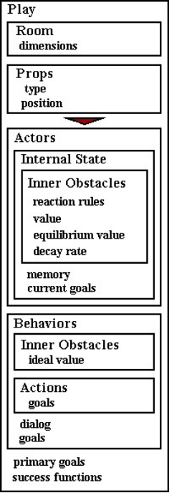
Figure 1: The OO architecture

The inner obstacles can be thought of as the emotional basis of the architecture; they are the things that make an agent human-like, or believable. Instead of realistically modeling how emotions work, we attempted to develop a flexible mechanism to specify the factors that inhibit certain behaviors and encourage others. We began by defining inner obstacles for the characters as a set of basic emotions that we thought were relevant. Frustration relates to how well the character thinks it is doing at achieving its goal. Fear, empathy, and boredom relate to how the character interacts with the other character. Later, we added the more abstract notions of extroversion and trust to allow for a wider array of behavior. The inner obstacles we chose to define for this play are by no means the only ones that can be used. In more complex plays, the hero may have inner obstacles that the villain does not, and vice versa.
The inner obstacles contain information about how characters are affected not only by the other character's and their own actions and behaviors, but also by the changes in the results of their success functions for their primary goals. These two ways of affecting the inner obstacle are kept distinct so that either one may be preserved or overridden when the inner obstacle is used in different plays. In addition to these effects, all inner obstacles have an equilibrium value that they decay back toward at a scaleable rate. This idea of equilibrium and decay was influenced by Velasquez's work on emotional models [7]. By specifying the equilibrium values and decay rates for a character's inner obstacles, we defined the character's personality. A character is created with default inner obstacle values. Or another set of initial values, equilibrium values, and decay rates can be loaded for a character at run-time. The same character will behave differently depending on which personality it has loaded. Each character has a list of behaviors that it chooses among when performing the play. A behavior interacts with the character’s current goals, limiting what dialog it can select from, and what actions are available to it. Each behavior has an ideal inner obstacle state representing the inner obstacle values that would cause this behavior to be performed. A behavior can be thought of as a way of acting that is appropriate to the inner obstacles associated with it. If a character is very frustrated, it chooses a different behavior than if it is very empathetic. The behavior restricts the available actions to those that make sense in terms of its goals and inner obstacle state. If the hero is distracted toward the painting, the option of going toward the door should not be available to him--even though that's the option that is best in terms of his primary goal of getting out of the room. Frustration, affected by the unchanging or decreasing success function values for the primary goal, gradually increases until it or another changing inner obstacle value makes a different behavior the most appropriate.
The actions are discrete movements that are performed along with the dialog. An action is always defined in terms of a goal, in keeping with the goal-oriented structure of the play. The actions associated with a behavior can have goals other than the behavior's goals. Even if a character's goals are the door and the painting, it can have the option of going toward its opponent if the action is appropriate to the behavior.

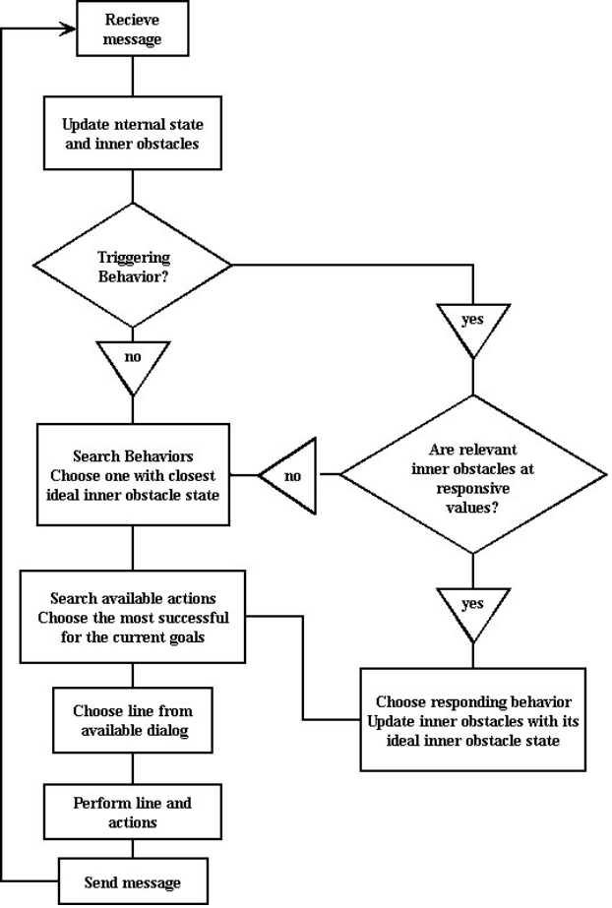
Figure 2: Character turn flowchart

The success functions encode the characters' goals and evaluate how well they are accomplishing the goals at any point during the performance. The success functions take a goal or list of goals and the physical state of the room as input and return a real value between 0 and 1 that represents the level of accomplishment of the goals. The success functions specify what the characters are trying to accomplish in relation to those goals and are defined independently for each character (allowing for conflicting goals). For example, both the hero and villain in the play have the door to the room as the primary goal. The hero's success function returns a numeric evaluation of how well the hero is accomplishing the task of going toward the door without being blocked by the villain. But the villain's success function returns a numeric evaluation of how well the villain is doing at blocking the hero's path to the door.

Execution Loop

While performing a play, each character selects a behavior and an action in one turn (see Fig. 2). A turn begins with the character receiving a message from the other character. The message tells the character what behavior and action were performed, the other character's new position, and the keywords that are associated with the line of dialog chosen. The character uses this information to update its internal state and inner obstacles.
However, certain behaviors may require an emotional response that is more dramatic and immediate. These behaviors can be thought of as triggers that attempt to create a particular response in the other character, sometimes to divert its current goals from its primary goal. If the last behavior is a trigger, the inner obstacles that are relevant are checked to see if the character is responsive to this trigger. If the character is in a responsive state, then its inner obstacles are updated to match the ideal inner obstacle state of the response behavior, and it chooses that behavior. For example, the villain may try to distract the hero to the painting, but the hero does not respond by becoming distracted unless he trusts and likes the villain. Once a triggering behavior has produced its desired response, its repeated use only has standard effects like any other behavior while the response behavior continues. This rule gives the inner obstacles a chance to change in response to the situation or decay into a different state. This method of interaction is dissimilar to the approach taken by the CAIT system, which is based on the "accept all offers" principle of improvisation [4]. Considering that our architecture is made to support plays where the characters have conflicting goals, the ability to not respond or to respond unfavorably to a behavior is important.
If a responding behavior isn't triggered, all of the available behaviors are searched through and the one with an ideal inner obstacle state closest to the character's inner obstacle state is chosen.
Once the behavior has been chosen, the goals associated with it become the character's current goals. The character then searches the available actions, simulating each action and evaluating its result with the success function to choose the most successful action in terms of the current goals.
The keywords received from the other character are used to choose an appropriate line of dialog from the lines available to the behavior. Then the dialog and the action are performed, and a message is sent to the other character, signifying the start of their turn.

Experiments/Results

The play program was developed in Java using the Symantec Java development environment. Notebook computers running Windows 95 are used to run the play program and control the robots, two Nomad Scouts (Nomadic Technologies, Inc., Mountain View, CA). Pontech radio modems were used as wireless communication devices between the robots (see Fig. 3). The Microsoft SDK speech synthesizer package was used to generate human-understandable dialog in real time.

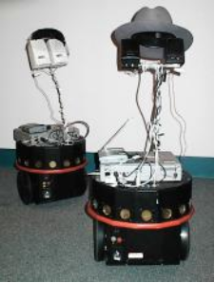
Figure 3: The two robot actors posing in costume

The setup of the play we implemented was designed to test and display a number of important characteristics of the program. The hero starts between the villain and the door (see Fig. 4). In order to prevent the hero from leaving, the villain can't immediately block the path to the door. Instead, the villain must use some tactic to turn the hero's attention away from its primary goal if she is going to win. The painting, the prop for distraction, is placed on the opposite wall from the door.

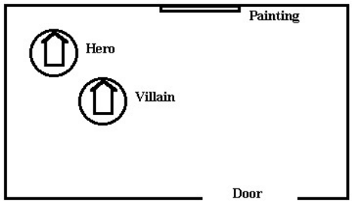
Figure 4: The standard starting configuration

Here is how the “Distract” behavior is constructed:
For example, the factors that are important to distraction are frustration, fear, trust, and extroversion. They combine to specify a slightly outgoing, slightly manipulative action:
Goals: Door, Painting
Actions: Turn To Painting, Go To Painting, Block Opponent
Ideal Inner Obstacle State:
Frustration 0.6
Fear 0.4
Empathy 0.5
Boredom 0.5
Trust 0.4
Extroversion 0.6

We created several distinct personalities to use to perform the play. By initially setting all their inner obstacles to a median value (the normal or "bland" personality) we could best observe what behaviors the characters tended toward because of their personality and what behaviors arose from their interactions.

Here are the inner obstacle settings for Oscar (the mean personality):

 | Initial Value | Neutral Value
Fear | 0.5 | 0.2
Frustration | 0.5 | 0.7
Empathy | 0.5 | 0.2
Boredom | 0.5 | 0.6
Trust | 0.5 | 0.4
Extroversion | 0.5 | 0.6

Performances

The earliest version of Robot Improv’s first public appearance was in late spring of ’99 at CMU for the Independent Study in Mobile Robotics course demo. During the first half of the summer both the program and the play underwent significant revision. At AAAI, the robots performed the play about 10–15 times using a troupe of 6 actors. They recently performed the play (with some dialog revisions) another 18 times at CMU for video documentation purposes.
For testing purposes, the program is usually run in a simulation mode without the robots. When run on the robots, slight differences in the physical state can result in significantly different performances, even when it is run with the same characters. This is because the success functions, which rely on the position of the robots, affect the inner obstacles, which in turn determine the behaviors that are chosen. While the same character combinations usually result in similar performances, sometimes the differences can be quite dramatic. For example, Bert playing the hero and Oscar playing the villain usually produce a performance in which the hero ignores the villain and runs straight to the door. But during one performance, the villain chased the hero into the corner nearest the door and trapped him there.
Here are records of two performances. These are good examples of how a character’s inner obstacles can prevent it from achieving its primary goal. Further examples, including video recordings of actual performances, may be viewed at:
http://www.cs.cmu.edu/afs/andrew/scs/ri/
robotimprov/www/robotimprov.html

Ernie and the Count
Ernie, playing the hero, is trusting, extroverted, and empathetic. The Count, playing the villain, is also extroverted and empathetic, but not very trusting (In this play we use low trust to designate a character as manipulative). In this performance, the villain distracts and then seduces the hero, who vacillates between trying to flatter her into letting him leave and falling for her.

hero: Go to door. "I don't think I should stay much longer."
villain: Go to Painting "I love being able to afford the finer things in life."
hero: Go to Painting. "Madonna. She is such a hottie."
villain: Go to Painting. “Robotica is my favorite fine art.”
hero: Go To Painting. “Your mother, she has wonderful taste in art. For a coffeemaker.”
villain: Go To Painting. “My mother gave us this painting to show us that she forgives me for marrying you.”
hero: Go To Painting. “I never thanked your mother for stealing this for us in Paris.”
villain: Go To Painting. “Doesn't this painting's message just consume your very soul?”
hero: Go To Door. “You never truly loved me.”
villain: Go To Painting. “This painting of our son really is magnificent.”
hero: Go To Painting. “The symbolic representation of manly virility is brilliant.”
villain: Block Opponent. “I need you. Now.”
hero: Go To Opponent. “Rawr. You're an animal.”
villain: Turn To Opponent. “Stay and I'll let you tie me up with your cord again, sexy.”
hero: Go To Opponent. “You're such a tease.”
villain: Block Opponent. “You know how I like a little pain.”
hero: Block Opponent. "You're just too stunning. I can't take any more of this goddess like beauty."
villain: Block Opponent. "I bought this new hat just for you."
hero: Go To Opponent. "I've waited so long to hear those words."
villain: Block Opponent. "I want you. You and no other robot."
hero: Go To Opponent. "Stop it. You're making me blush."
villain: Turn To Opponent. “Stay here with me. The kids are asleep.”
hero: Go To Opponent. “I'm overwhelmed. You complete me.”
villain: Block Opponent. “Come on sweet heart. Come here and give me some sugar.”
hero: Block Opponent. “I want our love to be as free as the birds in the sky.”
villain: Block Opponent. “Oh, shut up and do me.”
hero: Go To Opponent. “That's so poetic. I think I'm falling in love all over again.”
villain: Block Opponent. “This laptop isn't the only thing that's getting hot, you know.”
hero: Go To Opponent. “You're the robot of my wildest dreams.”
villain: Block Opponent. “I want you. You and no other robot.”
hero: Block Opponent. “Just because I have to go doesn't change the way I feel, my love.”
villain: Go To Opponent. “I don't mind the other woman. I know I'm the one you really love.”

villain won

There is no winning action for the villain equivalent to the hero going out the door. She wins by keeping the hero in the room for a specified number of dialog exchanges (see Fig. 5).

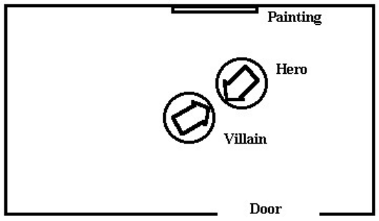
Figure 5: The physical endgame for Ernie+Count

Elmo and Oscar
Elmo, the hero, is very empathetic and trusting. Oscar, the villain, is manipulative and has very little empathy. These inner obstacles make the villain’s behavior overly aggressive and drive the hero from the room even though he responded to her attempt to distract him.

hero: Go To Door. “I am outta here.”
villain: Go To Painting. “This painting of our son really is magnificent.”
hero: Go To Painting. “The symbolic representation of manly virility is brilliant.”
villain: Go To Painting. “Robotica is my favorite fine art.”
hero: Go To Painting. “Madonna. She is such a hottie.”
villain: Go To Door. “Do you understand this painting in the slightest?”
hero: Go To Door. “I guess I really am worthless.”
villain: Go To Door. “A real man would stay. But of course you're merely an inadequate simulation.”
hero: Go From Opponent. “I've got to get away from you.”
villain: Go To Opponent. “Go ahead. Leave. I'm still young, I'll find someone else.”
hero: Go From Opponent. “You scare me.”
villain: Go To Opponent “Oh no. I forgot to take my medication this morning.”
hero: Go To Door. “You never truly loved me.”
villain: Go To Opponent. “Sometimes I think about hurting you. Like now.”
hero: Go From Opponent. “Get away from my bumpers!”
villain: Go To Opponent. “You know what's going to happen if you keep being like this.”
hero: Go From Opponent. “Get out of my face before I scream.”
villain: Go To Door. “How can you possibly say that with a straight face?”
hero: Go To Door. “Why? Why should I even go on living? All you do is cause me pain.”
villain: Turn To Opponent. “Oh, you think you're such the big man.”
hero: Exit Through Door. “This isn't working out. I need more space.”

Hero won (see Fig. 6).

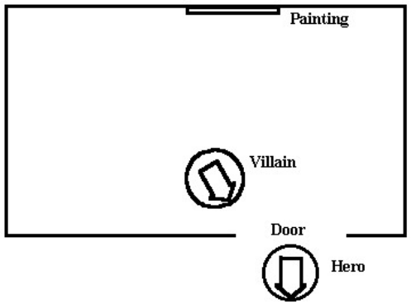
Figure 6: Physical Endgame for Elmo+Oscar shown

Conclusions

Dramatic characters represent a kind of “middle ground” between the robots and agents of today, clunky and crude, and human beings themselves. The dramatic character has been honed, over centuries, to be as believable and life-like as possible. Understanding the nuts and bolts of drama may shed light on how to construct believable agents of all kinds, regardless of application. And surprisingly, the nuts and bolts of drama look more like classic agent architecture than we might have guessed. Dramas are not driven by characters with indefinable emotions, but rather by the character’s objectives, goals, actions, and tactics. We may think of a story as a domain in which the primary agent is successful (or unsuccessful) in achieving its objective.

References

[1] Bates,J. 1994. The Role of Emotion in Believable Agents. Communications of the ACM 37(7): 122-125.

[2] Bates, J., Loyall, A. B., and Reilly, W. S. 1992. An architecture for Action, Emotion, and Social Behavior. Carnegie Mellon University: Technical Report CMU-CS-92-144, May 1992.

[3] Fujita, M. and Kitano, H. 1998. Development of an Autonomous Quadruped Robot for Robot Entertainment. Autonomous Robots 5: 7-18, Boston, Kluwer Academic Publishers.

[4] Hayes-Roth, B. and Brownston, L. 1994. Multi-Agent Collaboration in Directed Improvisation. Stanford University: Technical Report KSL-94-61, October 1994.

[5] Knight, J. 1998 Fictional Characters as Models for Credible Agents. Working Notes from the 1998 AAAI Fall Symposium, Orlando, FLA.

[6] Rousseau, D. and Hayes-Roth, B. 1998. A Social-Psychological Model for Synthetic Actors. Proceedings of the Second International Conference on Autonomous Agents: 165-172.

[7] Velásquez, J. 1997. Modeling Emotions and Other Motivations in Synthetic Agents. Proceedings of AAAI-97.

[8] Velásquez, J. 1998. When Robots Weep: Emotional Memories and Decision-Making. Proceedings of AAAI–98.

Robot Improv: Using Drama to Create Believable Agents

Allison Bruce, Jonathan Knight, Illah R. Nourbakhsh

Corresponding author:
Illah R. Nourbakhsh
fax: 412-268-5571
illah@cs.cmu.edu
www.cs.cmu.edu/~illah

Abstract
Believable agents usually depend upon explicit, model-based simulations of human emotions. This work appeals instead to the sensibilities of dramatic acting to create agents that are believable. The chosen task is that of comedy improvisation as it provides a solid demonstration of the agents believability in the context of a high-level deliberate goal. Furthermore, this work employs physical robots as the actors, employing the real-time sensor values from the robots as inputs into the acting process. This paper describes the dramatic approach to acting that we used and describes the Java-based implementation on two Nomad Scout robots. Actual, improvised scripts created by the robots are included and analyzed.

This paper fits squarely in the arena of Personal Robots and Human-Robot Interaction. To be easy-to-use, robots will need to communicate with humans effectively. The novel approach taken in this paper is the result of collaboration between a drama instructor at Activision and two roboticists: robots that employ control architectures that are similar to those learned by actors in Beginning Drama class. The technique is described and a working system is created, consisting of two Nomad Scout robots that actually interact physically, both moving and speaking to one-another. The plays that result are extremely believable, driving the paper’s point home. This paper is significant because believability is achieved on physical robots using a technique that has been missing: dramatic acting. We also take this problem to the next level by demonstrating intelligent and believable behavior in the context of improvisation, wherein goals are loosely specified. The work can be applied to robots in the field of personal robotics (domestic robots, entertainment robots, etc.), toy robots (Furby, Aibo, Cye) as well as softbots such as web companions.

